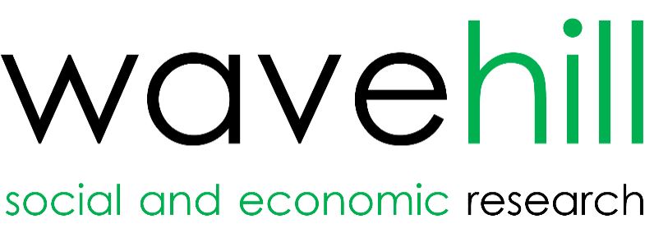
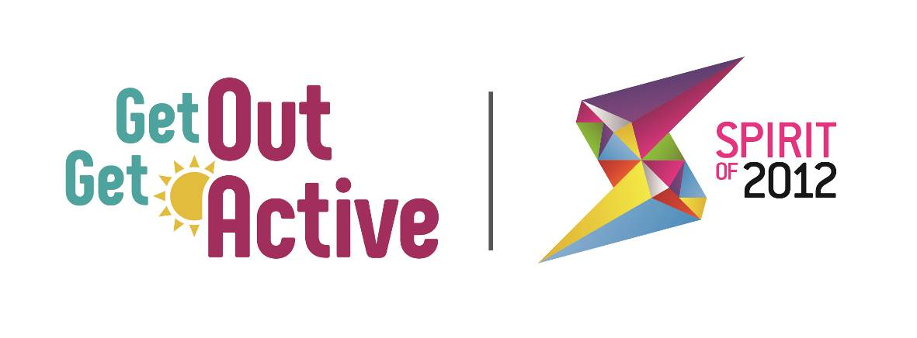
Get Out Get Active: Evaluation and Learning

2nd Annual Report
October 2018

Wavehill Ltd.

- Wales office: 21 Alban Square, Aberaeron, Ceredigion, SA46 0DB (registered office)
- West England office: 217 Paintworks, Arnos Vale, Bristol, BS4 3AH
- London office: 52 Cecile Park, Crouch End, London, N8 9AS
- North of England office: 2 Lyndhurst Crescent, Low Fell, Gateshead NE9 6BA

Contact details:
Tel: 01545 571711
Email: info@wavehill.com
Twitter: @wavehilltweets
Website: www.wavehill.com

© Wavehill Ltd. This report is subject to copyright. The authors of the report (Wavehill Ltd.) should be acknowledged in any reference that is made to its contents.

Authors:
Simon Tanner
Oliver Allies

Any questions in relation to this report should be directed in the first instance to Simon Tanner (simon.tanner@wavehill.com)

Date of document: 24th October 2018
Version: 3.5

Client contact:
Kat Southwell
Head of Programmes and GOGA Programme Manager
Activity Alliance
kat@activityalliance.org.uk
http://www.getoutgetactive.co.uk/

Glossary

BAME | Black, Asian, and Minority Ethnic
DPULO | Disabled People's User Led Organisation
DSNI | Disability Sport Northern Ireland
DSW | Disability Sport Wales
MI | Management Information
SDS | Scottish Disability Sport
Spirit | Spirit of 2012

Contents

Executive Summary 3
1 Background 4
1.1 Introduction 4
2 What this report is about 7
2.1 Introduction 7
2.2 Where the insight is drawn from 7
2.3 How the report will detail the ‘GOGA approach’ 7
3 Monitoring and outcome data 9
3.1 Overview of Impact 13
4 Reaching the Least Active 15
4.1 Underreporting of Inactivity Levels 15
4.2 Success in Reaching the Least Active 16
4.3 Increasing physical activity levels of the Least Active 16
4.4 Improving wellbeing of the Least Active 17
4.5 How GOGA works best for previously inactive participants 19
4.6 Deliverers and partners supporting ‘reach’ 20
4.7 Key Learning Points and GOGA examples 21
4.8 Talk to Me Principles that Most Strongly Apply to Reaching the Least Active 23
5 GOGA Volunteers and Peer Mentors 25
5.1 An Expanding Cohort of Volunteers and Peer Mentors 25
5.2 How Volunteers Have Been Used 26
5.3 Benefits and Impacts of Volunteering 27
5.4 Improved Volunteering Management Practice 29
6 Embedding ‘Active Together’ Delivery 30
6.1 Availability of Mixed Disabled and Non-Disabled Sessions 30
6.2 The Underreporting of Disability 30
6.3 How Active Together is Being Delivered 31
6.4 GOGA is changing perceptions of disability 32
6.5 Recruiting and engaging participants to be ‘Active Together’ 34
6.6 How to deliver ‘active together’ 35
6.7 Key Learning Points and GOGA examples 36
6.8 Talk to Me Principles that Most Strongly Apply to Providing ‘Active Together’ Sessions 39
7 Delivering Sustainability 41
7.1 Supporting Individuals to Remain Active Post-Intervention 41
7.2 Embedding New Ways of Inclusive Working 42
7.3 Transferring Learning Beyond the GOGA Network 43
7.4 Supporting participants to remain active post intervention 46
7.1 Delivery of Sustainability – supporting participants to remain active 47
7.2 Delivery of Sustainability – Embedding Inclusive Working 48
7.3 Delivery of Sustainability – Transferring Learning to External non-GOGA Partners 49
7.4 Key Learning Points and GOGA examples 50
7.5 Talk to Me Principles that Most Strongly Apply to Future Sustainment of Participation 53
8 Key Components of the GOGA approach 55
8.1 The GOGA Approach 55
9 Conclusions and Insight for 2018/19 Delivery 57
9.1 Conclusions 57
9.2 Insight for 2018/19 Delivery 59
9.3 Insight for 2018/19 Evaluation work 59

Executive Summary
A separate Executive Summary in the form of a PowerPoint slide pack accompanies this report.

Background

Introduction
In June 2016, Activity Alliance (formerly the English Federation of Disability Sport) commissioned Wavehill along with Consilium Research and Consultancy to evaluate Spirit of 2012’s Get Out & Get Active (GOGA) initiative.

Spirit of 2012

Spirit of 2012 (hereafter Spirit), is a Trust set up by the Big Lottery Fund to spread the spirit that radiated from the London 2012 Summer Olympics (particularly that associated with the voluntary efforts of the Games Makers) to everyone, everywhere. The objectives of the Trust are to:

- Use regional, national and international events as catalysts for social change; ensuring the country as a whole benefits from the values, opportunities and spirit of events.
- Enhance the volunteering infrastructure of the UK for community benefit, drawing on learning from the success of the London 2012 Games makers’ programme.
- Engage, enable and empower young people as leaders and ambassadors, in schools, communities and nationwide.
- Increase understanding of the challenges disabled people face and ways in which they overcome them to help achieve a step-change in positive attitudes to disability and impairment.
- Collect and share expertise and information gained by Spirit and its partners to inform and support others working in similar areas across the UK.

The GOGA Programme and Its Objectives
The GOGA programme is supported by £4.5 million from Spirit of 2012 to develop, deliver and learn from new and innovative ways to engage inactive people in active recreation. Delivered across the UK, the programme is overseen by the four Home Nation Disability Sport Organisations (Disability Sport Northern Ireland (DSNI), Disability Sport Wales (DSW), Scottish Disability Sport (SDS), and the Activity Alliance working in 18 Local Authority as shown below:

Area
- Bradford Council
- Greater Manchester - Manchester City Council
- Greater Manchester – Rochdale Borough Council
- Greater Manchester – Wigan Council
- Kent/Thanet
- Lincolnshire
- London - Lambeth Council
- London - Wandsworth Council
- Nottingham City Council
- Stoke City Council
- Armagh City, Banbridge and Craigavon Council
- Derry City and Strabane Council
- Fife Council
- Forth Valley: Stirling Council/Clackmannanshire Council/Falkirk Council
- Grampians: Aberdeenshire Council/Aberdeen City Council/Moray Council
- Pembrokeshire County Council
- Rhondda Cynon Taf County Borough Council
- Wrexham County Borough Council

This is underpinned by implementation of key Spirit of 2012 principles which advocate that by enabling people to participate in a wide-range of activities and being able to engage in their communities they will:

- Improve their health and well-being, and as a result, improve communities and society as a whole.
- Improve their perceptions towards disability and impairment.
- Lead them to experience greater social cohesion and understanding.

The overall aim of GOGA delivery is:

“Supporting disabled and non-disabled people to be active together, GOGA aims to get some of the UK’s least active people moving more through fun and inclusive active recreation".

You can view a video explaining what GOGA is all about below:

What GOGA is all about

GOGA delivery is guided at a local, national and programme level by the Talk to Me principles of Activity Alliance, and their equivalents in the other home nations.

The ten Talk to Me principles resulted from research with disabled people, which explored what helps to make activities more appealing and accessible. A link to a video explaining the Talk to Me principles can be found below:

Explaining the Talk to Me Principles

The GOGA programme is testing whether the effective use of the principles will influence the extent to which people are supported to become more physically active, actively engaged, and sustain that engagement over the longer term.

Programme delivery is supported in a number of ways across the GOGA programme though usually this involves strategic groups overseeing GOGA delivery which in the strongest examples increasingly includes key partners from across health and social care, and community development fields rather than just partners from purely sport or physical activity areas.

Activity Alliance is the programme lead for a wide-ranging partnership approach that is reaching out to new audiences for fun and inclusive active recreation that will lead to disabled and non-disabled people being active together.

Developing infrastructure for the engagement of participants and provision of inclusive active recreation in local communities that engages with partners outside of the traditional sport development fields to underpin delivery has proved to be particularly important.

This is an area where the support of programme partners (Age UK, Disability Rights UK, Sporting Equals, Volunteering Matters, Women in Sport) supplemented by support via national partners (the Amateur Swimming Association, England Athletics, Play England, StreetGames, and the Youth Sport Trust) continues to be critical in brokering contacts and supporting localities in developing these relationships, especially fostering new relationship across communities with organisations that predominantly do not currently work directly in the sport/physical activity field, or see a role for the provision of active recreation within their current delivery.

What this report is about

Introduction
This is the second annual report from the evaluation of the GOGA programme.

It provides insight that highlights the journey of organisations, participants, and volunteers and peer mentors through the programme, and from this, the ideas, inspiration, and tips on the ways in which delivery to communities could be shaped by learning from the delivery of the ‘GOGA approach’ emerging from the programme’s most successful work.

Where the insight is drawn from
The insight in this report is drawn from a range of key datasets that include:

- Analysis of Management Information reported by localities delivering the GOGA programme showing activities delivered, and data on participants, volunteers and peer mentors from programme commencement to September 2018. This information covers over 13,000 individuals.

- Reports provided by locality (18) and National Partners (covering quarters 3 and 4 in 2017/18, and quarters 1 and 2 in 2018/19 delivery).

- Annual update interviews with locality leads, partners and national partners. These were conducted by telephone and involved a total of 22 interviews with partners and national partners and 26 interviews with those representing all 18 localities.

- Three baseline telephone surveys with GOGA participants, volunteers, and peer mentors conducted in May/June 2017, February and July/August 2018 resulting in completed interviews with 409 people.

- Two follow up telephone interviews with GOGA participants between 6-9 months after they completed a baseline interview to track impacts of participation, resulting in completed interviews with 150 people. Further waves of baseline and follow up interviews are to continue on a rolling 3-6 months basis until the end of 2019.

How the report will detail the ‘GOGA approach’
This report uses the range of evaluation evidence collected thus far, to identify the emerging key components and practice of the ‘GOGA approach.’ These key components are highly transferable, enabling others to take them forward in undertaking work to reach the inactive, to engage and enrol them in increasing their levels of physical activity, and support them to sustain engagement over the longer term.

The report provides a concise summary of insight around the key focus for the GOGA programme:

- Reaching the least active – how the programme is reaching those individuals who are typically doing the least amount of, or no, physical activity

- ‘Active together’ - where disabled and non-disabled people take part in activity together

- Sustainability – how the programme is seeking to sustain its impacts for participants and the activities and support it is providing in the longer term, beyond the availability of funding for the GOGA programme.

The report also summarises how volunteers and peer mentors are being used successfully to support programme delivery and the way in which the Talk to Me principles are facilitating the work of the GOGA programme.

Each of the short chapters highlights practical insight into the way in which each key focus is being addressed in the GOGA programme. In doing so, the report findings will help shape further ‘in flight’ adjustments to ongoing GOGA delivery, but also help other organisations outside the programme in their work around these issues, particularly engaging the least active and providing inclusive delivery that supports the disabled and non-disabled to be ‘active together’.

A final chapter draws these elements together identifying the key components of the ‘GOGA approach’ for participants, volunteers, peer mentors, and delivery agents and their partners in a single page overview illustrating what emerging insight the evaluation has collected on what constitutes the ‘GOGA approach’. In concluding, we highlight options for the next phase of the evaluation, including further longitudinal work with some of the earliest GOGA alumni.

Before we examine delivery associated with reaching the least active, we detail the progress towards programme targets made by GOGA.

Monitoring and outcome data
Data drawn from the monitoring system covering two years of GOGA delivery shows:

Figure 3.1: Overview of GOGA delivery to September 2018

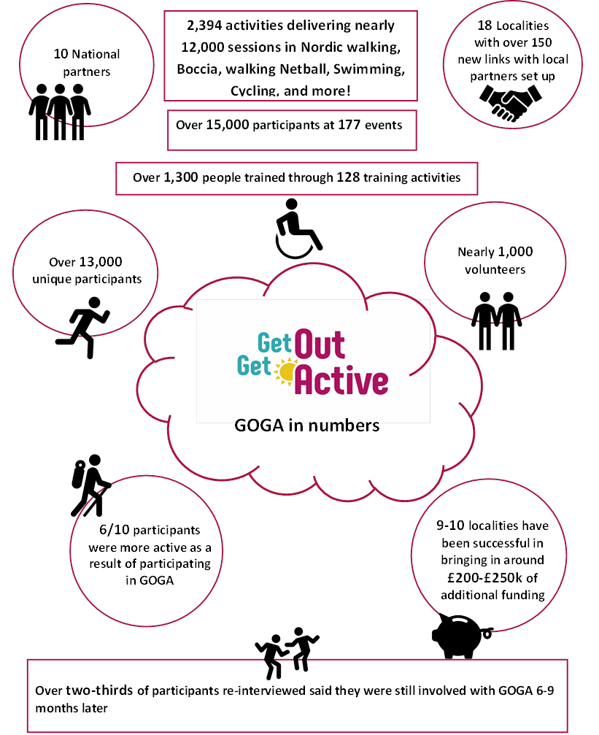
Source: GOGA Monitoring Data to September 2018
Figure 3.2: GOGA Experience of Participants
Prior to GOGA, 50% did not undertake any form of physical activity in the four weeks leading up to taking part in GOGA.
29% reported they had a physical, sensory, learning or mental health condition or illness that lasted, or was expected to last, 12 months or more.

35% are under 30 years of age.

17% are over 65 years of age.
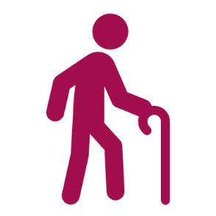
65% are female, 29% from BAME groups.
15% reported that their condition impacted on their ability to do normal daily activities.
Seven out of ten participants identify they have been referred to another activity outside of the GOGA programme with almost half of these taking up this referral.
Two thirds of tracked participants are still involved with GOGA 6-9 months after joining the programme, with over nine out of ten of these participants intending to continue to be involved for up to 12 months.
After 6 months, 15% of tracked GOGA participants were doing five hours extra activity over a four-week period.
And (of course!) participants like GOGA…

“because it's a varied exercise and they've shown me how to do things the proper way like lunges and squats so I've learnt different things, I like the instructors they're a laugh and they've got patience with me and it's led to me doing other things like the circuits now too. My knees are a lot better and stronger, I never used to be able to carry the shopping or walk very far and I can now, I've lost weight too. I'd be lost to death without it and I've made lots of new friends. It's changed my life I'm more outgoing and more willing to go out and do more things.”
Participants

Figure 3.3: GOGA Volunteers and Peer Mentors
33% of volunteers are under 30
28% are over 50

22% had a sensory, learning or mental health condition or illness that lasted, or was expected to last, 12 months or more.
Benefits they got through the programme:
- Improved physical health
- More physically active.
- More involved in my local community.
- Improved mental well-being.
- Met new people and made friends in the local area
- Had fun.
Volunteers / Peer Mentors perform a range of roles:

Formal Roles
- Leading a group/ being a member of a committee
- Getting other people involved
- Organising or helping to run an activity or event
- Mentoring people
Informal Roles
- Providing tea and cake
- Befriending / chatting to people
- Getting people to sessions
Volunteers interviewed 6 months after they started with GOGA needed less support to participate in activities.
6/7 volunteers interviewed volunteered for GOGA once a week
Most hear about GOGA through
word of month
Volunteers and Peer Mentors
Figure 3.4: Local Partner Learning from GOGA
Localities have shared learning and implemented changes in their organisations because of GOGA on matters such as training and recruitment policy
Localities have found that providing an opportunity to socialise can be just as important to participants as the activity itself
Local Partners
Some localities found that activities that weren’t traditionally associated with fitness tended to work well with less active participants.
Localities are finding that getting out into the community is an effective way to engage participants. This includes a move away from traditional sports venues.
Localities have worked with partner organisations that have closer links with certain groups to effectively target participants

Overview of Impact
Data up to the second quarter in 2018/19 illustrates the progress made by GOGA as it approaches its third year. The impact measures focus on a number of key areas wellbeing, perceptions of disability, and social connectedness.

Wellbeing
For all GOGA participants (further information on impacts for the least active is shown in Section 5.4) there are positive trends of wellbeing with statistically significant increases in those reporting improved life satisfaction and a sense of life being worthwhile.

Thus, at baseline, 71% of GOGA participants said they were very satisfied with their life, and this had risen to 83% 6-9 months after GOGA participation with a concurrent rise in the average score (when asked to rate how satisfied with life they were out of 10) from 7.49 to 7.86.

Perceptions of how much participants feel that the things that they do in their lives are worthwhile also demonstrate a positive upward trend rising from 81% to 86% scoring 7-10 for this measure (mean average score rising from 7.85 to 8.21).

Feedback on participant Happiness shows minimal change with the average rating out of 10 rising slightly from 7.90 to 7.93.

Furthermore, GOGA participants are reporting feeling less anxious, 52% of participants rated how anxious they felt yesterday as 0-3 out of 10 upon joining the programme which rose to 58% at follow up interview.

Perceptions of Disability
Perceptions of disability show a mixed set of responses:

- a marginal fall (from 89% to 87%) in the proportion who agree that disabled people can live as full a life as non-disabled people

- an increase in the proportion who say they have a positive view of disabled people from 93% to 97%

- a fall in those who say that GOGA has caused them to have a more positive view of disabled people (from 74% to 57%), although 38% of participants said their view was unchanged because they had a positive view of disabled people when they joined.

Social Connectedness
Role models play a critical role in facilitating engagement on to the programme with three quarters of participants agreeing that a role model has influenced their engagement with GOGA.

Following their engagement with GOGA, participants become more positive about taking part in activities in their local community. Prior to GOGA participation, 43% said they were positive about community engagement and after GOGA participation this had risen to 66%.

Participants feel more engaged in their community after participating in GOGA. Prior to their participation, 78% said they felt engaged with their local community rising to 88% after participating in GOGA.

A host of positive trends are evident therefore amongst GOGA participants. In the following chapters we review the key components of the ‘GOGA approach’ that evaluation findings identify contribute to these positive trends.

Reaching the Least Active

Underreporting of Inactivity Levels
GOGA is reaching some of the least active groups, but there remain challenges in this because many of those the programme has been working with are often reticent about sharing their true levels of physical activity. A more complete picture of inactivity levels only emerges after some initial engagement activity by GOGA programme staff in each of its 18 delivery locations.

Consistently, through interviews with partners and participants, the evidence of over reporting of activity levels at the point of registration by participants is clear. Consequently, it has been a key feature of GOGA that participants are often unwilling to admit to, or understand that, their own activity levels equate to them being within the least active groups in society. There is a real reticence for individuals in these groups to recognise themselves as the very least active people.

Locality leads have consistently identified how initial monitoring data provides a false picture of actual activity levels before these individuals join GOGA.:

“We’ve found that it’s the level of activity questions people fail to understand. It’s something they associate with forms you fill out at the doctors and they’re often putting higher levels of activity because they want to look good. It’s as though they are scared of a telling off.”

The sense of a false picture of self-reported activity has been identified through engagements with the organisations that have referred the participant or their wider knowledge of those individuals. Consequently, monitoring data from registration forms shows that just 19% of participants state they are not even doing at least 10 mins of exercise or physical activity any days of the week in direct contradiction of the much higher levels of inactivity that is subsequently identified in baseline interviews with GOGA participants (see Section 5.2).

This also illustrates an important feature of GOGA delivery where leads/coaches engage directly with participants to understand their barriers to participation. Building this trusting relationship at an individual level is especially important in reaching the least active groups. It also facilitates participants to be more willing to provide accurate perspectives on their levels of activity verbally, once they are familiar with an initiative and not within a form at the commencement of an initiative when a degree of unfamiliarity exists.

In baseline interviews following the critical engagement work by leads/coaches, the discussions with participants highlight that the initial picture of activity levels provided from figures collected at registration are often wide of the mark with 50% stating/confirming in these interviews that in the four weeks prior to taking part in GOGA they had not done any form of physical activity, a further 12% were doing 10 mins or less per day on average, and 19% under 30 minutes. These patterns mirror trends across all the baseline survey work we have completed in this evaluation so far, but qualitative evidence from interviews illustrates that some over reporting of activity levels remains when participants join the programme. The evaluation will keep this under review and continue to triangulate data to assess patterns in over reporting and utilise data to illustrate its scale.

Success in Reaching the Least Active
The baseline interviews highlight that GOGA is making progress in reaching the least active and highlight that the views provided to us by locality staff that new GOGA participants continue to under report their levels of inactivity.

Our analysis of these responses has shown that it is possible to identify three groups based on broad activity levels:

- Very least active – no physical activity, or only up to 10 mins of physical activity (involving at least one of walking for at least 10 mins; gardening, cycling, sport, or dance) per day in the four weeks prior to GOGA participation.
- Least active – over 11 minutes and up to 20 mins per day on average.
- Active – 30 mins per day on average.

Reviewing analysis on the very least active and least active participants interviewed highlights a number of key features:

- Over seven out of ten of the least active groups are female.
- They tend to come from either White ethnic groups, or Asian or Asian British groups.
- Over a third identify themselves as having physical or mental health conditions, or an illness that has lasted or is expected to last, 12 months or more.
- Whilst over four out of ten of those with a condition or illness in the least active groups say it has a significant impact on their day to day life.
- The most common physical, mental health conditions, or illnesses include mobility, difficulties learning or concentrating or remembering, mental health issues, and have stamina or breathing difficulties

It is therefore critical that when engaging with potential participants of whom very low activity levels are known, or suspected, that enough time is built in through initial engagement work to investigate activity levels in a non-threatening way to confirm the evidence or suspicion.

Increasing physical activity levels of the Least Active
Our analysis shows that where the GOGA approach is successfully applied those who the programme engages from the least active groups do demonstrate some particularly positive improvements in their physical activity levels.

Thus when tracking GOGA participants through our survey the data shows that over six out of ten are seen to become more active as a result of their GOGA participation therefore individuals move from being in the very least active group (10 mins or less per day), to being in the least active (10-20 mins per day) or even active group (30 mins or over per day), and those in the least active group move, through an increase in their time being active, to becoming part of the active group. Whilst these gains do not mean that these participants are necessarily now meeting guidelines for physical activity levels (see Table 4.1 below) they represent positive ‘small steps’, moving them out of the very least active groups.

These ‘small steps’ mean that on average tracked GOGA participants are doing up to 45 minutes extra of physical activity over the previous four week period compared to when they first joined the programme.

Table 4.1: The Physical Activity Guidelines of the Four Nations of the UK

 | Adults | Children
England | Physical activity guideline for adults of 30 minutes or more of moderate intensity on at least 5 days a week. | Physical activity guideline for children of 60 minutes or more of moderate intensity each day
Northern Ireland | Physical activity guideline for adults of 30 minutes or more of moderate intensity on at least 5 days a week. | Physical activity guideline for children of 60 minutes or more of moderate intensity each day
Scotland | Physical activity guideline for adults of 30 minutes or more of moderate intensity on most days of the week. | Physical activity guideline for children of 60 minutes or more of moderate intensity on 5 days a week.
Wales | Physical activity guideline for adults of 30 minutes or more of moderate intensity on at least 5 days a week. | Physical activity guideline for children of 60 minutes or more of moderate intensity on 5 days a week.

Improving wellbeing of the Least Active
Tracking respondents also shows that for the least active there are also positive outcomes in terms of wellbeing.

The analysis indicates that there are statistically significant increases in the average rating of life satisfaction and whether participants believe their life to be worthwhile following participation in the GOGA programme (see Table 4.2). However, happiness change is within the margin of error and the mean average of anxiety has fallen.

Table 4.2: Change in Wellbeing Measures for Least Active GOGA participants

 | Average Rating at Baseline | Average Rating Following GOGA Participation
Life satisfaction | 7.32 | 8.24
Sense that life is worthwhile | 7.84 | 8.44
Happiness yesterday | 8.04 | 7.98
Feeling of anxiety yesterday | 2.36 | 2.44
Source: Participant Baseline and Follow Up Survey – Matched Respondents

Furthermore, analysis shows that there is a statistically significant improvement in the belief that least active GOGA participants have that disabled people are perceived more positively in their local area because of GOGA. It rises from an average of 5.06 (out of 10) at baseline to 6.90 at follow up.

The focus of GOGA on reaching the least active has continued with Year 2 findings suggesting an enhancement on mechanisms identified in Year 1 and a greater willingness at a locality level to engage with organisations beyond the sport and physical activity field to engage more widely across health and social arenas. Some innovative thinking and practice is being applied, building the necessary momentum for continued engagement of the least active in to 2019.

In the following sections we illustrate what approaches have helped particularly the GOGA programme to reach the least active individuals it has engaged with showing:

- How the least active participants are typically attracted to GOGA (Section 4.1)
- Approaches partners adopt in their delivery (Section 4.2)
- Key learning that arises from delivery (Section 4.3), and;
- How the use of particular ‘Talk to Me’ principles (Section 4.4) have facilitated this delivery.

How GOGA works best for previously inactive participants
Key Factors in Reaching the Least Active
- A social dimension is more important than the active recreation. An opportunity to socialise is commonly a key reason why the very inactive have attended GOGA activities in the first place – almost half of the very least active in our follow up survey highlighted that the opportunity to socialise and meet new people was one of the main reasons they had joined GOGA.
- Encouraging friendship groups to be created, and maintained, around delivery is a critical approach to ensuring those individuals return for future sessions.
- It is critical that each participant experiences a friendly and welcoming environment at the outset and that this continues throughout their engagement with the activity.
- Attendance is supported when project staff follow up initial referral with a phone call, email, or face to face contact to check the participant is comfortable with attending and to address any worries they may have. In early stages of engagement support continues, facilitated by informal buddy arrangements using other participants, family, friends, peer mentors or formal volunteers where available.
- Coaches or activity leads are valued because of their social abilities, emotional intelligence, and friendly nature often above any expertise they might have in the activity involved. Volunteers and peer mentors are also key in filling this role particularly to ‘meet and greet’.
- The offer emphasises the focus on fun and opportunities to try or test a range of non-traditional sport or active recreation options. A ‘Tea, Talk, Try’ or ‘Meet and Greet Taster’ emphasises the participation decision is down to the individual.
- Activity is incorporated, but in a low-key manner, and in short segments leaving the most time for socialising. As the group dynamic builds the amount of time allocated to activity can increase.
- Inclusive, ‘active together’ (disabled and non-disabled together) approaches are welcomed by GOGA participants and can help to bring people in as they perceive they will not be out of their depth in a group with people with disabilities.
- Participants want opportunities to feedback and be listened to on their wishes for the activity. Scaling of activity up or down should be based on these needs and wishes.
- Avoid over emphasising the active recreation element of delivery and the most popular team sports (football, cricket, rugby) and focus on individual focussed activity (for example walking leading to jogging then running, swimming, dance, archery, climbing, golf), or scaled team sports (walking football/netball, boccia).
- A competitive dimension should be incorporated gently as the group dynamic develops and potentially in line with requests from the group.
- The best venues maybe facilities that are not known as previously hosting physical activity. Unless essential for specialist provision, leisure or sports centres should be viewed with caution.

Deliverers and partners supporting ‘reach’
To have success in reaching inactive groups analysis of our findings shows that some of these approaches may help in successfully targeting the inactive.

Key Approaches in Reaching the Least Active for All Partners
- Work with specialist non-sports/leisure organisations including charities, community groups focussed on specific groups/health conditions, specialist housing providers, specialist support agencies to recruit participants. The further removed from sport the better.
- Think where individuals might be if they are not in existing active recreation / sport sessions.
- Focus on venues where inactive individuals might be found:
  - Schools / Colleges / Universities
  - GP surgeries, Hospitals or other Health and Care Service settings
  - Adult Day Centres, Community/Faith Centres
  - Supported Living/Care Homes, Housing Associations
  - Sitting down venues - Bingo Halls, Cinemas
  - Takeaway establishments
  - Specialist support and respite services
  - The family home/household.
- Identify who accompanies existing participants to sessions that might also be inactive – parents, carers, support workers, other family members, friends. There may be opportunities to encourage them to participate at the same time.
- Ask the targeted organisations who invite people to your activities to focus on the social and fun aspects providing opportunities to meet and make friends with new people.
- Focus on socialising opportunities and build active recreation around these, a balance towards socialising initially rather than the activity. Active recreation to meet new people and make friends, not active recreation to be more physically active, at least at initial phases of engagement.
- Reaching the least active and the ‘active together’ agenda should not be treated as being mutually exclusive. Each supports the other in the strongest forms of GOGA delivery.
- Educate, and train, all staff (including coaches and leads) in inclusive delivery and ensure they understand the importance of a friendly and welcoming approach at all sessions.
- Volunteers and peer mentors are essential to support participants directly as ‘meeting and greeting’, supporting attendance, providing refreshments and organising transport to activities can be extremely time consuming. Used wisely they can extend the ‘reach’ and influence the programme can have.
- Foster the development of the group dynamic and encourage the development of friendships through the targeted group. Look at ways of safely encouraging contact outside the delivery setting to facilitate ongoing attendance through peer to peer support, and informal support in attending each session (travel together, meet ups before/after sessions, completing other activities together).
- Focus on delivery of opportunities to take part in a multiple range of active recreation options that best avoid more traditional team sports. Consider scaled options or seek feedback from your target group of participants on what forms of active recreation they might wish to pursue.

Key Learning Points and GOGA examples

Critical nature of the social aspects of participation
One of the key learning points around engaging the least active, is that the social aspects of participation outweigh the physical aspects. Groups come together because they want to use active recreation as an opportunity to meet new people and make friends. This is the main motivation and as such it is important to promote this and include sufficient time in planned sessions for social interaction (i.e. regular breaks/refreshments). Successful GOGA delivery has found that participants that maintain contact outside of the GOGA sessions enables groups to bond and they therefore have a confidence to engage in new / future activities together. As these quotes from GOGA leads regarding the importance of the emphasis on social interaction show:
“Since being involved in the GOGA programme…I have witnessed the impact the programme has had on the people…who don’t have much access to regular activity. We have two participants who joined at the start of the all ability boxing who wouldn’t usually do any activity or integrate with others at all. The GOGA All ability boxing focuses on social interaction and enjoyment and I have seen a big change in these participants, they even participated in the adventure days January.”

“Generally talking to them, Kate will go out to sessions and have conversations. Chat with tea and biscuits. Ask them what they enjoy, what works well and what doesn’t.”

For some participants, the group dimension is clearly important:

“Being in a group situation has been really useful. The guys that have been around are all so encouraging and fab.”

As one carer highlighted:

“She was very withdrawn and wouldn't look at people before and she's been going to the badminton for 2 years now and the difference in her is totally unreal, she's communicating more herself with people whereas before she would stand behind me and she has actually met up with one of the girls and they've gone for lunch, so it's given her a social life as well as bringing her out of herself and giving her a lot more confidence”

Whilst other participants identify:

“The feeling of inclusion. Before I started going to GOGA activities I used to just go out for lunch every day and my home life was not half as active as it is now. I love the activities. I have made friends and experienced things I never thought I would. It has also improved my home life as now I am knackered and manage to sleep every night whereas before I was up every hour. Safe to say my mum loves me going to GOGA.”

“The other part of it which is just as important, if not more important is it's quite a social activity, it's very social compared to the typical gym and so therefore the connections I've made and the fact that I see the regular faces there is something that'll encourage me to carry on.”

From this learning and assessment of findings it is clear that there are a number of the Talk to Me principles that actively support work in GOGA to reach the least active. We have summarised these overleaf in Section 4.4.

Talk to Me Principles that Most Strongly Apply to Reaching the Least Active
Overarching Principle | Talk to Me Principle | Application in GOGA to reach to very least active disabled and non-disabled people | Recommended Course of Action
Drive awareness | - Use the channels I already trust  - Stay local to me. | GOGA partners have:  - Considered different touch points to target a new audience e.g. Stoke and health care professionals, Bradford and takeaways to drive working in partnership to increase reach  - Engaged in partnerships that have direct reach to target audiences e.g. Lincolnshire and Talk Eat and Drink, and with the Royal British Legion  - Created steering groups with a membership with reach to target audience e.g. Northern Ireland - Derry and Strabane and ABC  - Seek links to residential and care home set ups in your local area – Wandsworth. | - Seek channels through other trusted individuals not tarnished with the ‘sport / physical activity field’ think health, housing, social care professionals, existing participants, friends and family.
Engaging the audience | - See me as an individual  - Talk to as many of my values as possible  - Continue to fulfil my values in new ways | GOGA partners have:  - Taken an inclusive approach to marketing not necessarily saying activities are explicitly for disabled people e.g. Wrexham and women’s night  - Shaped their offer to meet the motivations of their target audiences; e.g. Bradford and archery link to religious texts  - Provided opportunity for GOGA partners to shape future programme delivery e.g. Wrexham and Ladies night  - Used a variety of activities / offers to engage new participants where often activity is stealth e.g. Thanet and beach clean walk; Beachcombing in Pembrokeshire. | - Emphasise the fun and social dimension above any elements of physical activity.

Overarching Principle | Talk to Me Principle | Application in GOGA to reach to very least active disabled and non-disabled people | Recommended Course of Action
Offer support and reassurance | - Reassure me I’m going to fit in  - Make me feel I can do it  - Make it easy for me to tell you my needs  - Ensure my first experience is good  - Encourage me through existing advocates | GOGA partners have:  - Spent time engaging with participants before they attend a session e.g. Nottingham and walking netball group  - Worked with peer mentors and volunteers to support participants to attend activity e.g. Lambeth – Morris and co.  - Used existing advocates to engage the least active e.g. Bradford and champions  - Introduced welcomers to session e.g. Bradford and women’s night | - Begin with the social, and emphasise a ‘Tea, Chat, Try’ or ‘Taster’ agenda.

GOGA Volunteers and Peer Mentors

An Expanding Cohort of Volunteers and Peer Mentors
The journey for GOGA around Volunteers and Peer Mentors has been one focused on:

- providing more structured support to sustain volunteer recruitment and participation in the longer term,
- an increased focus on the use at a local level of informal volunteers, and
- an increase in the numbers taking on volunteer and peer mentor roles including previous participants of the GOGA programme.

Delivery in GOGA’s second year has been particularly focussed on work to extend and enhance the recruitment and use of volunteers and peer mentors by the programme. This led to focused audit work undertaken by national partner Volunteering Matters and additional quarterly reporting on volunteer numbers.

The results from this work show that there are:

- 976 volunteers and peer mentors working with the GOGA programme
- Of these 410 are in formal volunteering roles, 383 doing less formal volunteering roles, and 183 peer mentors

Amongst these individuals just over a fifth said they had a physical, sensory, learning, or mental health conditions, or illness that had lasted, or was expected to last, 12 months or more, a third were aged under 30 with over a quarter aged over 50.

We need to improve the data collected through surveys on those volunteering with the programme as the relatively lower registration of formal volunteers has limited the numbers of interviews we have been able to complete with this group of GOGA participants. To date we have been able to complete interviews with 15 volunteers and peer mentors, with seven responding to requests for a follow up interview. We propose in the future to work with localities to collate further details of all volunteers and ensure that a larger number of volunteers and peer mentors are interviewed for the evaluation.

How Volunteers Have Been Used
Those volunteering to support the GOGA programme perform some common tasks that include:

- Leading a group/ being a member of a committee
- Getting other people involved
- Organising or helping to run an activity or event
- Befriending people
- Mentoring people

Specific examples of how volunteers have been used at a locality level are revealed by data drawn from their quarterly reports that show:

- Bradford - a local community champion volunteer has been an integral part of encouraging local families and disabled people into the mixed ability swimming and family fun swim by reaching out into the community to recruit new participants. A volunteer administrator has played a role in engaging more disabled people into activity using their own experience of a long-term health condition to support local disabled people to attend GOGA.

- Lambeth – volunteers help set up equipment, run activities or lead the warm up. Furthermore, volunteers from a local trust alongside some fellow swimmers help those with sensory impairments get to the session and help guide them in the water once there.

- Stoke - are exploring the potential idea for volunteers to buddy up with new participants as and when required. This is expected to ease pressure on the Instructor and help make the new participant feel part of the sessions immediately.

Benefits and Impacts of Volunteering
For those who have been interviewed there have been some significant benefits that have arisen from their volunteering experience.

It is clear that the individuals have enjoyed, and are learning from, their experience:

“I feel like I'm enjoying the experience and I'm helping more people, I'm loving it, it's been absolutely fantastic, I feel like I'm still learning how to react with other people and how to help them as best I can so I feel that's been very, very good and has really improved my self confidence in talking to other people.”

Whilst another identifies:

“For fitness reasons as well as I don't particularly enjoy the gym and this is a way of being active without necessarily having to stick to a routine… in terms of the people you're delivering these sessions to [they] get so much out of it that it's a really rewarding experience watching people try things that they would ordinarily say they couldn't do and they give it a go and are like 'wow, I can do it!' so I think GOGA are really targeting a group of people who need that help and support.”

Generally, those volunteering identify a range of benefits that arise from their engagement with the GOGA programme that means they benefit from improved physical health, becoming more physically active, getting more involved in their community, improving their wellbeing, increasing their confidence and in providing an opportunity to meet new people and make new friends in their local area.

However, what is also clearly important is the opportunity to pass on knowledge and experiences to others:

“I like everything that I've been doing so far, I find it's been very exciting to pass on some of the experience I've learnt to other people and that they might pass that advice on to others in the future and hopefully they'll do well in competitions. I've been doing sport for a long time and I feel it's time for me to try and help other people and what encourages me is I've seen more people getting involved every time and that's helping the sport as well to see more people getting access and it's really good to see the younger ones starting too.”

Whilst for this volunteer, a sense of achievement around supporting others is particularly valuable:

“For me it's putting the session together and helping out and that but when you see the amount of people that get involved and are doing the sessions it's like 'wow' it's this busy and it's a sense of achievement. Having fun, plus making new friends as well and obviously it improves my skills, my confidence doing other things as it's helped me go on to do football coach and going onto different courses so I'm able to do this, it's improved my communication skills and my leadership skills.”

Further insight on the benefits of volunteering on the GOGA programme is highlighted by the following case studies:

Michelle – Wrexham

Michelle had been attending the GOGA sessions for nearly a year as a participant and throughout this time she was inspired and began telling friends, family, colleagues and people in her area about the sessions to spread the word of GOGA. Michelle stated “since starting, I have loved running and so being able to spread that to other people is a great thing to do as well as it being a new challenge. I love helping and assisting people to enjoy running as much as me and my daughter Maisie who now attends the GOGA running sessions with me. We’re a team and it has been great to attend the session together but also to spread the word of GOGA through the Wrexham community”

Michelle finally added “I have found that volunteering is extremely rewarding and if you’re volunteering at something you enjoy then it’s even better. So I would tell anyone to just get out and give it a go”

Serena – Manchester

Serena commented ‘I am a volunteer for the GOGA programme working as a sports coach with young people and their families, to get them involved in inclusive sport. The sessions are held at the Abraham Moss Leisure centre on Saturday afternoons 2:00- 4:00pm. I like working here, as the Lead coach helps me plan some of the activities, so I can look at how to adapt the session for the group, I get to meet new people too and work with other volunteers. We also have a swimming session, and I hope to gain a swimming qualification, so I can help deliver activities in the pool too” The coach added “Serena is also part of the session planning along with the main coaches and other volunteers. Serena is very focused on the session and wants to enhance the chances and opportunities to all young people wanting to do sport but especially being a strong advocate and motivator for all young people with a disability”

Improved Volunteering Management Practice
Through national partner, Volunteering Matters, GOGA has made strides in improving its structured approach to recruiting, engaging, training and utilising volunteers across the 18 targeted communities.

Following completion of volunteering audits and consultations with localities, Volunteering Matters have drawn up and have been implementing the more structured approach to the delivery of support for volunteering in GOGA programme areas.

This has involved the following elements to support the sustainable engagement of volunteers by GOGA:

- Establishment of an online learning hub and launch of the GOGA volunteer toolkit in April 2018
- Development of a programme of volunteer taster sessions – Give it a GOGA
- Development of a volunteer ambassador programme to create community champion roles to help spread word about volunteering opportunities in GOGA areas
- Support for local development of volunteers recognition and celebration approaches
- Continuation of bespoke volunteer consultancy to address more localised challenges

The increasing volunteer numbers (from 426 volunteers in the 3rd quarter of 2017/18 to 976 in the 2nd quarter of 2018/19) illustrate that these additional support mechanisms are gaining traction in localities. Improved reporting mechanisms to capture details of informal volunteers illustrates the importance of this activity to the GOGA programme. This has highlighted the need for the evaluation to ensure that the volunteer experience of informal and formal volunteers is comprehensively gathered. Therefore, it is envisaged that the evaluation work will seek further insight from individuals involved in voluntary roles for the programme.

Embedding ‘Active Together’ Delivery
The concept of ‘Active Together’ is a critical component of the approach that GOGA is seeking to test and achieve through its delivery. It means that GOGA actively seeks to provide a range of active recreation opportunities within which disabled people and non-disabled people can be active together.

In the following sections we illustrate that the journey for GOGA around this is one of an improving set of approaches that are ensuring that ‘Active Together’ is being more fully embedded in local GOGA delivery. Localities are more focussed on ensuring it is delivered, and stakeholders and partners are working in a more focused way to deliver these key elements of the original objectives of the programme.

Availability of Mixed Disabled and Non-Disabled Sessions
Progress continues from our findings in the first year of programme delivery with ‘Active Together’ a more prominent feature of delivery in year two and plans for year three of GOGA delivery showing that the approach is to gain further traction in the 12 months to September 2019.

Analysis of activity records across the programme shows that there has been an increase in the number of activities that have been offered that include an explicit ‘Active Together’ approach (with localities identifying specifically that the activity was targeted a mixed disabled and non-disabled group) making up 47% of all activities offered on GOGA in the second quarter of 2018/19. However, there remain a number of disability only activities being offered through GOGA – around one in ten of all available activities in the second quarter of 2018/19, details concerning the remaining proportion of activities were either not specified or open to all without specifying targeting of any specific types of participant.

Our partner interviews and review of quarterly reporting by localities show that many disability only sessions are however being used as an initial engagement approach to re-engage disabled people with active recreation, build confidence through improving core physical literacy skills amongst them, to then facilitate a move into activities where the ‘Active Together’ approach is being applied.

The Underreporting of Disability
A continuing issue is that there remains a reticence amongst individuals to identify themselves as having a disability or impairment that affects their day to day lives. This arises when GOGA locality leads have highlighted to us where they have targeted specific specialist disability/condition organisations for the precise purpose of reaching out to individuals from a group – perhaps mental health, learning difficulties/challenges, or a physical disability. Despite this targeting, returned registration forms identify far fewer individuals identifying themselves as disabled in spite characteristics of the group being confirmed by staff at the specialist organisation.

The reasons for this have been highlighted in previous work by Activity Alliance identifying that some people fear losing benefits if seen to be physically active, do not see their disability as part of their identity, or are not willing to share such information. A range of scenarios summarised well in this quote from a GOGA lead in an interview in August 2018:

“A lot of people are disabled, but don’t tick it on the form. We tend to find this across a lot of our programmes, not just GOGA. People won’t say that they have a disability, but we discover they have. Reluctant to say it, mixture of people not perceiving themselves as having a disability and others who don’t want to give out that information.”

However, a number of areas have addressed the underreporting by ensuring participants are clear on how more accurate information leads to the provision of more relevant activities and using volunteers to support the data collection, adopting more informal, conversational approaches to completing the registration forms so that a more accurate picture is collated. The evaluation team will continue to monitor registration, support localities to improve registration data collection and strengthen the accuracy of this information through triangulating data across the evaluation. We also know that this also reflects how participants perceive themselves, with or without a disability, and that other data collated through our monitoring and evaluation framework will provide a more nuanced picture of individual circumstance around disability, impairment and illness.

How Active Together is Being Delivered
Our partner interviews show that delivery of an ‘Active Together’ approach must by underpinned by inclusive delivery by leads/coaches and that the group dynamic for participants between those with disabilities and those without is managed effectively.

If this is not done it can detrimentally affect the cohesiveness of the group which (as Chapter 4 illustrates) is critical for engaging the least active to enable them to attain the outcomes the GOGA programme is beginning to demonstrate.

This is ably summarised by this participant:

“At first I thought it was more for disabled people and their carers which it was when it started, it was great then but as more able bodied people got involved it wasn't as good because they tended to keep themselves to one side. It was a bit off putting watching them doing their thing on one side while the disabled people struggled on the other. The social aspect of it was great at the start though.”

There are though examples from partners that their consultation work has shown also that some disabled people do want to have disability only activities. However, our early tracking evidence suggests that the ‘Active Together’ approach does demonstrate some of the most positive outcomes for participants and suggests that disabled people should be encouraged to consider ‘Active Together’ sessions more actively.

GOGA is changing perceptions of disability
GOGA is changing perceptions of disability, almost half of all GOGA participants report that they have a more positive view of disabled people as a result of their GOGA experience. Furthermore, over half of GOGA participants believe strongly that perceptions of disabled people in their community have been improved by GOGA delivery, with a statistically significant increase in the proportion strongly agreeing that this has occurred.

The findings also illustrate that there is particular synergy between aligning ‘Active Together’ approaches to the aim of GOGA to reach the least active. The mixing of participants that combining these two approaches brings, seems to enable each agenda to support the other. Thus ‘Active Together’ delivery provides active recreation opportunities that are more appealing to the groups of least active individuals GOGA is targeting, whilst drawing participants from the least active group means that an ‘Active Together’ approach is more likely to meet the needs of those least active programme participants.

They are in simple terms, mutually reinforcing, and therefore should not be treated as mutually inclusive elements of successful GOGA delivery.

From our analysis the following approaches towards delivering ‘Active Together’ sessions seem to be the most common and deliver some of the most success in embedding such delivery in GOGA localities. These approaches include:

- Family focussed activities that provide opportunities for a whole family to participate in a common activity.

- Encouraging carers to participate alongside those they are caring for as part of a single session delivered in care homes or other supported living.

- Engaging specific demographic groups for example working with older populations who as a group have higher probability of impairments so approach provides a good opportunity to engage both disabled and non-disabled participants.

In addition, some specific examples in localities include:

- Bradford - weekly GOGA sessions have also been established at a women’s mental health charity and also at a mental health referral service.

- Grampians - Volunteer support is being provided to enable people with disabilities to take part and supporting other able-bodied family members/peers to take part as well.

- Manchester - Active Family provision targets mums and their disabled and non-disabled children to get active together.

- Northern Ireland – have been recruiting disabled people into already established programmes which have more non-disabled participants, whilst also making new contacts for referrals through contacts in local health trusts.

- Nottingham – have been working with impairment specific groups who traditionally cater just for the individual with an impairment. They have encouraged the organisation to extend engagement and activity supporting disabled and non-disabled people to enjoy active recreation together, to include the wider family including siblings, parents, friends and support workers.

- Wandsworth - have managed to achieve links through schools for pupils with and without additional learning needs and within sheltered housing communities that have a both disabled and non-disabled individuals living on estates.

Success around ‘Active Together’ GOGA delivery has strong parallels with the practice for reaching the least active outlined in Chapter 4, but in the following sections we again highlight the components for delivering this agenda drawn from our review of GOGA delivery in its second year.

Recruiting and engaging participants to be ‘Active Together’
Key Factors in Active Together Success
- To recruit participants from disabled and non-disabled groups work through specialist non-sports/leisure organisations including charities, community groups focussed on specific groups/health conditions, specialist housing providers, specialist support agencies to recruit.
- Identify who could/does accompany participants to sessions that might also be inactive – parents, carers, support workers, other family members, friends. There may be opportunities to encourage them to participate at the same time. Ask participants if there is anyone they would like to bring.
- Remember that the social dimension is often as important, if not more important, than the physical activity and encouragement to bring others can help to achieve ‘Active Together’ delivery.
- Inclusive groups facilitate the use of ‘Tea, Talk, Try’ or ‘Meet and Greet Taster’ approaches because social interaction is a key engagement approach. The least active may feel more comfortable in a ‘mixed’ ability group as they can perceive they will not be out of their depth in a group with people with disabilities.
- Coaches or activity leads will be valued because of their social abilities, emotional intelligence, and friendly nature often above any expertise they might have in the activity involved, but they will need to be skilled in managing inclusive groups to prevent groups segregating themselves on the basis of being disabled/non-disabled.
- Inclusive groups are popular with most GOGA participants who have already worked with the programme and the balance in delivery so far seems to be right with over half of all participants saying they had not found inclusive sessions to be too disability focussed. For the least active inclusive sessions are one of the main reasons they have participated in GOGA in the first instance.
- Training volunteers and peer mentors in inclusive practice means they can assist in bringing participants together, some can be nervous or lack confidence about participating so sometimes needs a little help to participate in the first instance.
- Coaches/leads focussed on, and trained in, inclusive delivery approaches are a key mechanism for bringing participants into an Active Together session. Participants want to feel involved and that they are encouraged to interact with other participants in the group.

How to deliver ‘active together’
To have success in delivering ‘Active Together’ sessions analysis of our findings shows that some of these approaches may help to be successful.

Key Approaches for All Partners to Deliver Active Together Programmes
- Recruit through specialist disability organisations, but specifically focus on the individuals who support disabled people in their day to day lives – carers, peers, friends, parents and specifically encourage them to participate in activities.
- For regular participants, identify who accompanies them to sessions that might also be inactive – parents, carers, support workers, other family members, or friends. Observe what these individuals are doing whilst the activity proceeds and ask them to support you by joining in for short sections of the activity provided, allow these sections to get longer until they are fully immersed in the activity.
- Working with whole families, or the range of support workers involved with some participants can be a good way to create disabled and non-disabled groups.
- The ‘Active Together’ agenda and reaching the least active should not be treated as being mutually exclusive. Each supports the other in the strongest forms of GOGA delivery. Inclusive activities are likely to be much less daunting for the very least active who may or may not be disabled.
- Educate, and train, all staff (including coaches and leads) in inclusive delivery and ensure they understand the importance of the ‘Active Together’ approach to the success of the GOGA programme. Actively encourage innovative approaches to developing ‘Active Together’ sessions showing that such approaches are more likely to have significantly wider appeal than sessions targeted at just disabled people’s groups.
- Key staff skills should be developed around managing group working so that all aspects of delivery include the disabled and non-disabled participation in activities alongside each other. Coaching management skills ensuring that groups are encouraged not to segregate themselves into disabled/non-disabled groups. Activities should foster co-operative working and identify ways in which participants can be active with others particularly in relation to disabled and non-disabled participants.
- Use inclusive groups to provide opportunities for cohesion that build on shared values, needs or desires for active recreation. Consulting across a mixed group will highlight that commonalities exist in the types of activities that all groups want to do.
- Focus on delivering of a range of flexible opportunities that facilitate scaling up, and down, of the level of activity.
- Risks can be taken, inclusive groups provide the greatest flexibility in which to try new approaches and get a good range of feedback on the applicability and relevance of such an approach to a particular group of people. Don’t be afraid to test some approaches out.
- Make sure all delivery is welcoming and friendly from first to last ensures all participants are more likely to return, it may encourage others who haven’t originally come along to take part, to participate.

Key Learning Points and GOGA examples

How ‘Active Together’ is Welcomed by Participants
Reinforcing previous Activity Alliance research findings, the key learning drawn from GOGA around delivery is that ‘Active Together’ is welcomed by participants. As this parent comments on their child’s experience of GOGA:
“Just being in a big group as it's quite nice for him, he's tried lots of things like football over the years but he really wasn't able to join in fully and do so just being able to go and have fun and do a new sport he really enjoys it and I've noticed a big difference in him since he's been doing it as going definitely improves his mood. It was quite challenging at first for him because he can only use one arm but the coaches there are really good and have given him tips on how to throw it up and serve with one hand and he can do it now and even stays for an extra hour before the badminton too doing the other sports they do.”

Common with other comments we have seen across interviews the key aspect arising from this is the level of involvement it fosters for those taking part in such inclusive groups. As such participants have a better experience, feel they are made more welcome, and are likely to see more pronounced outcomes because they are more likely to attend more regularly. A situation well summarised by this carer:

“She just loves going and thoroughly enjoys it, she loves sport but apart from this there's not any other activities run locally that are inclusive that she's able to join in with apart from what she does at school. She knows the other kids at the…[Club]…now so there's a social aspect to it too and it's great to see it's encouraging independence for them as well.”

Whilst another parent adds:

“She enjoys doing things as a group and challenging each other, plus it's varied, there's lots of activities she can do and it's improved her confidence, I can see that in other things she does.”

Appropriate Scaling is Key
An essence of this enjoyment and a key component of inclusive delivery is the appropriate scaling of activities across the range of abilities found in a group such that all feel able to participate as this carer of a disabled adult outlines:

“It gives him something to look forward to, the instructors make it work for the children so if something's not working they'll change it and they really put a lot of thought into it and it's making the kids more confident and more able to join in at different levels, a lot of it is down to the way the instructors work with the children they've really got to know them and they feel like they belong there, I think my son definitely feels he belongs there as part of that group and that's really important, it's all about catering to their needs and all the kids are included.”

An approach further backed up by this GOGA lead:

“People with a disability bring their family and friends – we encourage that through our leaflets.”

Approaches for Creating ‘Active Together’ Groups
Working through families, or networks of support staff are common ways in which ‘Active Together groups can be easily created. As this example highlights:

“I liked the family involvement and going with the children and seeing the children happy in the pool and also seeing they're learning to swim which gives you reassurance for the future that they'll be safer in the water, plus my older niece met other children that she could play with as well.”

However, in developing an ‘Active Together’ programme it is important to advertise the sessions correctly focussing on the inclusivity of the sessions offered as this GOGA lead highlights:

“The first thing we do is that all our advertising doesn’t specify disabled or non-disabled, advertised as inclusive so we don’t differentiate. We’ve also stopped doing that across all our other sessions. Taken off disabled where was specified before.”

Whilst another emphasises:

“We avoid leading with impairments, where we have a particular group, such as limb power which works with amputees, we will often run a taster session which is specifically for their group so they have the comfort of a tailored session but we then slowly feed them into the mainstream.”

Across review of these examples it is also clear that a number of Talk to Me principles have also played a role in the roll out of ‘Active Together’, Section 5.4 below highlights those of most relevance.

Talk to Me Principles that Most Strongly Apply to Providing ‘Active Together’ Sessions
Overarching Principle | Talk to Me Principle | Application in GOGA to Embed ‘Active Together’ Delivery | Recommended Course of Action
Drive awareness | - Use the channels I already trust;  - Stay local to me. | GOGA partners have:  - Work through impairment specific groups to target the non-disabled carers, support workers, friends, and families of those with disabilities to recruit the non-disabled – for example work in Nottingham with the Ear Foundation.  - Advertised events as family friendly open to disabled and non-disabled people – Grampians  - Work through local residents associations to reach inclusive groups of participants – Wandsworth  - Using volunteers as ambassadors to champion inclusion and inclusive delivery out through communities, so message comes through the community - RCT  - Promote activities through families and friends – Wigan. | - Consider carefully the suitability of a venue for ‘Active Together’ activities enhanced accessibility might be required.
Engaging the audience | - See me as an individual;  - Talk to as many of my values as possible;  - Continue to fulfil my values in new ways | GOGA partners have:  - Recruited more disabled people to existing sessions dominated by non-disabled people - Derry | - Identify target groups and the organisations that work with then seek to recruit non-disabled participants through them.

Overarching Principle | Talk to Me Principle | Application in GOGA to Embed ‘Active Together’ Delivery |  | Recommended Course of Action
Offer support and reassurance | - Reassure me I’m going to fit in;  - Make me feel I can do it;  - Make it easy for me to tell you my needs;  - Ensure my first experience is good;  - Encourage me through existing advocates. |  | GOGA partners have:  - Offer mix of individual and class based / group activities – these have broad appeal and overcome any concerns around need to socialize - Thanet  - Offer free sessions to families and friends of existing GOGA participants if they accompany them to sessions – Bradford  - Use ethos of peer education to encourage existing participants to support new members when they join – Wigan. | - Ensure coaches and leads are adequately skilled in managing multi ability groups and managing group dynamics to avoid segregation of participants.

Delivering Sustainability
In quarter 3 of 2017/18, localities and partners were asked to specify details of their sustainability plans in their regular quarterly report for that period. The evaluation followed up these details in interviews in August/September of 2018. We have also reviewed the evidence from follow up surveys with participants to identify key features of how engagement in activity being fostered by GOGA is being maintained and facilitated to continue for these individuals into the future.

In addition, we highlight how inclusive working is being newly embedded in the working practices of those involved in GOGA, and how learning is being transferred within and beyond the GOGA programme.

This chapter demonstrates that for GOGA, the journey around sustainability is being more embedded in year 2 than in year 1. The focus on sustainability plans has identified some useful practice. It is strongest around the delivery approaches that are being used to sustain participation in active recreation through the delivery of friendly and welcoming approaches, support from role models, the development of new friendship groups, and signposting and participation in additional activities outside GOGA (although participants remain very committed to the GOGA activity that first introduced them to active recreation).

Approaches to embedding inclusive working are emerging and are being pushed forward particularly in terms of the provision of widespread inclusive delivery training, whilst there are active examples (though not utilised by all localities, or partners, yet) of sharing or learning through quarterly reporting and GOGA update arrangements, the use of the GOGA Hour, and the very successful Annual GOGA conference. The latter elements are likely to become a greater part of the journey for sustainability as the programme moves into 2019.

Supporting Individuals to Remain Active Post-Intervention
For participants, our survey results show that following GOGA engagement, participants increase their activity levels and sustain participation over time. This is because the early waves of follow up surveys identify statistically significant improvements in the amount of time GOGA participants are undertaking physical activity. This equates to relatively small increases in the time involved in active recreation for the very least active individuals engaged by the programme, around an extra 45 mins on average per participant over a four week period. However, for 15% of tracked GOGA participants the difference is an extra 90 minutes or more rising to over five hours extra activity over that four week period.

New Activity Take up
Furthermore, over two thirds are still involved with GOGA 6-9 months after joining the programme, with over nine out of ten of these participants intending to continue their involvement for up to 12 months. Seven out of ten participants have been referred to another activity outside of the GOGA programme with almost half of these taking up this referral. Given the startlingly low levels of physical activity undertaken by GOGA participants prior to programme engagement, this is a major step forwards in those individuals being active for life though further support for these individuals may be needed to continue these positive trends outside of the GOGA programme.

In Wigan and Wrexham, ongoing engagement by participants is also being supplemented by reward schemes where participants receive a free leisure pass to join a local authority gym or other activities (Wrexham), or are rewarded with an additional special activity after attending a set number (24) of sessions.

Embedding New Ways of Inclusive Working
The most pronounced impacts and opportunities for sustainment of GOGA inclusive working approaches for localities and partners have been noted in three key areas:

- From a partnership perspective all localities and partners have established new partnership arrangements as a result of their work on the programme. For almost all localities and partners these have been with organisations outside the sport/physical activity field and in many cases far from arenas they have previously engaged. Work with care/residential homes, specific community/faith centres.

- Capacity to drive forward delivery has been developed through work by localities with partners and national partners. This has brought new insight directly into delivery and fostered much of the partnership development work highlighted above.

The work by Disability Rights UK supporting the roll out of peer mentors, Sporting Equals on connecting with BAME communities, Volunteering Matters supporting the development of a structured volunteering programme and tailored support around key elements of the ‘volunteer journey’, and Women in Sport’s work on women’s engagement and reaching older women has proved especially beneficial. In addition the roll out of programmes of inclusivity training through the national disability sports bodies has also raised future capacity for the programme in the longer term.

Yet there remain those who have yet to utilise this support in full and the challenge moving into the final year of delivery will be for these areas to build their capacity by accessing this expertise wherever possible.

Capacity building has also occurred through the provision of education and training activities focussed on transfer of practice and skills around inclusive delivery. Most localities have utilised the specialist expertise of their national disability sports body to provide a range of Disability Inclusion training to staff in their own, and partner, organisations.

- Funding - interviews with localities highlighted that the majority of localities have sought to use GOGA as a mechanism to draw down additional funds to supplement some elements of GOGA delivery or provide additional forms of support outside of the programme based on GOGA learning. 9-10 localities across the UK have been successful in these applications bringing around £200-£250k of additional funds.

Primarily, these have drawn funds from Public Health budgets, some monies from Sport England, and some from local authority budgets. They do illustrate that delivery through the programme can provide useful evidence to support such funding applications, something that provides some positive opportunities for sustainment of GOGA forms of delivery based on learning from the programme beyond delivery to September 2019.

Transferring Learning Beyond the GOGA Network
The GOGA programme has been undertaking a lot of activity in this area, particularly in its second year of operation. Activities through the national programme have included (see Figure 7.1 overleaf for some examples:

- Extensive use of social media via the @GetActiveGOGA Twitter account

- A new initiative via Twitter of the #GOGAHour a specially focused online Twitter discussion on key topics and learning from the GOGA programme. Recent examples include #GOGAHour on reaching older people, BAME, communities, and women through programme partners

- Continued updating of the GOGA website at http://www.getoutgetactive.co.uk/

- The third annual GOGA conference in Manchester which included a special invite to external partners

- Production and online publication of the Volunteering Matters Volunteer Toolkit

- External engagement by the Programme Team with the Sport England Inactivity Working Group and provision of specialist advice to a range of Sport England funded Local Delivery Pilots

In addition, GOGA localities have been actively encouraged to engage with external local partners with particular contact being made with inactivity, and inclusion working groups and sub committees.

From the evaluation work the following sections highlight how examples from GOGA activity show how sustainability might best be attained for participants and GOGA partners.

These are covered against each of the three sustainability themes for GOGA:

- Supporting individuals to remain active post intervention

- Influencing organisations and partners to embed new ways of inclusive working

- Providing good quality transferable learning on how to reach the least active disabled and non-disabled people and support them to be active together.

Figure 7.1: Examples of Learning Transfer by Social Media by GOGA
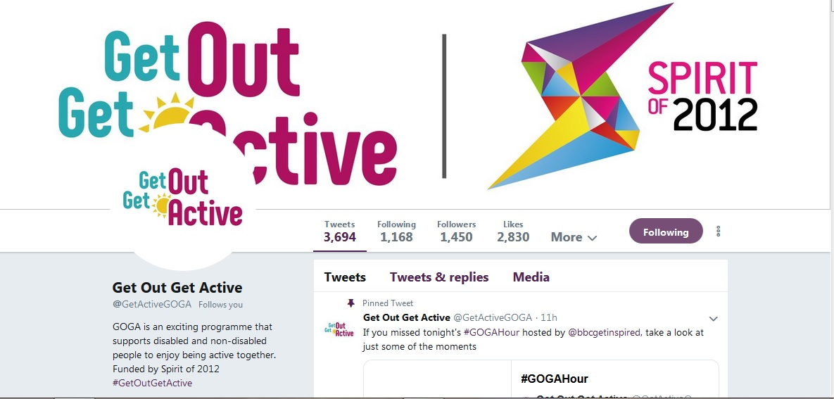
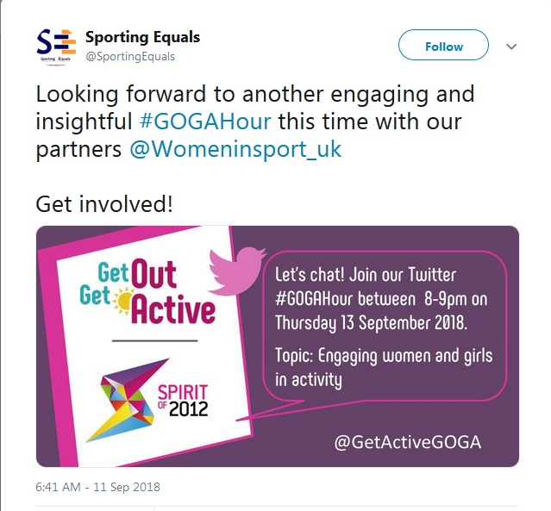
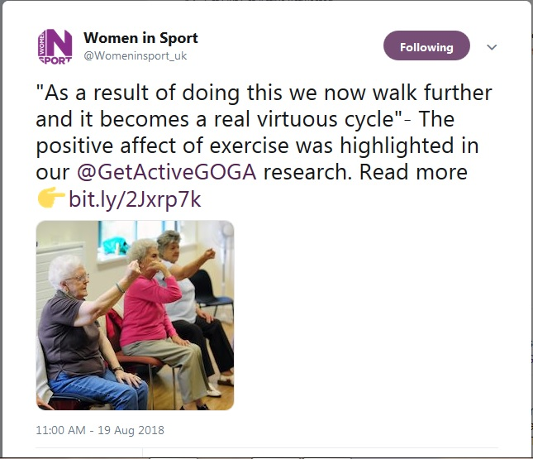
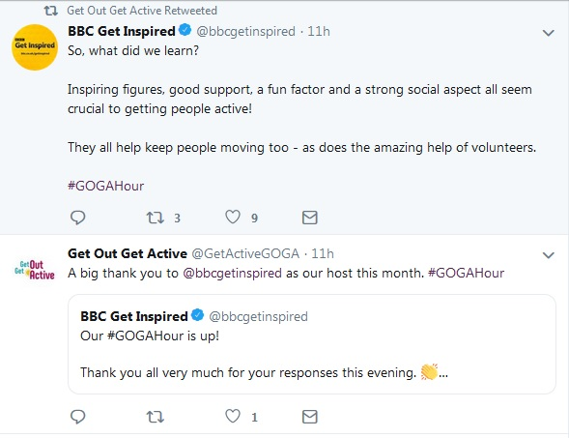
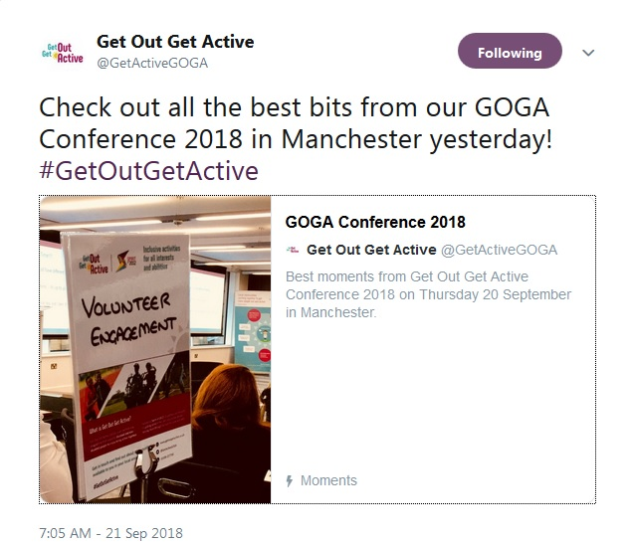

Supporting participants to remain active post intervention
Key Factors in Achieving Sustainability – Remaining Active
- To facilitate regular return a focus on socialising, friend making and fun delivery is key.
- The facilitation of contact outside project sessions helps formalise friendships developed during GOGA delivery.
- An opportunity to speak to a representative of GOGA prior to participation is often welcomed. This role can be taken by the coach/lead, a volunteer, or peer mentor, or project champion. Such communication will allay fears and facilitate initial and then regular attendance.
- Facilities and venues that offer ‘safe’ spaces for participants where they are able to develop a sense of ownership or have familiarity to it arising from previous non-sport use are often very useful to use.
- Activities that seek to develop/reinforce core physical literacy skills to facilitate access to other opportunities and build confidence of participants to become more active within and beyond GOGA delivery are often good ways to help participants sustain future activity.
- Include active recreation into individual support plans whenever possible, potentially identifying ways in which GOGA participation might also be included.
- Regular signposting of local opportunities for active recreation are helpful for participants, because participant interests may evolve so the activity offer needs to evolve with them.
- Activity delivery should give individual participants the confidence and capability to say they want to be more active, rather than being pushed by organisations to do so.
- Volunteering or mentoring opportunities as a ‘step up’ in participation, perhaps starting with informal opportunities first, are a useful way for participants to engage further.

Delivery of Sustainability – supporting participants to remain active
To support participants in remaining active post-intervention, analysis of our findings from GOGA shows that some of these approaches may be worth considering.

Key Approaches for All Partners to Sustain Active Recreation
- There should be a focus on working with specialist support services to identify ways in which participation in active recreation could be added to individual support plans.
- Progression and transition options for volunteers and mentors are as important as those for participants. These could involve moves from informal to formal roles, or the shaping of new volunteer roles by the individuals themselves. Shaping these around the skills and interests of the individual will be of particular benefit in such cases.
- Establishing reward and recognition events for participants, volunteers, and mentors can reinforce the progress individuals have made and highlight how progression into further activity is a real possibility for them.
- Helping participants build their own active support network through friends, families and peers should be actively encouraged. Wherever possible these individuals should be encouraged to take part in the activities put on.
- Appropriate and regular coaches build effective and regular relationships with participants. Social focussed coaches skilled in appropriate scaling and empathising with those from least active groups should be a key focus for project development.

Delivery of Sustainability – Embedding Inclusive Working
Analysis of our evaluation findings suggests that to have success in embedding inclusive working across GOGA localities and beyond use of the following approaches and practices may prove to be useful.

Key Approaches for All Partners to Embed Inclusive Working
- Building sustained partnership relationships requires time to develop face to face contact to open up new relationships. Those partners outside the sport/physical activity field may require alternative messaging that focuses on benefits outside the sport field to participants perhaps emphasising reduced use of other health and social care services, improvements to wellbeing, and/or mental health.
- Inclusive education and training should be provided to all staff working with targeted groups including front of house staff so all are able to engage groups effectively.
- Staff should also be supported to work with participants to change attitudes of participants to understand the value of being active using a fun and welcoming approach.
- Spreading the word on learning from GOGA through local commissioning structures for health and social care services can help open up new partnership arrangements.
- Use the ‘Talk to Me’ principles or other local inclusivity approaches/principles to underpin any embedding work.

Delivery of Sustainability – Transferring Learning to External non-GOGA Partners
Analysis of our findings shows that some of the following approaches may help to transfer learning from GOGA to other external partners.

Key Approaches for All Partners to Transfer Learning
- Partners (local and national) should actively seek to spread the word on learning from GOGA through local commissioning structures for health and social care services to help open up new future partnership arrangements.
- Partners should actively seek out opportunities to engage with localities and other partners to share best practice and network. They should encourage local communities to utilise the range of online resources available through the project including the GOGA website and the Volunteering Matters Online Volunteering Toolkit
- Joint work with other local stakeholders should be undertaken to provide expert insight and input into local inclusive practice, sharing details in particular of the ‘GOGA approach and the ways it can be put into practice
- Stakeholders and partners should investigate the use of social media and other local communications networks to disseminate GOGA experiences and outcomes. They should actively seek help from the GOGA programme team and/or their national Disability Sport organisation to gain advice and support on the best ways to do this
- Stakeholders, partners and locality leads should ensure that they are providing detailed content on shared learning and practice through GOGA’s quarterly reporting mechanisms, and the GOGA monthly update. Contributions to the annual GOGA conference and other local conference or workforce development activities should be actively considered
- Stakeholders, partners and locality leads should transfer learning on the use and application of the ‘Talk to Me’ principles to partners outside of the GOGA network wherever possible.

Key Learning Points and GOGA examples

Supporting Individuals to remain active post intervention
The key learning and lessons on sustainability around supporting individuals to remain active post intervention emphasise a particularly important role for the coach or lead for the activities delivered. Two thirds of all participants agree that a specific role model had inspired / encouraged them to get involved in GOGA and that seven out of ten of participants said they had new role models as a result of their participation in the programme. Such roles are especially important for under 16s where over eight out of ten highlighted they had taken part because of a role models influence.

The role models were most commonly the coach/lead of the activity or a family member and quotes from participants illustrate the importance of this role to the programme. As this participant highlights:

“Actually, the instructors were fantastic and very encouraging and that made a huge difference as you really felt they were watching out for you, they were completely non-judgmental, very engaging and supportive which really increased my confidence”

Whilst this project lead highlights how such a role should work:

“Our pool helpers are also important in helping people to access more facilities and opportunities. They help reduce anxiety by building up relationships with participants to cater to removing their anxieties. They try to cater to participant needs without the participant having to ask.”

This participant summarises well, how it is the all-round support that has made the biggest difference:

“I'm registered blind and one of the brilliant things about it is that you could briefly forget you were disabled, you didn't feel singled out and they're a brilliant group of people there, it was nice to do something healthy. One of the highlights was the chap actually in the pool with us is a Welsh guy called Rhys who is one of the nicest people I've ever met, he never patronises and is just really nice from start to finish, the volunteers they provide to guide you to and from the train station are brilliant too and also the two organisations involved in running this particular activity are just amazing, the camaraderie is fantastic, I'm very cynical in general and have actually found it quite moving seeing how many others had been brought out of their shell by taking part”

Approaches to embed new inclusive working
Locality sustainability plans drawn up in the third quarter of 2017/18 show some approaches adopted to embed new ways of inclusive working including:

- GOGA staff offering pan-local authority training and support to embed inclusive working

- Using volunteers as ambassadors to champion inclusion in the community by discussing its approaches with local voluntary and community groups in the areas where they are working

- Delivery of a programme of Disability Inclusion across community partners including those organisations that may not yet be working with GOGA to build future capacity and awareness of the approaches that might be possible

- Actively aligning the delivery of inclusive provision to local strategic priorities to create a strategic focus for the further roll out of such approaches

- Actively championing inclusion at an operational level across partners so that delivery staff can see the relevance of it to their own practice but also how it might widen their own pool of participants.

Provision of Good Quality Transferable Learning Outside of the GOGA Network
Sustainability plans identify some approaches including:

- Active engagement with local partners and stakeholder to use the learning from GOGA to influence new strategies, ongoing delivery to disabled people, and approaches to inclusive provision

- Undertaking constant promotion of value of inclusivity and the ways it has been implemented in GOGA by developing links with other local non-sports organisations and providing expert guidance and input on practical delivery of inclusive practice

- Work through adult social care teams and health and wellbeing teams to share learning more widely

- Offering specialist support and expert insight through development days for community partners

- Investigating opportunities to share learning through commissioning structures, including providing content for commissioning plans within a local authority to encourage shaping of local delivery

- Active participation on local partnership boards to spread good practice and engage with alternative delivery routes.

There is a need for this to be developed and accelerated further as locality leads and partners/stakeholders move into the final year of GOGA delivery. This should build on the great progress that has been made in second year delivery as highlighted above seeking to position GOGA teams (at local and national levels) as the ‘go to’ experts on the inclusive engagement of the inactive and delivery of opportunities for disabled and non-disabled people to participate in active recreation together.

It is also clear that a number of Talk to Me principles also underpin the work associated with sustaining participation in active recreation yet have less relevance to the other two sustainability objectives. Although dissemination of the value of the Talk to Me principles or other national principles around inclusive working should be shared when embedding inclusive practice in future years. Section 7.9 below highlights those of most relevance to the sustainment of active recreation participation post GOGA intervention.

Talk to Me Principles that Most Strongly Apply to Future Sustainment of Participation
Overarching Principle | Talk to Me Principle | Application in GOGA to Sustain Participation | Recommended Course of Action
Drive awareness | - Use the channels I already trust;  - Stay local to me. | GOGA partners have:  - Helped support work to upgrade or open new community settings that have be brought back into use - Lincolnshire | - Keep under review the venues used for provision and seek regular feedback from different groups on the suitability, also collect intelligence on other settings that could be used in the future.
Engaging the audience | - See me as an individual;  - Talk to as many of my values as possible;  - Continue to fulfil my values in new ways | GOGA partners have:  - Identified ways that GOGA activities can be included in individual support plans - Rochdale.  - Established loyalty and reward schemes for regular attenders including offers of ‘special’ events for the most regular – Wigan, Wrexham and Lincolnshire  - Had coaches offer ‘do at home’ exercises and activities – Stoke.  - Reviewed option to establish an ongoing participant focus group to collect participants views of the course of their programme engagement - Thanet.  - Rolled out a programme of inclusive delivery training to wide ranging number of staff in different roles – Fife. | - Don’t be afraid to use new settings if participants identify new preferences for venues.

Overarching Principle | Talk to Me Principle | Application in GOGA to Sustain Participation | Recommended Course of Action
Offer support and reassurance | - Reassure me I’m going to fit in;  - Make me feel I can do it;  - Make it easy for me to tell you my needs;  - Ensure my first experience is good;  - Encourage me through existing advocates. | GOGA partners have:  - Focussed on building core physical literacy skills for the least active to facilitate access to other activities and build confidence to participate – RCT.  - Used buddy systems to sustain attendance – Lambeth, Manchester, and Wigan. | - Reassurance needs to continue throughout delivery, participants value this at joining, but are likely to need it on an ongoing basis.

Key Components of the GOGA approach

The GOGA Approach
In identifying the essence of the ‘GOGA approach’, we have developed the diagrams shown in Figures 8.1 and 8.2 illustrating it from a participant and organisational perspective.

Figure 8.1: The key components of a GOGA approach – a Participant Perspective

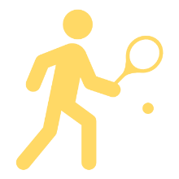
Inclusive delivery of 'Active Together' takes centre stage.
Coached by someone who quickly becomes a role model.
It's friendly and welcoming each and every time I attend.
I can meet new people and make friends

I can socialise first and be active later

Delivery is in a safe venue I can access easily.
I’m offered a wide range of active recreation. options and progression opportunities.
Participants
Figure 8.2: The key components of a GOGA approach – an Organisational Perspective
We share learning with other partners to help them learn from our experiences.
We actively train our staff in inclusive delivery practice and seek out expert help to identify solutions to reach the least active.
We have a structured approach to volunteer recruitment and management.
We utilise a range of volunteers and peer mentors to support delivery AND participants. Some have formal roles running activities, whilst others a more social, informal role making participants welcome.
Organisations
We treat people as individuals, and embed the Talk to Me / inclusive working principles into our work.
We target partner organisations that have closer links with certain groups that usually work outside the sports arena.
We ensure our delivery enables participants to meet new people, build new friendship groups, engage with new role models, work with coaches that implicitly understand their needs, and support disabled and non-disabled people to be ‘Active Together’ in a truly inclusive setting.

Conclusions and Insight for 2018/19 Delivery

Conclusions
The main findings from this second year evaluation report demonstrate that GOGA has continued on the positive trajectory reported in October 2017. This is exemplified in the following ways:

- GOGA has continued to unlock access to the least active; baseline data shows that 50% of participants state that in the four weeks prior to taking part in GOGA they had not done any form of physical activity, a further 12% were doing 10 mins or less per day on average, and 19% under 30 minutes. This reach is impressive and shows that a ‘GOGA approach’ is building momentum and demonstrating that the greater joint working between partners and localities is bearing fruit, although there remains a need for all localities and partners to continue to review the ways in which they might work better together.

- For the key target group of the least active individuals, GOGA is proving successful in increasing activity levels such that over six out of ten participants are seen to become more active as a result of their GOGA participation. Individuals are moving from being in the very least active group (10 mins or less per day), to being in the least active (10-20 mins per day) or even moving into what can be termed the ‘active group’.

- Follow up surveys show that these increases in the amount of time GOGA participants are undertaking physical activity for are statistically significant. They do however equate to a relatively small increase in the time involved in active recreation for the very least active individuals engaged by the programme of around an extra 45 mins on average per participant over a four week period. However, for 15% of tracked GOGA participants, the difference is an extra 90 minutes or more per week.

- For over two thirds of participants this engagement in activity is sustained as they are still involved with GOGA 6-9 months after joining the programme, whilst over nine out of ten of these participants intend to continue their involvement for up to 12 months. A further seven out of ten participants have been referred to another activity outside of the GOGA programme with almost half of these taking up this referral.

- Coupled with this, participants also report improvements in some wellbeing measures, their perceptions of disabled people, and their sense of social connectedness, particularly associated with their engagement with their local community. These are changes that a majority link directly to their participation in the GOGA programme.

These outcomes have been achieved because the majority of localities, partners and stakeholders are working together to ensure that GOGA is able to provide a friendly and welcoming active recreation offer, that emphasises social connection over immediate participation in active recreation. GOGA also provides a range of new opportunities to participate in activities new to participants. Importantly, in the most successful GOGA delivery, this is enabling participants to meet new people and build new friendship groups, engage with new role models, work with coaches that implicitly understand their needs, and support disabled and non-disabled people to be ‘Active Together’.

In achieving this successful delivery in its second year GOGA has seen shifts in the approaches adopted across key components and partners in its delivery. These shifts represent a refinement in the approach and are reflective of the journey to achieving the aims of the programme.

- The journey for GOGA Volunteers and Peer Mentors in partnership with Volunteering Matters and Disability Rights UK has been one focused on providing more structured support to sustain volunteer recruitment and participation in the longer term, an increased focus on the use, at a local level, of informal volunteers, an increase in the numbers taking on volunteer and peer mentor roles including previous participants of the GOGA programme, and wider thinking about how volunteers/peer mentors might best be used by GOGA.

- The focus of GOGA on reaching the least active supported by all partners has continued through an enhancement on mechanisms identified in Year 1 and a greater willingness at a locality level to engage with organisations beyond the sport and physical activity field to reach more widely across health and social arenas. For such groups the ‘GOGA approach’ is especially engaging.

- ‘Active Together’ is being more fully embedded in local GOGA delivery, and increasingly seen, alongside work with the least active, as a concurrent component in GOGA success. Localities are more focussed on ensuring ‘Active Together’ approaches are delivered, and stakeholders and partners are working in a more focused way to support the delivery of these key elements of the original objectives of the programme, particularly exemplified in the work by Women in Sport in Thanet and Wrexham.

- For GOGA, the journey around sustainability is becoming more embedded in year 2 than in year 1. The focus on sustainability plans has identified some useful practice. It is strongest around the delivery approaches that are being used to sustain participation in active recreation.

- Approaches to embedding inclusive working by localities are emerging, particularly in terms of the provision of widespread inclusive delivery training, there are also examples (though not utilised by all localities or partners yet) of sharing or learning through quarterly reporting and GOGA update arrangements, the use of the GOGA Hour, and the very successful Annual GOGA conference. These latter elements need to become a greater part of the journey for sustainability as the programme moves into 2019 and begins to identify options beyond the Spirit funding.

- The evaluation work and approach continues to be reviewed and we identify some specific options arising from the ‘journey’ the evaluation team have taken since the previous annual report. This has involved some revision to registration and reporting arrangements to simplify and rationalise where appropriate. It has also supported specific focus in quarterly reporting on the use of volunteers and peer mentors and mechanisms to capture a better picture of informal volunteering in GOGA, and a focus on the sustainability planning of localities.

Insight for 2018/19 Delivery
From our work for this Annual report, our findings suggest that delivery through 2018/19 should be focussed particularly on:

- Spreading the knowledge and learning from GOGA within and beyond its partnerships and networks, and working specifically to influence the work delivered to inactive groups, such as the Sport England Local Delivery Pilots. This should continue the progress made in Year 2 particularly around the extensive social media presence (Twitter - @GetActiveGOGA and #GOGAHour) the programme has, but also prioritising transferring learning beyond the GOGA network to shape wider practise around the inactive and disengaged individuals.

- Working to use the GOGA brand, to access further additional funding opportunities to embed working with the least active in GOGA areas but identify ways in which the learning might be utilised in neighbouring areas.

- Ensuring that the GOGA approach emphasises its opportunities for fun active recreation, in welcoming and reassuring environments, that include socialising and chances to meet new people and make friends first, with role model support, providing opportunities for disabled and non-disabled people to be active together, within their local community most commonly in venues not necessarily primarily associated with physical activity.

- Building on the networks and partnerships that have been established to embed them sustainably further in localities to support the final year of programme delivery and foster a GOGA legacy for those areas.

Insight for 2018/19 Evaluation work
For the evaluation work there are two main areas of focus moving into the third year of GOGA delivery:

- The lack of self-identification as volunteers has meant that we are not engaging with the volume of volunteers or peer mentors that we had anticipated engaging with. In response we will focus on assessing the use of informal volunteer roles in GOGA delivery, and how such informal volunteers are being encouraged by localities to progress into more formal volunteer roles.

- There is clear evidence of sustained engagement amongst GOGA participants, particularly as follow up survey work shows that over two thirds are still involved with GOGA 6-9 months after joining the programme and over nine out of ten of these participants expect their involvement to continue for up to 12 months. To better understand the longitudinal effects of this sustained engagement there will be a focus on developing an additional longitudinal element of the participant interviewing to track individuals up to 18 months post initial follow up. This will seek to identify a picture of the longer term impacts of GOGA participation, and to refine our understanding of the models that have particularly supported sustained engagement in active recreation within and beyond GOGA delivery.

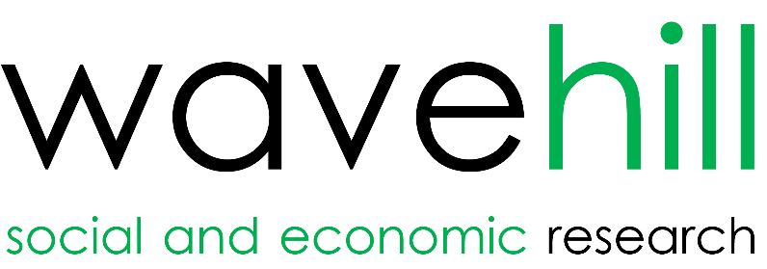

See http://www.activityalliance.org.uk/how-we-help/research/1878-talk-to-me-october-2014
For full details of all GOGA partners please visit the programme website at: http://www.getoutgetactive.co.uk/about-us/partners
More detail on the methodology and the key data sources the evaluation is utilising can be found in Chapter 2 of the first annual report.
Gave a score of 7-10 when asked this question. 0 indicates a response of not at all, whilst 10 indicates a response of completely. The 7-10 scoring is used as the standard national measure for life satisfaction, that life is worthwhile, and happiness. The measure of anxiety focuses on a score of 0-3.
See https://www.gov.uk/government/publications/uk-physical-activity-guidelines for full detail of the rationale and guidelines for the UK
Approaches that could be prioritised are nearer the top of the list.
An individual that has signed up / registered to undertake this designated role and has been provided formal training / support to carry out this role effectively. Likely to be volunteering on a frequent basis.
An individual who has decided to take on role without being specifically asked, isn't registered as a volunteer and hasn't had a specific training course. Typically helps on an ad hoc basis.
See Activity Trap (2018) http://www.activityalliance.org.uk/how-we-help/research/4404-the-activity-trap-benefits-or-being-fit
A key Talk to Me principle see http://www.activityalliance.org.uk/how-we-help/research/1878-talk-to-me-october-2014
Approaches that could be prioritised are nearer the top of the list.
See https://www.sportengland.org/our-work/local-delivery-pilots/
Approaches that could be prioritised are nearer the top of the list.

