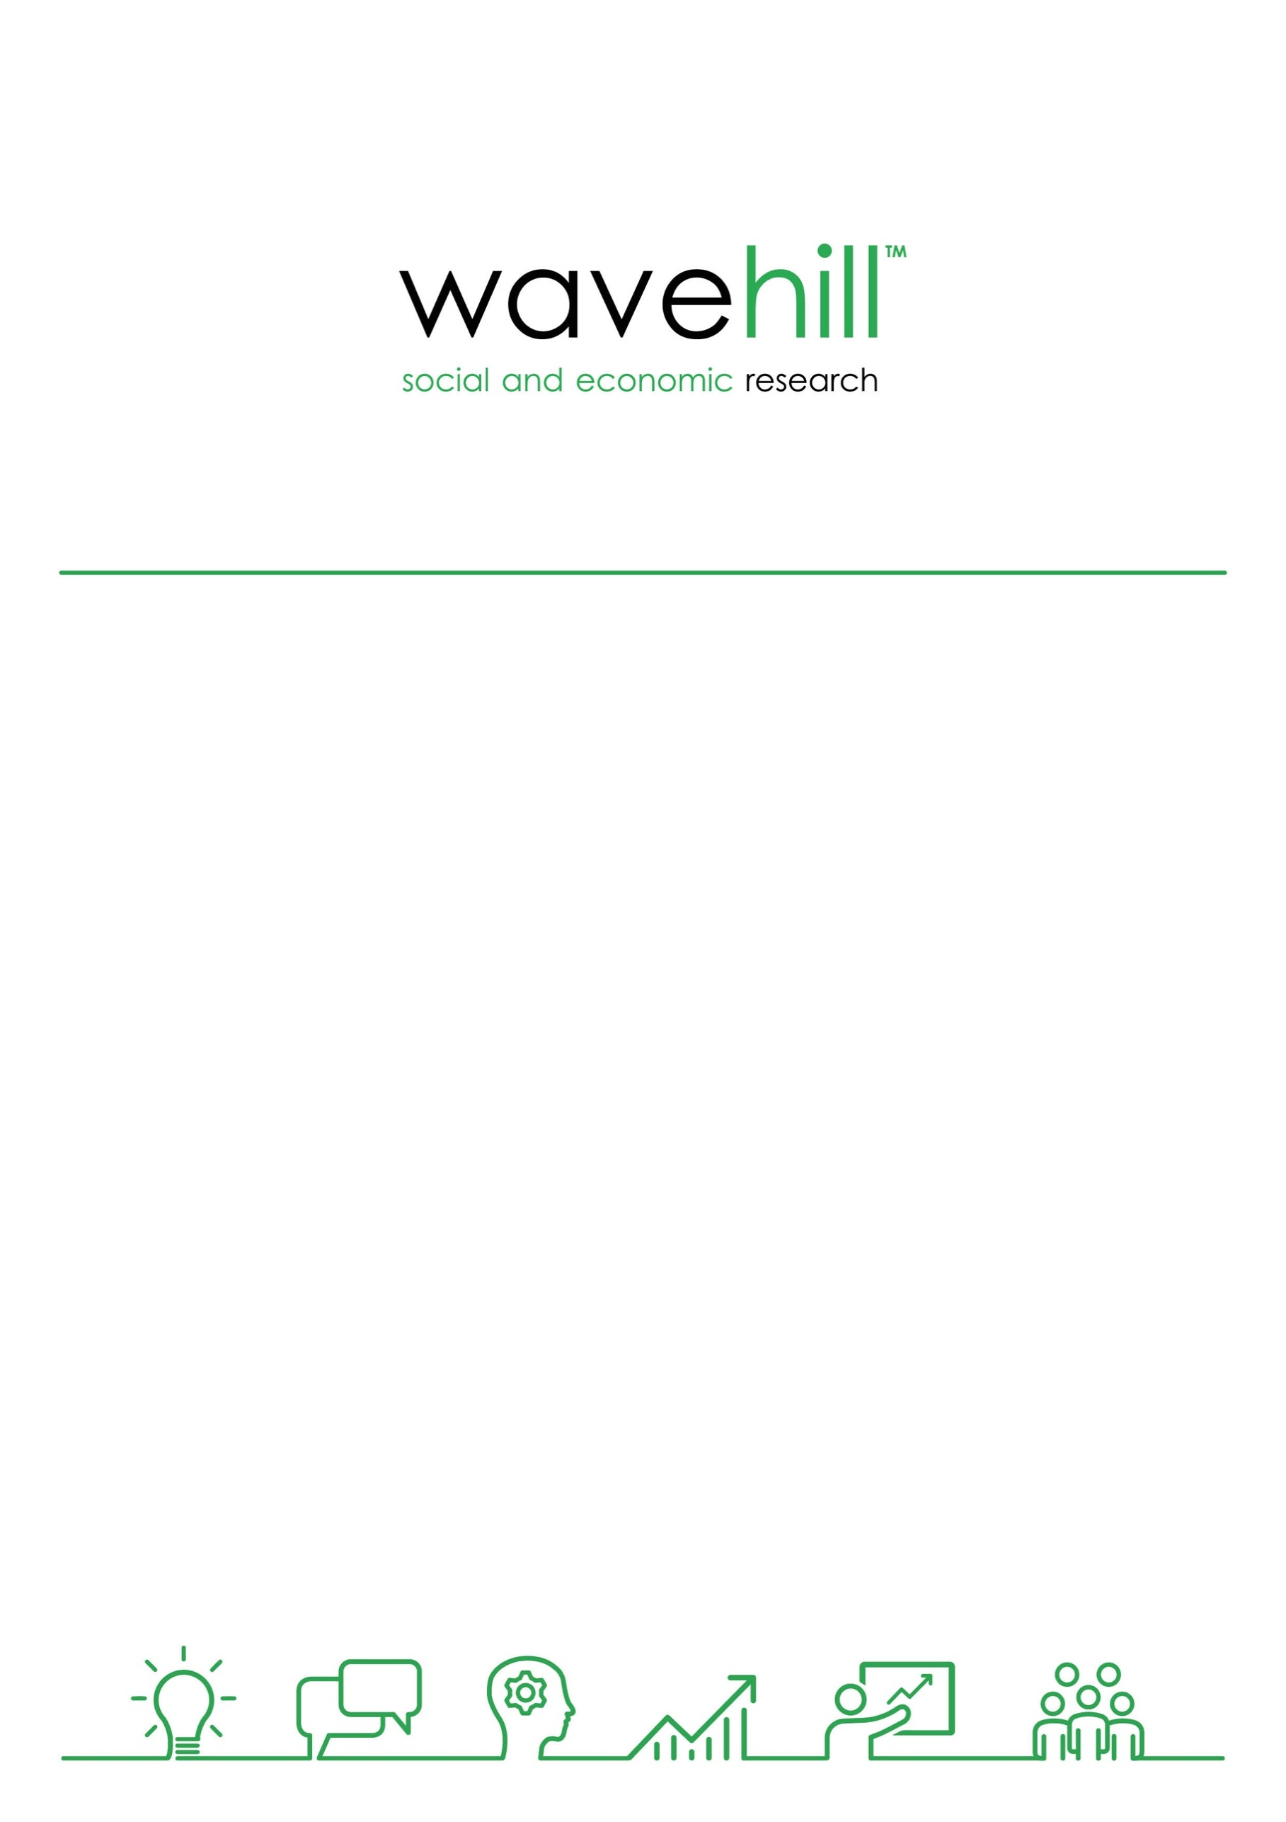
GOGA Evaluation:
3rd Annual Report

December 2019
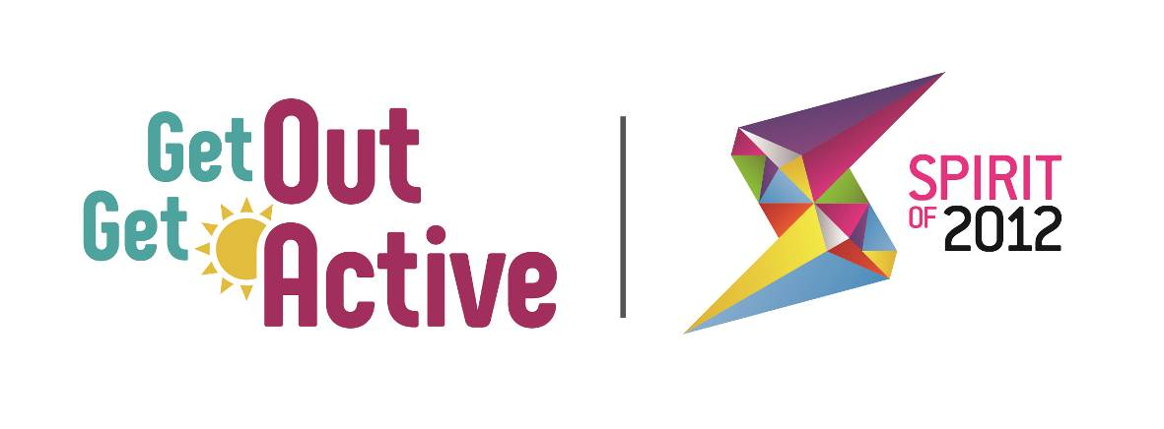
Wavehill: social and economic research

- Wales office: 21 Alban Square, Aberaeron, Ceredigion, SA46 0DB (registered office)
- West England office: 2-4 Park Street, Bristol, BS1 5HS
- North of England office: Milburn House, Dean Street, Newcastle, NE1 1LF
- London office: 52 Cecile Park, Crouch End, London, N8 9AS

Contact details:

Tel: 01545 571711
Email: wavehill@wavehill.com
Twitter: @wavehilltweets

More information:

www.wavehill.com
https://twitter.com/wavehilltweets

© Wavehill: social and economic research.

This report is subject to copyright. The authors of the report (Wavehill: social and economic research) should be acknowledged in any reference that is made to its contents.

Report authors:
Simon Tanner, Paula Gallagher, and Eddie Knight

Any questions in relation to this report should be directed in the first instance to Simon Tanner (simon.tanner@wavehill.com)

Date of document: 28.01.20
Version: 1.5

Client contact:
Kat Southwell
Head of Programmes and GOGA Programme Manager
Activity Alliance
E: kat@activityalliance.org.uk
W: http://www.getoutgetactive.co.uk/

Acknowledgements

We would also like to thank the many individuals who gave their time to assist in the evaluation, including participants, volunteers and peer mentors, project leads in national and local partners, delivery staff, all of whom were important in the writing of this report.

Particular thanks go to Kat Southwell and Helen Derby at Activity Alliance for all their support and active contribution to the monitoring and evaluation work.

This evaluation would not have been possible without all these contributions.

List of abbreviations

GOGA | Get Out Get Active
BAME | Black, Asian, and Minority Ethnic
DPULO | Disabled People's User Led Organisation
DR UK | Disability Rights UK
DSNI | Disability Sport Northern Ireland
DSW | Disability Sport Wales
MI | Management Information
SDS | Scottish Disability Sport
Spirit | Spirit of 2012

Contents
Contents ii
1 Background 1
1.1 Introduction 1
2 What this report is about 3
2.1 Introduction 3
2.2 Programme Evidence Base 3
2.3 How the report will detail the ‘GOGA approach’ 4
3 GOGA Impact 5
3.1 Achieving GOGA Aims and KPIs 8
4 Ingredients of Success 23
4.1 The GOGA approach 23
4.2 Volunteers and peer mentors 36
5 GOGA Sustainability 39
5.1 Supporting individuals to remain active 39
5.2 Embedding new ways of inclusive working 43
5.3 Providing good quality transferable learning 49
6 GOGA Learning 51
6.1 Conclusions 51
6.2 Insight for 2019/20 Delivery and Beyond 52
Appendix 1: The GOGA localities 55

Background

Introduction
In June 2016, Activity Alliance (formerly the English Federation of Disability Sport) commissioned Wavehill to evaluate Spirit of 2012’s Get Out and Get Active (GOGA) initiative.

The GOGA Programme
The GOGA programme is supported by £4.5 million from Spirit of 2012.

The overall aim of GOGA delivery is:

“Supporting disabled and non-disabled people to be active together, GOGA aims to get some of the UK’s least active people moving more through fun and inclusive active recreation".

The programme is delivered in 18 localities .across the UK, led by the Activity Alliance and supported by the Home Nation Disability Sport Organisations (Disability Sport Northern Ireland (DSNI), Disability Sport Wales (DSW) and Scottish Disability Sport (SDS)) and a network of local and national partners working

Guided by key Spirit of 2012 principles, GOGA seeks to enable people to participate in a wide range of activities and engage in their communities to:

- Improve their health and well-being, and as a result, improve communities and society.
- Improve their perceptions towards disability and impairment.
- Lead them to experience greater social cohesion and understanding.

The GOGA approach aims to reach out to new audiences by providing fun and inclusive active recreation that will lead to disabled and non-disabled people being active together. It also develops new infrastructure for the engagement of participants and provision of inclusive active recreation, and new and existing partnerships across health and social care, and community development fields rather than just partners from sport or physical activity arenas.

GOGA delivery is also guided at a local, national and programme level by the Talk to Me principles of Activity Alliance that seek to widen the delivery of inclusive practice, directly through the programme, AND influencing other organisations to incorporate such practice into their own delivery.

The ten Talk to Me principles resulted from research with disabled people, which explored what helps to make activities more appealing and accessible.

The GOGA programme is testing whether the effective use of the principles will influence the extent to which people are supported to become more physically active, actively engaged, and sustain that engagement over the longer term.

A video explaining what GOGA is all about can be viewed here: What GOGA is all about

GOGA Funders - Spirit of 2012

Spirit of 2012 (Spirit) are the London 2012 legacy charity set up by the National Lottery Community Fund. Spirit invests in happiness by funding projects that enable people to be active, creative and connected. Spirit funds arts and sports projects that foster greater community cohesion, empower those who are most under-served and challenge perceptions of disability

What this report is about

Introduction
This is the third annual report from the evaluation of the GOGA programme.

It provides a picture of the journey that organisations, participants, volunteers and peer mentors have taken through the programme drawing on data collected throughout the three years of GOGA delivery.

It draws out the ideas, inspiration, and tips on the ways in which delivery to communities could be shaped by GOGA learning and how this can involve a particular ‘GOGA approach’ to achieve success.

Programme Evidence Base
The learning in this report is drawn from a range of GOGA evidence collected by an independent programme evaluation that includes:

- Analysis of locality monitoring data showing activities delivered, and participant, volunteer and peer mentor numbers, characteristics, outcomes and impacts from programme start to September 2019. This information covers over 20,000 individuals.

- Quarterly monitoring reports provided by locality (18) and National Partners (covering quarters 3 and 4 in 2018/19, and quarters 1 and 2 in 2019/20 delivery).

- Annual update telephone interviews with locality leads, partners and national partners involving a total of 41 interviews, 23 interviews with those representing all 18 GOGA localities, and 18 interviews with partners and national partners.

- Three baseline telephone surveys with GOGA participants, volunteers, and peer mentors conducted between May/June 2017 and July/August 2019.

- Two follow up telephone interviews with GOGA participants between 6-15 months after they completed a baseline interview to track impacts of participation. Further waves of baseline and follow up interviews have continued on a rolling basis until the end of 2019.

How the report will detail the ‘GOGA approach’
This report uses the range of evaluation evidence collected thus far, to identify the key components and practice of a ‘GOGA approach.’ These key ingredients are highly transferable, providing a set of approaches that can influence widely the practice of partners and delivery agents to more effectively engage and sustain the activity of the least active across the UK.

This report provides a concise summary of evidence around the key focus of the GOGA programme:

- Reaching the least active – how the programme is reaching those individuals typically doing the least amount of, or no, physical activity and enabling an increase in the amount of physical activity they do;

- ‘Active together’ - where disabled and non-disabled people take part in activity together;

- Sustainability – how the programme is seeking to sustain its impacts for participants, practitioners and partners

The report also shows how volunteers and peer mentors are being used to support programme delivery and how the Talk to Me principles are facilitating the work of the GOGA programme.

Before we examine the GOGA Approach, we detail the impact the programme has had on those it has been working with.

GOGA Impact
Figure 3.1 overleaf illustrates that the GOGA programme has already had some notable achievements:

- Targets have been achieved for the number of individual participants (19,431 achieved v. 16,500 target) who have participated in GOGA activities; number of activities delivered by the programme (1,383 v. 550); number of GOGA events held (409 v. 100); and the number of people attending GOGA events (24,171 v. 12,000) have all been achieved;

- GOGA through all its delivery (activities and one off events) has reached over 29,000 individuals since it began delivery in October 2016;

- Significant strides in delivery have been made in the last 12 months in particular against the target for volunteers (up 57% on Q2 2018-19 to 2,255); the number of people trained by the programme (up 56% on Q2 2018-19 to 2,879) reflecting the growth of training sessions provided (up 59% on Q2 2018-19 to 324).

GOGA KPI performance has already demonstrated success. This success, as later sections of this report will show, is predicated on the fact that partners have had a critical focus on the programme experience available to all participants. As actively encouraged by Spirit, partners have sought to test out approaches to provide fun and welcoming opportunities to attract the least active to the programme, as this quote illustrates:

“It's been different from other programmes to run in Northern Ireland, and the targets haven't driven everything and we've been given leeway to just try things out and keep working with groups even though things don't work out straightaway. It's been refreshing to have that approach. Ryan, Armagh.

GOGA has been able to achieve its KPI targets because it has been successful in attracting and retaining inactive participants who have then recruited others through word of mouth because their experience has been so positive. In essence GOGA delivery is thus driven by an experiential focus, rather than one solely focussed upon numerical target achievement, which has enabled the numerical target to be achieved.

Figure 3.1: Overall summary of GOGA performance to September 2019

The programme:
18 local partners across the UK with 150 + community partnerships
10 national partners
2,400 activities delivered in over 12,000 sessions
180 events
130 training opportunities
Over £1 million match funding
The supporters:
2,255 volunteers and peer mentors
2,879 individuals trained (staff and volunteers)
35% reported they had an impairment
34% under 30 years old / 27% over 65 years old
Typically volunteering once a week in formal and informal roles
The participants:
19,431 unique participants
Further 24,000 engaged through one-off events, an estimated 9,500 of whom were unique attendees
42% didn’t take part in any activity at least four weeks prior to their involvement in GOGA
32% reported they had an impairment
64% women
20% from BAME groups
43% under 30 years old / 18% over 65 years old
Majority (84%) motivated by FUN with sport coming secondary to the social element.

Figure 3.2: GOGA in One Page

How does a programme reach 19,431 through 1,383 activities and 409 events attended by 24,171, and ensure that 65% are in the least active group (42% not active at all) before taking part?

How does a programme:

- Enable 58% of participants to do more physical activity and 28% do a lot more, with 91% of all participants saying this is down to GOGA?
- More than halve the proportion of disabled people who participate in it who were inactive at the start?
- Increase average amounts of physical activity by 15 minutes per day after 6 months, and by 16 minutes per day after 15 months?
- Give enough confidence to over half of its participants to take up additional sport and physical activity opportunities 9-12 months after taking part in it?

It’s a programme that creates an infrastructure, a collaborative working approach, and ‘fear free’ attitude and philosophy of risk-taking and testing of new ideas, that allows participants an experience like this:

- I can have fun and enjoy my activity every time I attend, and it all happens in settings where I feel ‘safe’ and that are familiar to me;
- In the sessions I can take part in welcoming and reassuring activities, some new to me, that I have had a role in deciding upon and a choice in participating in;
- I enjoy taking part in activities where disabled and non-disabled people are active together and can take part in activities with my friends/family members;
- I’m supported to attend by volunteers and/or have access to someone like me who understands me and can act as a role model for me;
- I’m actively encouraged to return and consider other forms of activity.

A programme where partners:

- Actively consult with the least active to understand the barriers/hurdles to participation and works with them to co-produce and co-create the activity offer;
- Embed an ‘Active Together’ approach to delivery that support the disabled and non-disabled to participate together;
- Ensure all delivery consistently offers a friendly, welcoming approach in locations/venues that participants feel are ‘safe’ and familiar to them supported by volunteers and peer mentors;
- Extend partnership building into communities and specialist community groups beyond traditional physical activity routes;
- Actively seek help from specialist partners to improve delivery;
- Underpin delivery through workforce development focussed upon providing inclusivity training for all levels of staff.

Achieving GOGA Aims and KPIs

Reaching the least active
GOGA has continued its success in reaching the least active group (as reported in the 1st and 2nd Annual reports).

In assessing this, the evaluation has focussed upon three groups based on broad activity levels:

- Very least active – no physical activity, or only up to 10 mins of physical activity (involving walking for at least 10 mins; gardening, cycling, sport, or dance) per day in the four weeks prior to GOGA participation.
- Least active – over 11 minutes and up to 20 mins per day on average.
- Active – 30 mins per day on average.

Figure 3.3a illustrates the latest data (to September 2019) that shows these patterns with 65% of all GOGA participants being in the least active group, 42% of which admitting to no physical activity in the four weeks prior to them joining the programme. A pattern which holds across all the UK nations involved in the GOGA programme as Figure 3.3b shows.

Figure 3.3a: Average activity levels per day by GOGA participants in the four weeks prior to joining the programme (All Participants/ Whole Programme)

Source: Tier 2A Baseline Survey – July 2017 – June 2019

Figure 3.3b: Average activity levels per day by GOGA participants in the four weeks prior to joining the programme (All Participants by nation)

Source: Tier 2A Baseline Survey – July 2017 – June 2019. Bases – England = 380; Northern Ireland = 131; Scotland = 107; Wales = 38.

These patterns hold equally for disabled and non-disabled GOGA participants showing that the programme has had comparable success in reaching the least active individuals irrespective of whether they have a disability or not. This again is a pattern that holds across each of the UK nations.

Across the whole GOGA programme amongst disabled GOGA participants 46% say they had undertaken no activity in the four weeks prior to them taking part in GOGA, 61% up 10 minutes, and 67% up to 20 minutes. For participants without disabilities, 40% identified no activity, 53% up to 10 minutes, and 56% up to 20 minutes on average per day in the four weeks prior to joining the GOGA programme.

Increasing activity levels of the least active
The evaluation has tracked participants to show how their levels of physical activity have changed since their engagement with the GOGA programme. This follow up has involved contacting participants 6, 12, and 15 months after their GOGA participation has begun. The latest data shows that increases in physical activity have continued to be maintained across GOGA delivery into 2019-20 delivery.

Figure 3.4 overleaf shows that:

- Levels of activity have increased, such that across all GOGA participants at 6-9 months post-GOGA start, 59% report doing 20 minutes or more on average per day of physical activity, this reaches 65% 15 months after GOGA participation.

- Levels of inactivity have fallen substantially for all GOGA participants, a pattern that has been maintained up to 15 months after participation in GOGA such that only 12% of all participants say they had done no activity in the previous four week 6-9 months after GOGA participation, and 11% identify the same inactivity at 15 months after participation.

Table 3.1 shows these patterns are repeated across the UK nations with noted reductions in inactivity and rising proportions of GOGA participants joining the Active group.

Table 3.1: Change in Activity Levels by Nation

 | 4 weeks prior to GOGA | 12 months Post-GOGA (Actuals)
% Inactive
England | 43% | 11%
Northern Ireland | 50% | 22%
Scotland | 32% | 0%
Wales | 37% | 0%
% Active
England | 37% | 69%
Northern Ireland | 27% | 50%
Scotland | 37% | 76%
Wales | 39% | 50%
Source: Tier 2A Baseline Survey and Tier 2c Follow Up survey – July 2017 – June 2019. Bases – England = 380; Northern Ireland = 131; Scotland = 107; Wales = 38.

Analysis across groups illustrate that increased levels of physical activity have been achieved for both disabled and non-disabled GOGA participants, again a pattern repeated across each of the UK nations.

This is summarised in Table 3.2 below.

Table 3.2: Change in proportion of disabled and non-disabled GOGA participants engaging in physical activity

Group | Joining GOGA | 6 months post-GOGA | 12-15 months post-GOGA
Disabled
Being active | 54% | 87% | 83%
Active over 30 mins per day | 20% | 41% | 30%
Non-disabled
Being active | 60% | 89% | 95%
Active over 30 mins per day | 26% | 58% | 62%
Source: GOGA Participant Surveys – July 2017 – June 2019

Figure 3.4: Change in activity levels for GOGA participants 6 (Tier 2b) and 15 (Tier 2c) months after programme participation (All Participants)

Source: GOGA Participant Surveys – July 2017 – June 2019

This increase in activity levels is also illustrated by these quotes from participants:

“I've been doing more activities and I'm now doing 9 different sessions a week...”
Howard, Nottingham

“it's just made me more aware of the need to exercise and keep healthy and I go to the pool now too to swim once a week when I can.”
Julia, Fife

“Because if I wasn't encouraged to go originally by the person who ran it I wouldn't have started walking and getting myself fitter I'd have been sitting down not doing much most of the time and now I go to the walking football twice a week and also do circuits once a week”
Ernest, Bradford

Amounts of activity increase

For the least active GOGA participants, there have been step changes in the additional amount of physical activity being completed by them, but it is also apparent that this occurs for all groups whether active, or not, prior to GOGA participation.

Figure 3.5 shows how the least active groups have increased their average daily amounts the most by 18 minutes (very inactive) after 6 months, and by 24 minutes 15 months later. For inactive groups amounts of activity increase by 33 minutes per day 6 months after starting with GOGA, and by 12 minutes 15 months after starting GOGA.

Figure 3.5: Summary of increases in physical activity by previous activity group
15 months after GOGA
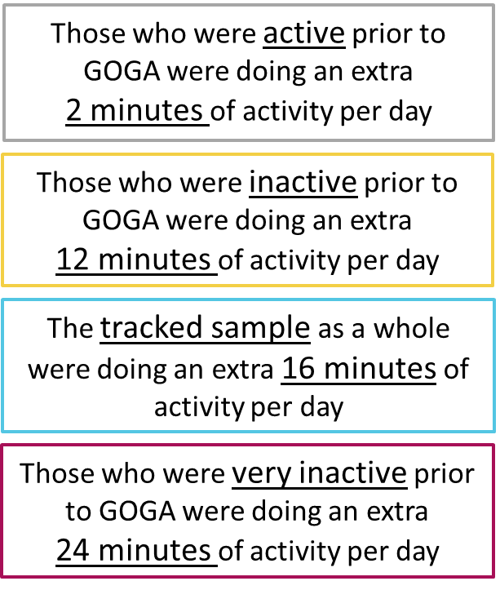
6 months after GOGA
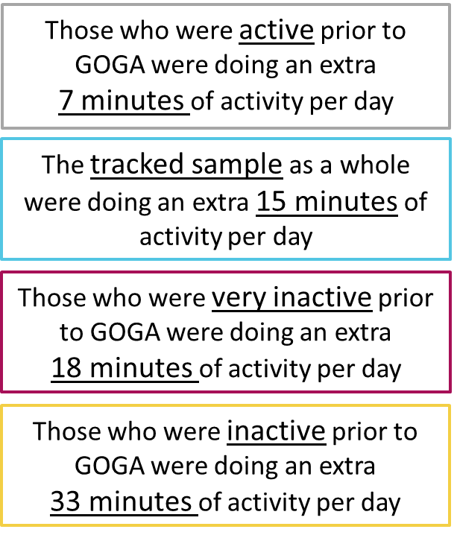

Source: GOGA Participants Surveys

Similar trends are seen in each of the home nations with the inactive groups also showing the largest increases in average daily time spent taking part in physical activity. These patterns are also broadly similar for the disabled and non-disabled.

This participant highlights how GOGA has addressed fitness issues, improved health and weight, and increased their mobility over time:

“I was doing nothing before (GOGA) [less than 5 minutes per day], I was trying to lose weight but I was unfit and had a bad foot, I was walking with a stick but I've not needed it now for 3 years, the chair based exercise class right at the beginning made a big difference to my legs, a special shoe was made for me as I've still got a bad foot but I've got more flexibility in my foot now. I've lost 9 stone altogether now, I can do things I couldn't do before, I can wear clothes I couldn't wear before and I've got more confidence. I've made friends down there, I've been on holiday with some of them which I never envisaged, I'm a lot more mobile now I'm completely different, I tend to lose my balance with my foot but at least now I can regain my balance, before I'd trip over my foot, I'm more agile now and part of it is tai chi and part is all the other activities and just generally using it more now. According to my diabetic nurse now I'm perfect, my diabetes is in remission and has been for 2 years, my weight's okay, my bloods are okay and my kidneys are too, I've turned it around.”
John, Bradford

The role of GOGA in increasing physical activity levels

Our findings show that the least active participants strongly associate their GOGA ‘experience’ with an increase in their physical activity levels. 69% say they have become more active, and that for this group, over nine out of ten (91%) attribute this to their GOGA experience.

This is backed up by analysis of the data for tracked participants which shows that 43% of those in the least active group have moved into the active group as a result of GOGA participation.

These interview responses further illustrate the role played by GOGA in these life changes for participants:

“you've always got GOGA there to give you that spirit to carry on and if you haven't been for a while”
Emily, Wigan.

“I'd been doing yoga and Pilates before I became ill and I'd stopped it because physical activity just hurt but going to the GOGA class I kind of realised that people can tailor the exercises to suit me and then I was able to actually achieve them rather than going and trying to keep up with everybody else so because I couldn't go to the GOGA class during the day because I'd gone back to work full time the Pilates class was on during the evening and that was available to me so that's why I joined. They both have different attributes, the Pilates is good because it's an individual thing where I'm doing it by myself and strengthening my core, whereas GOGA was a group activity where people were there to encourage you and to chat to you while you were doing it and it was much more fun, there was a real social aspect to that, at Pilates I don't really chat when they're doing the exercises.”
Heather, Stoke.

Active Together
GOGA also continues to deliver on its core focus on providing activities where disabled and non-disabled participants are ‘Active Together’. Our partner interviews in 2019, further reinforce findings that show that delivery of an ‘Active Together’ approach must by underpinned by inclusive delivery by leads/coaches and that the group dynamic for participants between disabled and non-disabled people is facilitated and managed effectively by those running the sessions.

If this is not done it can detrimentally affect the experience of participants and undermine their moves into increased levels of physical activity which was first noted in the GOGA 2nd Annual Report, 2018 and remains a key element of delivery in 2019.

When it works well, the Active Together approach brings real benefits to those participating as this quote illustrates:

“I loved it, because I have…[a disability] I didn't realise how much I could actually do because the instructor did the exercises to suit my needs and those of the rest of the group which was great, it was amazing and I definitely felt the difference physically in my body and my whole attitude I just felt so much better.”
Joan, Thanet

In addition, the core focus on Active Together approaches is also helping to reshape, and change, perceptions that individuals have of disability.

GOGA is changing perceptions of disability

Survey evidence from participants shows that GOGA continues to change perceptions of disability, over half (51%) of all GOGA participants report that they have a more positive view of disabled people as a result of their GOGA experience.

Furthermore, 70% of GOGA participants (up from just over a half in 2018) believe strongly that perceptions of disabled people in their community have been improved by GOGA delivery, with a statistically significant increase in the proportion strongly agreeing that this has occurred.

How Active Together is Being Delivered

The findings continue to illustrate that there is particular synergy between aligning ‘Active Together’ approaches to the aim of GOGA to reach the least active. ‘Active Together’ delivery provides active recreation opportunities that are more appealing to the groups of least active individuals GOGA is targeting including disabled people. Effectively the approach provides an equal opportunity to individuals to participate irrespective of their impairment or confidence or capability in terms of physical activity participation. As one partner highlighted:

“The idea of disabled and non-disabled being active at the same time. It is so simple but something that people have really bought into. Articulating it as a philosophy is easy as part of GOGA and I've been able to work with partners because they feel part of something”
Shaun, Grampian

They are in simple terms, mutually reinforcing, and therefore should not be treated as mutually exclusive elements of successful GOGA delivery, rather a critical component of the ‘GOGA Approach’

This approach is particularly valued by participants and, as we shall see in Chapter 4, is seen by localities them as a key ingredient in the success that GOGA has been able to demonstrate in its delivery that is able to attract and retain the least active in physical activity. As these participants highlight it is a core part of programme delivery that contributes to them feeling more able to participate and overcome any fears they might have in taking part in physical activity:

“I think it was doing it with such a range of people so I didn't feel I was getting left behind with the things that I couldn't do, everybody had different abilities so nobody was left out, everything was tailor made to each person and their own ability which was absolutely fabulous, I loved the way they adapted some of the exercise programmes to suit everybody involved in the class.”
Mo, Thanet

“with GOGA you never know with the next new child who's coming in and they're all made to feel welcome and they all play games together so if she sees someone she's not looking at them because they're disabled they're looking thinking oh they've got the same chair as me, they're not really focused on the disability as such.”
Donna, Parent of Participant, Fife

“Just the participation with both able and disabled people able to play the same game because my son has an impairment as well so it's great to be involved”
John, Derry and Strabane

Updated analysis combining findings from Year 2 and 3 annual interviews with partners show that the following examples of ‘Active Together’ delivery are particularly common. These approaches include:

- Family focussed activities that provide opportunities for a whole family to participate in a common activity.

- Encouraging carers to participate alongside those they are caring for as part of a single session delivered in care homes or other supported living.

- Engaging specific demographic groups for example working with older populations who as a group have higher probability of impairments so approach provides a good opportunity to engage both disabled and non-disabled participants.

- Offering regular ‘Activity for All’ sessions at a range of community venues across target localities so participants know that there are always scheduled ‘Active Together’ opportunities readily available when they wish to participate.

In addition, some specific examples in localities include:

- Bradford - weekly GOGA sessions have also been established at a women’s mental health charity and also at a mental health referral service.

- Grampians - Volunteer support is being provided to enable disabled people to take part and supporting other able-bodied family members/peers to take part as well.

- Northern Ireland – have been recruiting disabled people into already established programmes which have more non-disabled participants, whilst also making new contacts for referrals through contacts in local health trusts. There is a strong programme of family focussed walking events in parks in GOGA localities.

- Nottingham – have been working with impairment specific groups who traditionally cater just for the individual with an impairment. They have encouraged the organisation to extend engagement and activity supporting disabled and non-disabled people to enjoy active recreation together, to include the wider family including siblings, parents, friends and support workers.

- Pembrokeshire – Family surfing sessions that incorporate disabled and non-disabled participants being supported in their participation by other family members.

- Thanet – family rounders sessions to build inter-generational participation.

Across the partner interviews in Years 2 and 3 it has been possible to identify some key ways in which Active Together has been delivered providing useful learning points on how to embed similar approaches.

Table 3.3 below illustrates some of these key factors in order of priority.

Table 3.3: Key themes in Active Together GOGA delivery

Key approaches in delivering Active Together
- To recruit participants from disabled and non-disabled groups delivery organisations should work through specialist non-sports/leisure organisations including charities, community groups focussed on specific groups/health conditions, specialist housing providers, specialist support agencies to recruit.
- Identifying who could/does accompany participants to sessions that might also be inactive – parents, carers, support workers, other family members, friends is a useful way of developing Active Together groups. This is because there may be opportunities to encourage them to participate at the same time. Asking participants if there is anyone they would like to bring can also be a good recruitment approach. Noted more strongly in Year 3 delivery.
- The social dimension of the activity is often as important, if not more important, than the physical activity for participants and encouragement to bring others can help to achieve a stronger social or ‘community’ element of delivery.
- Partner interviews highlight that inclusive groups in GOGA delivery use ‘Tea, Talk, Try’ or ‘Meet and Greet Taster’ approaches to foster social interaction and as a key engagement approach. Partners identify that in GOGA delivery the least active may feel more comfortable in a ‘mixed’ ability group as they can perceive they will not be out of their depth in a group with people with disabilities. Noted more strongly in Year 3 delivery.
- Coaches or activity leads should be valued because of their social abilities, emotional intelligence, and friendly nature often above any expertise they might have in the activity involved, but they need to be skilled (or trained if skills gaps in this area exist) in managing inclusive groups to prevent groups segregating themselves on the basis of being disabled/non-disabled.
- Inclusive groups are popular with most GOGA participants who have already worked with the programme and the balance in delivery so far seems to be right with over half of all participants saying they had not found inclusive sessions to be too disability focussed. For the least active, inclusive sessions remain one of the main reasons they have participated in GOGA in the first instance.
- Training volunteers and peer mentors in inclusive practice means they can assist in bringing participants together, some can be nervous or lack confidence about participating so sometimes needs a little help to participate in the first instance. Skilled activity leads are an important factor in embedding this kind of practice. Noted more strongly in Year 3 delivery.
- Coaches/leads focussed on, and trained in, inclusive delivery approaches are a key mechanism for bringing participants into an Active Together session. Participants want to feel involved and that they are encouraged to interact with other participants in the group.
Source: Evaluation analysis of partner and stakeholder interviews and participant survey responses.

It is clear therefore, GOGA has proved successful in its work to:

- recruit and engage the least active;
- increase the levels of physical activity of all programme participants;
- encourage the delivery of activities that allow disabled and non-disabled participants to be ‘Active Together’.

It is also clear that there are several key ingredients that have allowed a ‘GOGA Approach’ to become embedded in the localities delivering the GOGA programme which detailed in the next chapter.

Wellbeing
For all GOGA participants there are positive trends of wellbeing with statistically significant increases in those reporting improved life satisfaction and a sense of life being worthwhile.

In data up to September 2019, at baseline, 74% of GOGA participants said they were very satisfied with their life, and this had risen to 83% 6-9 months after GOGA participation with a concurrent rise in the average score (when asked to rate how satisfied with life they were out of 10) from 7.54 to 7.88.

Perceptions of how much participants feel that the things that they do in their lives are worthwhile also demonstrate a positive upward trend rising from 83% to 86% scoring 7-10 for this measure (mean average score rising from 7.98 to 8.33 – a statistically significant change for these participants).

Feedback on participant Happiness shows minimal change with the average rating out of 10 rising from 7.86 to 8.06.

Furthermore, GOGA participants are reporting feeling less anxious, 60% of participants rated how anxious they felt yesterday as 0-3 out of 10 upon joining the programme which rose to 63% at follow up interview.

Tracking respondents also shows that for the least active there are also positive outcomes in terms of wellbeing with trends being particularly positive for this group of GOGA participants.

The analysis of data for the least active groups indicates that there are statistically significant increases in the average rating of life satisfaction and whether participants believe their life to be worthwhile following participation in the GOGA programme (see Table 3.4). Happiness has also risen following GOGA participation and the mean average of anxiety has fallen.

Table 3.4: Change in Wellbeing Measures for Least Active GOGA participants

 | Average Rating at Baseline | Average Rating Following GOGA Participation
Life satisfaction | 7.10 | 7.70
Sense that life is worthwhile | 8.10 | 8.44
Happiness yesterday | 8.08 | 8.64
Feeling of anxiety yesterday | 3.10 | 2.66
Source: Participant Baseline and Follow Up Survey – Matched Respondents

Perceptions of Disability
Perceptions of disability show a mixed set of responses:

- a rise (from 55% to 59%) in the proportion who strongly agree or agree that disabled people can live as full a life as non-disabled people

- an increase in the proportion who say they have a positive view of disabled people from 93% to 95%

- a slight rise in those who say that GOGA has caused them to have a more positive view of disabled people (from 64% to 66%), although 20% of participants said their view was unchanged because they had a positive view of disabled people when they joined.

- Furthermore, analysis shows that there is a small decline in the belief that least active GOGA participants have that disabled people are perceived more positively in their local area because of GOGA. It falls from an average of 6.76 (out of 10) at baseline to 6.74 at follow up though this change is within the overall margin of error.

Social Connectedness
Role models play a critical role in facilitating engagement on to the programme with almost seven out of ten of participants agreeing that a role model has influenced their engagement with GOGA when followed up. The role models are even more important for the least active groups with over three quarters agreeing they had been influenced by a role model to join GOGA.

Following their engagement with GOGA, participants become more positive about taking part in activities in their local community. Thus, prior to GOGA participation, 83% said they were positive about community engagement and after GOGA participation this had risen to 89%.

Participants feel more engaged in their community after participating in GOGA. Prior to their participation, 83% said they felt engaged with their local community rising to 89% after participating in GOGA.

A host of positive trends are evident therefore amongst GOGA participants. In the following chapters we review the key components of the ‘GOGA approach’ that evaluation findings identify contribute to these positive trends.

The GOGA Approach

Ingredients of Success
In reaching the least active, as Section 3.1 has shown above, GOGA has demonstrated that there are several components, or ingredients, that underpin what can be called the ‘GOGA Approach’. These ingredients do not necessarily represent major innovations in practice or delivery approach, but the combination of these ingredients underpins the ongoing success GOGA has had in its delivery.

It is possible to identify a number of ways of focussing the GOGA Approach. One focussed on participants that seeks to provide activities that ensure that they find fun, welcoming opportunities occurring in ‘safe’ spaces using an Active Together central theme.

The second is focussed on the way in which programme partners have changed how they engage and support the least active in the programme to support them increasing their physical activity levels in the short, medium and longer term.

The third is reflected in a risk-taking approach to collaborative working by partners that seeks to test approaches without fear of failure and to make ‘in flight’ adjustments to delivery based on learning. It resists a focus on numbers for numbers sake and provides opportunities that participants enjoy and want to return to.

We also highlight in this chapter the multi-faceted role played by volunteers and peer mentors in GOGA delivery who have played a key role as a key ingredient for both organisational delivery and the ongoing positive experience of programme participants.

GOGA approach – Programme participants
GOGA has worked best for the least active when partners created and maintained the right ‘experience’ for individuals. One that engages them in the local GOGA programme and then maintains their participation over time.

Figure 4.1 overleaf illustrates the key components of the approach that first attract people to GOGA (from Tier 2a baseline interviews), but also the features that help maintain their engagement over time (from interviews following up participation – Tier 2b and Tier 2c).

These results show that for participants five factors (in priority order) particularly attract them to GOGA:

- That they expect it to be fun
- It will help improve their physical health
- Increase physical activity levels
- Learn something new
- Meet new people and make new friends in their local area.

Figure 4.1: Reasons for joining GOGA (Tier 2a) and what participants achieved from being involved (Tier 2b and 2c) (All Participants)

Source: GOGA Participant Surveys

When asked what they have achieved through their GOGA experience individuals highlight how the factors above (particularly opportunities to have fun, increased activity, improved health) are maintained but that there are some elements that become more important for them as they continue their GOGA engagement. Factors that support ongoing participation include:

- Learning something new (highlighted as achieved by 84% of GOGA participants at Tier 2c);
- Meeting and making new friends in their local area (96% at Tier 2c);
- Being Active Together (75% at Tier 2c);
- Improved mental wellbeing (83% at Tier 2c);
- Having friends and family involved at the same time (73% at Tier 2c).

These are important because they align strongly with what participants highlighted as the best parts of GOGA as these selected quotes (evaluators emphasis) show:

“I loved it there, I loved every minute of it, I loved the whole atmosphere in the place as it was one of lightheartedness, uplifting, bonding with people you'd never met before and it was just like a big family although you didn't know people you got a great chance to exchange ideas and thoughts. I found it was a great forum for myself in that I became much more aware of myself and what stage of my life I was at and I learnt to look at things differently and learnt that there were activities I could participate in even with my disability.” Sharon, Derry and Strabane.

“Because initially it was tailored to individual needs very often especially the chair based exercises, everyone's got different requirements and the people involved there would tailor the exercises to suit you, if you couldn't do one exercise they'd give you something else if they could make it harder for you they would which is what they do with me as we go along…I've been doing more activities and I'm now doing 9 different sessions a week...”
Howard, Nottingham

“The social thing of walking and talking to other people I really enjoy, and it's just made me more aware of the need to exercise and keep healthy and I go to the pool now too to swim once a week when I can.” Julia, Fife

“It gets us out of the house, it’s a way of meeting people and sitting down and talking to people while we're having a meal, it's the community that you're mixing with that keeps you going and it gets my wife going as she's taking part in some form of exercise which she wouldn't otherwise do.”Peter, Wigan

“I think it was doing it with such a range of people so I didn't feel I was getting left behind with the things that I couldn't do, everybody had different abilities so nobody was left out, everything was tailor made to each person and their own ability which was absolutely fabulous, I loved the way they adapted some of the exercise programmes to suit everybody involved in the class.” Mo, Thanet

These quotes also align with summaries of case studies produced about some participants emphasising particularly the strong community feel that GOGA groups have:

Couch to 5K Nottingham- Helen
Saw Notts women runners group were doing a couch to 5k. Signed up and realised it was a GOGA Notts activity. They had supported by training the coaches and helping to run sessions in different areas around the city. She met many amazing women and got to learn their reasons for getting involved, this varied from wanting to become healthier, lose weight, make friends, be more social, boost mental health and wellbeing and of course fun!

Dean- Fife Men’s health
Signed up for a number of GOGA activities and is about to begin swimming competitively. Has competed in the Fife Track and Field Championships for the first time and was then selected for Team Fife for the Scottish Championships in Grangemouth Has enjoyed meeting new people and enjoys staying after the sessions to socialise with friends.

Shirley Wrexham
Wanted to get fit again after cancer and a mastectomy. Started couch to 5K. Now goes to swimming with GOGA ladies after. Has met new friends and has helped her believe in herself.

Key Ingredients

Consequently, the essence of the GOGA approach for participants are shown in Table 4.1 overleaf. This highlights the key ingredients of the GOGA approach that engage the least active and sustain their engagement in priority order are:

Table 4.1: Key ingredients of a GOGA approach – Participants

Ingredients for Success | Enabling Features
I can have fun and enjoy my activity every time I attend…(Talk to Me Principle: Welcome Me) | - Changes perceptions of physical activity often derived from previous poor experiences;  - Gives another reason for a return;  - A key previous hurdle to participation for many of the least active.
It all happens in settings where I feel ‘safe’ and that are familiar to me…(Talk to Me Principle: My locality and Reassure me) | - These are readily accessible irrespective of the mobility needs of participants because they are located close to home or another place the participant regularly visits;  - Settings may not have previously hosted, or been associated, with physical activity and represent safety away from such arenas because they are ‘familiar’ to a participant for another reason other;  - Participants feel ‘control’ over the setting either through its appearance, the way their activity is provided at the settings, or they can exercise away from others.
In the sessions I can take part in welcoming and reassuring activities, some new to me, that I have had a role in deciding upon. I have had choice in what I am participating in…(Talk to Me Principle: Reassure me) | - Participants have been listened to and a programme has been co-produced/co-created by them, or they feel they have had some input into the options that are provided to them;  - Activities offered may therefore need to be new or configured differently for multiple ability levels.
I enjoy taking part in activities where disabled and non-disabled people are active together…(Talk to Me Principles: Me, not my impairment, and Include me) | - Active Together delivery can facilitate engagement as participants may feel less exposed for their own perceived lack of ability or capability;
I’d like to take part in activities with my friends and/or family members…(Talk to Me Principle: My values) | - Friends and family members can often be as inactive or more so than participants;  - They can also be alternative role models or peer mentors to encourage/maintain attendance.
I’m supported to attend by volunteers and/or have access to someone like me who understands the hurdles I face or have faced in the past who could act as a role model for me…(Talk to Me Principles: My channels, Show me and Listen to me) | - These mechanisms can be critical to get people ‘through the door’;  - They facilitate the feeling of ‘community’ amongst participants and lived experience is a powerful mechanism for those individuals to be able to understand the hurdles some people have to overcome to participate on a regular basis.
I’m actively encouraged to return and consider other forms of activity…(Talk to Me Principle: Welcome Me) | - A simple invitation to return can make a very real difference;  - A negative response can establish important dialogue that can identify some further insight into how activities might be reshaped to better engage participants further.
Source: Evaluation Analysis

GOGA approach – delivery organisations
The GOGA approach for delivery organisations is about a set of key ingredients that facilities them in providing the GOGA experience that participants have highlighted in section 4.1.1 above.

Local and national partner highlighted these to include:

- A flexible and open commissioning approach that encourages testing and piloting of new ideas.

“It is flexible, fluid and open…There are no right and wrong answers. The localities were able to adapt to what the organisations and groups wanted/needed.”
Shaheen, Sporting Equals

“The flexibility of Spirit is really welcomed, and the lack of prescription is great to give us the opportunity to try things out and stop flogging a dead horse when things weren't working. We had to overcome the historic method of other grants to really make use of the Spirit ethos. Flexibility is welcomed. We wouldn't have had the impact of the branches without the flexibility.”
Aileen, Disability Sport Scotland

- Partnership building with a community development focus to foster improved sports development utilising local and national partner expertise.

“We were able to have access to national partners and are able to tap into their expertise. Women in sport, Volunteer matters and Disability Rights UK have been really good.”
Ian, Kent

“The GOGA approach is about partnership working without a doubt - engaging the right people has been the key. “I definitely think this project has shifted peoples’ perceptions of sport delivery. I think one of the lasting impacts will be that there is a lot more time and energy dedicated to partnership development rather than just delivery.”
Claudia, Nottingham

- Getting out into the community to reach out to the least active, avoiding a ‘if we build it they will come’ attitude.

“It was about getting us known and out in the community and that has been critical to being able to work with local community groups.
Ryan, Armagh

“They were doing whatever was right for that community and listened to what the participants wanted. A wide range of activities were offered, and some weren't even that physical.”
Shaheen, Sporting Equals

- Rethinking how programmes are developed to identify ways of gaining a better understanding of the needs and motivations of the least active groups and the barriers to physical activity participation they face, and work to actively remove these.

“We put a hold on the roll out of delivery and sat with communities and ensured they co-designed the programmes and delivery of GOGA. We utilised members of the community with lived experience to deliver programmes. We put a stop on assuming what people wanted and started offering new activities, social and fun activities and most importantly added an element of non-physical activity to allow participants to talk, relax and if they didn’t want to join in the activity they were still part of the programme…Sessions were run in local centres, cafes and churches where inactive people attended for non-physical activity reasons and began to offer low impact; appealing activities such as Tai Chi, Yoga, Climbing, kickboxing, seated exercise and many more. The use of green space (when weather permitted) was particularly successful…It’s not about asking for someone’s complicated medical history but understanding what the barriers are that stop someone being active and finding creative ways to remove them. Focus on what someone can do rather than what they can’t and offer different options according for people to select what they feel comfortable doing.”
Karla, Bradford

- Emphasising a friendly and welcoming environment that’s maintained throughout a participant’s engagement with a focus on the social dimension before a focus on physical activity.

“It’s become evident that informal relaxed approach to activity has been best- for example going for a cup of tea after. As that relaxed approach continues, users tend to then up their activity levels without specific conversation. As they do an activity they enjoy, they find time to do more of it. There are good social relationships from the group activities and they often go off and do other activities outside of GOGA.”
Ian, Thanet

“Another thing is giving people the chance to have a go without having to commit. It is a friendly supportive environment. People are trying out a wide range of activities. We have created a more relaxed approach which people seem to buy into.”
Graham, Grampian

- Extended use of volunteers and peer mentors with lived experience supported by a structured approach to recruitment, management, and training with equal importance attached to formal and informal roles.

“We would simply not be able to run as an organisation without volunteers. Volunteers are part of the family and really get behind the charity’s aims and objectives. The volunteers add that community-feel into the organisation.”
Karla, Bradford

“Volunteers are crucial and are key to the programme in Thanet. Without their support and dedication, we could not have achieved what we have so far in the project.”
Ian, Thanet

“Peer mentors are also used and are invited based on the qualities they have. Volunteers come from participants from within the disability community. We have got into areas that we haven't been in before. Our people have made this happen, our coaches, volunteers and mentors are critical.”
Richard, Fife

“Some of our participants just need a friendly face, a little encouragement and someone who understands their needs. That’s where we come in with our own experience. We feel empowered to help our participant to achieve their goals.”
Adam, Volunteer and Peer Mentor, Fife

“I volunteer with my heart in this role, I love it. I can help remove barriers for those participant who may be unsure of sport or physical activity when they first join GOGA, and I do this by working with them one-to-one, have fun, take my time, break down skills into easy instructions, it all helps. Hopefully, we can inspire participants to want to volunteer when they are ready too.”
Robert, Volunteer and Peer Mentor, Fife

“We have many informal volunteers - inactive people that have gone through the journey into activity and now going to support others in that journey.”
Claudia, Nottingham

- Identifying explicit ways that delivery can focus on ‘Active Together’ provision (including family, or household units) to actively enable friends and family to join participants.

“It has enhanced our offer and enabled us to give a wider choice to local families, especially those that have disabled and non-disabled children that have previously not been able to access many activities together due to targeted funding sources. Through GOGA we have been able to develop activities and try new sessions without the financial pressures. Throughout the delivery of GOGA we have been able to maintain and sustain sessions that have been successful as well as analyse why sessions haven’t worked and engage more with families. The activities we have developed through GOGA have given chances to engage new participants as well as provide exit routes for those engaged through our targeted services. This has enabled my team to provide an option for everyone no matter what age or ability.”
Rachel, Wigan

“Taking a family approach. If you have a member of family coming with you it breaks down the barriers of getting them through the door.”
Kieran, Derry and Strabane

- An explicit focus on ‘Active Together’ as a key delivery philosophy and approach that means activities are chosen for their scope to provide multi age/ability groups to participate together.

“The idea of disabled and non-disabled being active at the same time. It is so simple but something that people have really bought into. Articulating it as a philosophy is easy as part of GOGA and I've been able to work with partners because they feel part of something”
Graham, Grampian

“For example, there might be a surfing session and the one participant might be disabled but the whole family are going surfing rather than sat watching. They have then been able to mix with other families too. This has been successful so we will continue to roll out this approach to other areas of the organisation”
Jess, Pembrokeshire

“We make sure that anyone can take part, we try to cater for as big a group as possible. People participate in what they are comfortable with doing. We are more aware about doing that now.”
Ryan, Armagh

“We set up activities for all. This is based on activities that everyone can do. There’s two or three in each district per year. Many people come from long way away to take part-both disabled and non-disabled.”
Ian, Lincolnshire

- Roll out of extended programme of inclusivity training to embed ‘Active Together’ approaches across all project delivery.

“Inclusive delivery is the main thing, especially for our key audiences. Many don't see themselves as having a disability, some have some form of mobility. Its offering those participants an opportunity. We’ll start with a taster session and build them up gently. We always liaise with the support group first when we are planning activities. We make sure it's local to people. Working with the organisation to help them understand the benefits that can come from participation.”
Kieran, Armagh

“Our focus is on the LEAD piece of work which is all about making the organisation more inclusive by providing training for all front of house staff. We then decided that all managers should be put through training including the board. It’s going well. We have done the training day, come up with action plans and set individual goals. Each member of lead team has specific focus...Key aim is to make sure the organisation is as inclusive as possible. It is now an agenda item for the board and reviewed at each board meeting. We also have a disability customer focus group who inform our decisions- this is all set up and ready to go. As coordinator and management, we decided that it was important as a leisure provider we went through the process of ensuring the whole organisation becomes more inclusive.”
Ian, Thanet

- Active, ongoing use of learning to reshape organisational practice and process during programme delivery within and beyond GOGA delivery.

“I definitely think this project has shifted people’s perceptions of sport delivery which will stay beyond GOGA”
Claudia, Nottingham

“Taken what has worked well with GOGA and applying the learning to elsewhere in our service.”
Rachel, Wigan

“People are changing their thinking and approaches as a part of GOGA and the approach has had a big influence on the wider organisation. In the process of looking at our strategic direction. The decision has been made to follow the GOGA approach as an organisation.”
Graham, Grampian

“…we will use our GOGA learning throughout our business, from staff recruitment, to training, to marketing to services, we will touch every part of our business…now appreciating the “size of the prize” by taking this thorough approach in regard to not just revenue but reaching the most inactive in our communities…Being exposed to this project and the learnings we have taken have played a significant part in the shift of our business chasing the 15% of the population that are generally active and go to gyms, to using learnings to “seek-out” the 85% who are either less active, very inactive or choose/are interested in other ways of getting active. ”
Ian, Thanet

“Link4Life is much more accessible organisation and this very clearly visible when you see the change in customers accessing the facilities…[there’s been]…a big change in attitudes amongst support services and support workers towards disability participation. It is now much more valued.
Graham, Rochdale

Key Ingredients

Table 4.2 overleaf illustrates in summary how the findings above translate into some key ingredients that support a successful GOGA approach supporting a programme experience as identified by participants (see Table 4.1).

Table 4.2: Key ingredients of a GOGA approach – Delivery Partners

Ingredients for Success – We’re an organisation that…
Actively seeks to consult with the least active to understand the barriers and hurdles to participation and works with those groups to co-produce and co-create an activity offer that provides opportunities for multi ability groups.

Embeds an ‘Active Together’ approach to delivery that support the disabled and non-disabled to participate together.

Ensures all delivery consistently offers a friendly, welcoming approach in locations/venues that participants feel are ‘safe’ and familiar to them. Participants help us to make the decisions on where our activities will be delivered.

Gets out and gets engaging with the communities most likely to harbour the least active. We undertake extensive outreach using local community contacts with expertise in reaching different parts of the community often beyond physical activity networks we might already be accessing.

Extends partnership building into communities and specialist community groups beyond traditional physical activity routes, we investigate previously unexplored routes into communities and work with others to develop new contacts and delivery opportunities.

Is open to testing and piloting approaches and changing tack when we identify approaches are not working.

Actively seeks help from specialist partners to improve delivery.

Reshapes its own delivery in response to learning.

Has a structured approach to the recruitment, management and use of volunteers, peer mentors and role models in formal and informal roles and an emphasis on lived experience

Underpins delivery through workforce development focussed upon providing inclusivity training for all levels of staff.

Source: Evaluation Analysis

Volunteers and peer mentors

Volunteers
The use of volunteers has been a major, and growing, aspect of the GOGA approach and in many cases a critical component of success. In part this has been due to the success GOGA has in recruiting disabled people to be volunteers/peer mentors with monitoring figures showing that a third of them identify as being disabled.

Many of the localities comment that they simply could not have done what they have done without the support of volunteers.

“We use volunteers for monitoring, evaluating, inputting data, attended activities, meet and greet, make people feel welcome, one volunteer even ran their own activities.” Sarah, Thanet.

This is for several key reasons.

They are described by all locality leads as integral to the running of many activities helping to directly support delivery by supporting coaches or activity leads, supporting administrative duties, and providing other project support.

Data from Volunteering Matters (Table 4.2 below) shows that up to September 2019 GOGA had worked with 2,255 volunteers across a range of formal and informal roles with 1,049 in informal roles.

Table 4.2: Total Volunteers Used by the GOGA Programme by Role

 | Roles | Total to Sept 2019
Formal GOGA volunteering roles | Administration | 90
 | Social | 106
 | Activity | 705
 | Support | 305
 | Total Formal | 1,206
Other informal volunteering roles | Administration | 71
 | Social | 233
 | Activity | 540
 | Support | 205
 | Total Informal | 1,049
Total All GOGA Volunteers |  | 2,255
Source: Volunteering Matters Monitoring Data, Sept 2019
This distinction between informal and formal volunteering roles is reflected in this quote:

“Getting people to label themselves as a volunteer is really difficult. Many just feel like they are helping out and wouldn't identify themselves as a volunteer.” Ian, Lincolnshire.

“One of the hardest parts was to identify someone as a volunteer. Informal volunteer title is very helpful.” Jess, Pembrokeshire

- Volunteers come from a wide range of backgrounds with a wide range of experiences. E.g. Students/young people looking to get experience in the sector, carers/family members of disabled participants, from the disabled community, people with specific interests who want to contribute to physical activity, older people who are members of other community groups, competitive sporting backgrounds;

- A key criteria for GOGA volunteers is their ‘lived experience’ and localities have noted real benefits in recruiting volunteers that have faced the same challenges around their own barriers to physical activity as those experienced by GOGA participants helping them actively support participants engage with the programme;

- Locality leads highlight how support is offered by volunteers on several levels and they help in a wide variety of ways for example by:
  - Helping to welcome and introduce new participants ensuring they feel welcome and generally keeping an eye out to ensure they are enjoying sessions
  - Promoting activities outside of GOGA and actively recruiting people they think would benefit from the activities on offer in the localities
  - Assist in the delivery and running of sessions. (assist deliverers) including helping with administration and collection of monitoring and evaluation data;
  - Some are taking qualifications to enable them to run their own GOGA sessions
  - Ensure that the sessions appeal to both disabled and non-disabled participants.
  - Increase capacity so that a more personalised approach can be met and to ensure all participants are getting the most from the activity
  - Increasingly, becoming participants themselves and increasing their own physical activity levels.

- There are examples of how volunteering has had a huge impact on the lives of the volunteers who may have suffered with anxiety, depression and lack of confidence. Volunteering can give people a purpose and motivation to get out and about and engage with the community. There are also examples of how GOGA has given the confidence and encouragement to get back into work and education following reengagement through supporting the GOGA programme.

Underpinning this work, has been the key role played by the partnership with, national partner, Volunteering Matters in providing support to localities to help set up volunteer programmes in each. This has included a key role in:

- Signposting from Volunteer Matters to the locality leads once an enquiry has been made through their website;
- Development and distribution of a toolkit for localities to refer to;
- Provided valuable information about how to recruit volunteers and the dos and don’ts;
- Giving the volunteers ownership over their role and input into shaping the role has also been important in sustaining volunteers and retaining them in their roles.

Peer Mentors
The peer support project for GOGA was provided by Disability Rights UK (DR UK). It was delivered by an experienced peer support lead who provided training and matching services, check-ins and held links to the sector.

A research review by Traverse published in October 2019 highlighted that the GOGA peer mentoring project had delivered a range of benefits for those taking part including:

- Increased understanding of, and participation in, physical activity including increased levels of personal physical activity as well as supporting other to be more active;
- Improved ability to overcome barriers to participation; confidence, stereotyping, and accessibility;
- Improved empathy, understanding and ability to support others;
- Improved connectedness to the communities they were working with;
- Improved health and wellbeing for mentors;
- Transferable skill development to support other areas of their life;
- Sense of achievement;
- Encouragement and motivation to reengage in other activities in their local community.

The research also highlighted that the GOGA delivery had been particularly successful because:

- Clear roles and structure; from marketing through to close of project had been defined for peer mentors and the organisations they were working with;
- A consistent ongoing support system was readily available;
- Reflective practice and regular check-ins were available that were used to revise approaches where problems were identified;
- Peer mentors were encouraged to take a human interest in participants and matching on personality and interest, as well as recruiting peer mentors who demonstrated similar ‘lived experience’ to those they were supporting;
- Support provision was o-produced; working in partnership with user-led organisations e.g. DPULOs
- Development was focussed upon capacity building and ongoing up-skilling for peer mentors so they could ‘grow’ into their roles

GOGA Sustainability
Sustainability within GOGA is focused around achieving three main objectives:

- Support Individuals to remain active post intervention;
- Influence organisations and partners to embed new ways of inclusive working;
- Provide good quality transferable learning on how to reach the least active disabled and non-disabled people and support them to be active together.
In the sections below we outline the evaluation findings against each of these dimensions. The chapter concludes by updating sections from the 2nd Annual Report highlighting practice to sustain GOGA delivery into, and beyond, the final phases of the delivery of GOGA Phase 1, and also in the establishment of the GOGA Phase 2 delivery.

Supporting individuals to remain active
Supporting individuals to remain active post intervention has been achieved by GOGA with the least active groups have increased their average daily amounts by 18 minutes (very inactive) after 6 months and by 24 minutes 15 months later. For inactive groups by 33 minutes per day 6 months after starting with GOGA and by 12 minutes 15 months after start.

Evaluation evidence shows that this is best achieved through three key approaches:

1. Provide suitable activities and present them in ways that support participants on a stepped journey to ongoing physical activity including:
- A wide range of activities on offer which are suited to the target audiences;

- Activities are selected to combat barriers, respond to motivations and needs, to provide activity that includes multi-ability opportunities for participation. For example archery in Nottingham has been effective in attracting families and inactive participants with a majority from the South Asian community because it links to motivations derived from their religious beliefs. Some are now looking into how they can become volunteers and do qualifications;

- Localities have started activities and have then realised from feedback received that these have not suited everybody. This has shifted delivery towards more multiactivity approaches focused on doing a range of activities suited to those who were in the least active group. This has included examples of circuit training, boxercise, chair-based exercise and target games. These have provided an opportunity for targeted groups (older people, BAME groups, women) to be active as there was previously nothing as targeted for these groups in their local community;

- Localities collect feedback and continually review what has worked, and what hasn’t, to ensure that the activities they deliver are hitting the target audiences, and make changes in response to this feedback and in consultation with the target audiences themselves;

- Activities are specifically aimed and advertised as beginner, introduction or fun activities to ensure that the target audience is clear to potential participants. Examples of this include the couch to 5k.

- Some localities also planned and ran activity days/afternoons including taster sessions in order to raise the profile of GOGA and showcase the active opportunities that were available in the area. It also meant participants could try out activities without having to commit to something immediately. For example, Bradford ran the Holmewood activity day and gave taster sessions in the following activities:
  - Non-contact boxing – Delivered by coaches from Holmewood
  - Ladies Zumba – Delivered by a community coach from Holmewood
  - Rolling Roads and Spinning
  - Balanceability
  - Rugby with Bradford Bulls
  - Free Massage and Physio
  - Smoothie Bikes
  - Bouncy Castle
  - Healthy Eating Advice and Nibbles

These approaches support participants to engage with physical activity opportunities in a ‘stepped approach’ as shown in Figure 5.1 below:
Figure 5.1: Step approach to participants remaining active post-GOGA intervention

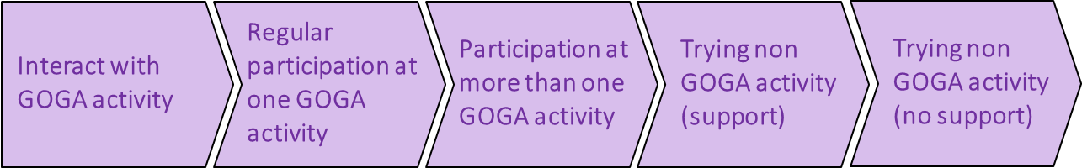

Participant survey data shows that over half of participants take up further sport or physical activities recommended to them 9-12 months after taking part in GOGA.

2. Ensure people are comfortable and confident about taking part so they are encouraged to make the ‘first step’ and to keep coming back:

- Volunteers and peer mentors have been integral to not only assisting with the running of sessions but also breaking down barriers some participants have. They provide support for new participants making them feel comfortable in participating. This gives new participants confidence to attend in the first place. This is supported by having a friendly and welcoming face to ensure the individuals want to return. Individuals with ‘lived experience’ of tackling their own barriers to physical activity are particularly useful for this role;
- A focus on social/fun aspect rather than “keep fit” or competitive style activities, therefore:
- Getting the promotional material right to ensure sessions look relevant for the target audience so that it includes pictures of local participants, or the actual settings the activity is taking place in rather than stock images of generic gym or sport centre provision. Also give a clear sense of the activities involved and that all abilities are catered for;
- Getting the location right to use settings in the local communities of potential participants to reduce travelling time, or use a setting familiar in a capacity not previously linked to physical activity;
- Ensuring a quality experience- before during and after the activity;
- Ensuring the deliverers are right- well trained and understand inclusive approaches in detail.

- Ensuring activities give participants the opportunity to meet new people and create new social groups improving participants confidence about attending other GOGA activities or meeting outside of GOGA to be active.

- Understanding the importance of identifying barriers to inclusion for certain communities of interest (e.g. women) and work hard to ensure that these barriers are addressed in order to make participants feel comfortable.

- Getting to know participants before they come to the session to reduce any specific issues or anxieties about the sessions.

- Using the 10 talk to me principles, to appeal to individuals who are the least active to motivate and encourage them to stay active, particularly:
  - Me, not my impairment
  - My values
  - Reassure me
  - Include me
  - Listen to me
  - Welcome Me

3. Provide support and guidance to participants and deliverers so they have an enjoyable initial and ongoing experience:

- Use of volunteers and peer mentors to encourage participants to continue attending have been an invaluable addition to many GOGA localities

- Many volunteers don’t see themselves as volunteers or peer mentors despite doing the job of one- they just see themselves as “helpers”- an informal volunteer, and there are increasing examples of volunteers becoming active participants themselves.

Delivery of Sustainability – supporting participants to remain active
To support participants in remaining active post GOGA intervention, the 2nd and 3rd GOGA Annual Reports show that some of these approaches are worth considering.

Key Approaches for All Partners to Sustain Active Recreation
- There should be a focus on working with specialist support services (particularly those related to specific health concerns or the needs of particular community groups) to identify ways in which participation in active recreation could be added to individual or community support/engagement plans.
- Progression and transition options for volunteers and mentors are as important as those for participants. These could involve moves from informal to formal roles, or the shaping of new volunteer roles by the individuals themselves. Shaping these around the skills, interests, and lived experiences of the individual will be of particular benefit in such cases. Transition options should also include engagement such that the physical activity levels of volunteers and mentors can also be seen to increase.
- Establishing reward and recognition events for participants, volunteers, and mentors can reinforce the progress individuals have made and highlight how progression into further activity is a real possibility for them. Consideration should be given to establishing these as regular (Annual) events.
- Helping participants build their own active support network through friends, families and peers should be actively encouraged. Wherever possible these individuals should be encouraged to take part in the activities put on, and volunteers and mentors encouraged to support the development of these networks.
- The ongoing recruitment and retention of ‘social focussed’ coaches skilled in appropriate scaling and empathising with those from least active groups should be a key focus for project development.

Embedding new ways of inclusive working

Embedding of inclusive working is more in evidence than noted in the 2nd Annual report with the key influence being the increased numbers of individuals trained by the programme, extended partnership working, and substantial changes to organisational working including changes to the constitution of partners (Fife) and focus of the organisational working (Fife and Grampians now have an explicit focus on active recreation).

Across national and local partners this has involved several key themes including:

- Workforce development involving the upskilling of staff through training that provides understanding of inclusive practice at all layers of a delivery partner. This has meant that an increasing number of capable staff are available to deliver sessions and influence wider organisations, as well as helping to sustain activities beyond GOGA funding. This has influence beyond the local partner as well:

“A lot of feedback saying organisations wouldn't have had the confidence to deliver the activities without the training GOGA has given them.” Jess, Pembrokeshire.

- Extended partnership working including work with local councils, facilities, community groups, disability groups, national partners, clubs, NGBs. Partnerships are now well established and have contributed significantly to enabling local and national partners to extend their influence beyond their own previous sphere of influence. 9 of the 18 GOGA localities say that GOGA has had an extensive impact on partnership working, with all the others saying it has had some impact. As these interviewees highlight:

“This has been one of the biggest impacts. We have brought about big cultural changes in the organisations we have worked with and would like to continue working with them.” Lois, Pembrokeshire.

“Developed and linked with new partners that we haven't worked with before. Community links have been increased extensively.” Eva, Grampians.

“It’s given partners the belief and passion to go on and do projects that wouldn't be delivered without GOGA.” Brendan, RCT.

“Historically we have done things ourselves but now we are using partners much more and using what is already available in the community. Sonia, Northern Ireland.

The final reporting amongst the first localities to reach the final months of delivery shows this partnership working will, in most cases, continue post GOGA ensuring the opportunities and learning is not lost. This also includes the continuation of partnership working across National Partners who confirm they will also continue working together particularly across Women in Sport, DR UK, and Volunteering Matters.

- Organisational change with significant evidence that the GOGA programme has led to change at strategic and operational levels for large number of organisations:
- Through staff training and development (disability awareness training) with coaches, leisure centre staff, board members etc.
- Localities carrying out in-depth reviews of their inclusivity practice and undertaking a LEAD peace of work to embed inclusive principles throughout their organisation, whilst others (for example Fife and Grampians) have changed their organisational focus to embed the GOGA approach across all their activities, and/or having an explicit focus upon supporting the delivery of active recreation, alongside sport.
- Changes to organisational focus and constitutions to focus more directly on active recreation and provision of fun and enjoyable activities rather than just a focus on competitive sport.

- Greater reflective practice with local and national partners investing much more time and resource in reviewing GOGA delivery on an ongoing basis to revise and reshape activities as these interviewees demonstrate:

“Taken onboard learning from GOGA and the approach and tried to apply this learning into other projects we are working on.” Darren, Volunteering Matters.

“We’ve learnt a lot about what it means for us to collaborate on a programme of this scale. We've learnt that our offer might have been different. Have learnt a lot about evaluation from GOGA as well…we are now reviewing how we demonstrate our impact as a result of our GOGA experience. Learnt what our role is in the physical activity sector. Biggest thing is what role we can play around co-production.” Aileen, Scotland.

- Increased openness to try new things and approaches with examples including pop-up forms of delivery, new activity offerings in new settings in local communities, offering taster sessions, trialling new approaches to test the offers being made.

Delivery of Sustainability – Embedding Inclusive Working
The 2nd and 3rd Annual reports show that the following approaches and practices may prove to be useful in further embedding inclusive working.

Key Approaches for All Partners to Embed Inclusive Working
- Extending partnership working to engage a far wider range of community partners not necessarily already engaged in physical activity and sport.
- Revisiting organisational aims and objectives to identify where scope might lie to embed inclusive delivery approaches as a cornerstone of future delivery.
- Inclusive education and training should be provided to all staff working with targeted groups including front of house staff so all are able to engage groups effectively.
- Staff should also be supported to work with participants to change their attitudes to understand the value of being active using a fun and welcoming approach.
- Spreading the word on learning from GOGA, and the value of adopting the ‘GOGA approach’ through local commissioning structures for health and social care services can help initiate new partnership arrangements.
- Use the ‘Talk to Me’ principles or other local inclusivity approaches/principles to underpin any embedding work.

Further illustrations of how these approaches become embedded can be shown by considering the ‘journeys’ that partners (local and national) and the workforce engaged in GOGA delivery have taken. This journey has been directly experienced by the learning these two key stakeholder groups have had from their GOGA ‘experience’.

Figure 5.2 provides an overview summary of this showing how learning from GOGA has brought about change in the overall approach from before GOGA, to its influence on current day and future practice.

Figure 5.2: Overview of a changing approach to inclusive working (GOGA workforce and partners)

Source: Thematic Analysis of Evaluation Interview Findings

Tables 5.1 and 5.2 overleaf provide more detail on the changes and how they can be supported by specific inputs to embed the inclusive working.

Table 5.1: Overview of the Embedding Journey for the GOGA Workforce

Before | Now | Future | Inputs Needed
- I know best.  - This is a sports development challenge.  - Let’s just get delivering.  - If we put it on, people will come.  - I know where to find people.  - Separate sessions for people with disabilities are important. | - Let’s get the consultation started.  - Fancy a cup of tea?  - Who’s up for some fun?  - Let’s try this…  - It’s a community challenge, less about the sport.  - Where in the community could this take place?  - Inclusive delivery training was critical. | - I need to widen the community partners further.  - How can I share the insight on inclusive delivery?  - How can the volunteers get even more involved? | - Sustaining training.  - Mechanisms to facilitate sharing of insight to other local partners.  - Signposting to alternative funding options.  - Future ‘coach’ training options to embed inclusive delivery further.  - Celebration of the practice changes made
Source: Thematic Analysis of Evaluation Interview Findings

Table 5.2: Overview of the Embedding Journey for GOGA Partners (local and national)

Before | Now | Future | Inputs Needed
- We haven’t had specialist input on women, BAME, etc groups.  - We think we know how to reach the inactive?  - Pretty sure our existing partnerships will provide the right support.  - Of course we have inclusive delivery approaches…. | - Expert insight has really reshaped our delivery approach.  - Our delivery before wasn’t as inclusive as we thought.  - We understand much more about the inactive and where to find, and engage, them.  - Volunteers and peer mentor numbers have increased. | - Using insight to access new funding opportunities.  - We’re still upskilling our volunteers and peer mentors.  - GOGA alumni are a key resource for us.  - This is an approach we want to roll out across all our activity delivery. | - Links to nation inactivity programmes (eg Sport England Local Activity Pilots, Enabling Success in N.Ireland, Get Active, Stay Active in Scotland, Wellbeing in Wales)  - Support to spread GOGA messages beyond local area.  - Sustainability consultancy.  - Activity Alliance to continue support please…..
Source: Thematic Analysis of Evaluation Interview Findings

Providing good quality transferable learning

Key examples of this transfer of learning include:

- A range of toolkits produced and engaged with by localities to provide practical help and support.

- The monthly GOGA Hour has continued providing updated insight into practice around a range of topics including monitoring and evaluation, inclusive marketing and communications, and use of volunteers.

- Many national partners have made new partners through GOGA and signal that they want to keep working with these new partners in the future.

- Sharing of information across localities has been done well by Activity Alliance staff but also acknowledging that what works in one area will not necessarily work in another.

- A variety of new learning developed by National Partners which can be shared and disseminated across GOGA and beyond

- Lots of learning that has informed wider working of organisations, for example Women in Sport have done deep dives with the learning and information producing an engaging women fact sheet.

- Evidence that involvement with GOGA has led to some national partners adapting and shaping their practice in order to apply the learning and support the very least active as these examples demonstrate:

“Accessibility of our work, documents, resources are now much more accessible, and we review these regularly. We reviewed our communications. E.g., videos won't go out without subtitles. We are updating our website to ensure it is accessible for users who are blind. Visibility of disabled women- we reviewed our website and saw there was limited visibility of disabled women in sport. We looked at our Facebook too to improve that.”
Emma, Women in Sport

“We have much more of an understanding of disability physical activity. We need to think about whether what we are offering is hitting the whole community disabled and non-disabled.”
Shaheen, Sporting Equals

“We have developed more partnerships, and this is as a result of GOGA. We will maintain GOGA forums. We learnt why people got engaged and how people stayed engaged. It’s helped us to support our sustainability.”
Kevin, Disability Sport NI

Delivery of Sustainability – Transferring Learning to External non-GOGA Partners
Analysis of our findings from partner and stakeholder interviews and review of quarterly monitoring reports shows that some of the following approaches will help to transfer learning from GOGA to other external partners.

Key Approaches for All Partners to Transfer Learning
- Partners (local and national) should continue to actively ‘spread the word’ on learning from GOGA and the ‘GOGA approach’ through local commissioning structures for health and social care services to help open up new future partnership arrangements.
- Partners should actively seek out opportunities to engage with localities and other partners to share best practice and network. They should encourage local communities to utilise the range of online resources available through the project including the GOGA website and the Volunteering Matters Online Volunteering Toolkit. This should form the key basis for the initial stages of practice sharing as preparations begin for the development of GOGA Phase 2 delivery focussed upon delivery through an early planning and network event.
- Stakeholders and partners should investigate the use of social media and other local communications networks to disseminate GOGA experiences and outcomes. They should actively seek help from the GOGA programme team and/or their national Disability Sport organisation to gain advice and support on the best ways to do this
- Stakeholders, partners and locality leads should ensure that they are providing detailed content on shared learning and practice through GOGA’s quarterly reporting mechanisms, and the GOGA monthly update. Contributions to the annual GOGA conference and other local conference or workforce development activities should be actively considered
- Stakeholders, partners and locality leads should transfer learning on the use and application of the ‘Talk to Me’ principles to partners outside of the GOGA network wherever possible.

GOGA Learning

Conclusions
The main findings from this third year evaluation report demonstrate that GOGA has exceeded many of its KPIs and embedded a ‘GOGA Approach’ of value to both participants and delivery organisations. This approach facilitates the least active to be enrolled, engaged with, by GOGA and enables an increase levels of, physical activity for a majority of participants.

This has been a trajectory the programme has followed for at least the last 18 months but has become more embedded in the activities of most localities and National partners as illustrated by the acceptance of the ‘GOGA Approach’ across the work of these partners.

This is exemplified in the following ways:

- GOGA has continued to unlock access to the least active; baseline data shows that 42% of participants state that in the four weeks prior to taking part in GOGA they had not done any form of physical activity, a further 14% were doing 10 mins or less per day on average, and 9% under 21 minutes, with 65% overall doing 20 minutes or less of activity per day. This reach is impressive and shows that the ‘GOGA approach’ has built momentum and is demonstrating that the greater joint working between partners and localities is bearing fruit.

- For the key target group of the least active individuals, GOGA has achieved more success in increasing activity levels such that almost seven out of ten participants are seen to become more active as a result of their GOGA participation. Individuals are taking a stepped approach to increasing their activity levels that are most pronounced for the least active.

- Follow up surveys show that these increases in the amount of time GOGA participants are undertaking physical activity for are statistically significant. They do however equate to a relatively small increase in the time involved in active recreation but that such changes are sustained in the longer term if ‘GOGA types’ of activity provision have been accessed.

These outcomes continue to be achieved because the majority of localities, partners and stakeholders are working collaboratively to ensure that GOGA is able to provide a friendly and welcoming, active recreation, offer. An approach that emphasises social connection over immediate participation shaped by the needs and wishes of the participants themselves.

GOGA also provides a range of opportunities to participate in activities new to participants. Importantly, in the most successful GOGA delivery, this is enabling participants to meet new people and build new friendship groups, engage with new role models, work with coaches that implicitly understand their needs, and support disabled and non-disabled people to be ‘Active Together’. It is these features that are thus the key ingredients of the GOGA approach.

In achieving this successful delivery, GOGA has facilitated, and enabled, partners to test out new delivery approaches to deliver ‘Active Together’ physical activity opportunities. These are focussed upon friendly and welcoming and fun opportunities that the least active respond best to. This has meant the new/revised approaches to delivery have gained significant traction in the work of most localities and national partners.

Critical to GOGA success is the fact that ‘Active Together’ is fully embedded in local GOGA delivery. Localities are focussed on ensuring ‘Active Together’ approaches are delivered, and stakeholders and partners are working in a more focused way to support the delivery of these key elements of the original objectives of the programme.

This has been supported by the increase in provision of inclusivity training across those organisations involved in GOGA delivery, supported by a significant expansion in the use of volunteers and peer mentors in formal and informal opportunities. Roles that facilitate delivery and at the same time provide additional resource to provide a person-centred approach so important to GOGA participants that helps them make the ‘first step’ engagement AND makes them want to come back for more.

Insight for 2019/20 Delivery and Beyond
From our work for this Annual report, our findings suggest that delivery through 2019/20 should be focussed particularly on:

- Continuing to spread the knowledge and learning from GOGA within and beyond its partnerships and networks and working specifically to influence the work delivered to inactive groups, such as the Sport England Local Delivery Pilots, and particularly GOGA Phase 2. This should also prioritise the transfer of learning beyond the GOGA network to shape wider practise around the inactive and disengaged individuals. It should also be used to support the securing of additional funding to underpin the continuation of GOGA delivery in areas not involved in GOGA Phase 2.

- Using the GOGA brand, to influence other organisations to embed working with the least active in GOGA areas but identify ways in which the learning might be utilised in neighbouring areas.

- Embedding the GOGA approach by articulating that its success is predicated on the delivery of fun, active recreation, in welcoming and reassuring environments. These also need to include socialising and chances to meet new people and make friends first, with role model support, that provides opportunities for disabled and non-disabled people to be active together. This takes place within their local community, most commonly in venues not necessarily previously associated with physical activity.

- Building on the networks and partnerships that have been established to embed them sustainably further in localities to support the final year of programme delivery and foster a GOGA legacy for those areas.

Specific Insight for GOGA Phase 2
- Reflection that a slow start to the beginning of programme may not be problematic thus localities highlighted that:

- Some localities and several national partners identified difficulties at the beginning of the programme with the time it took for localities to get set up and get their programmes running. This caused a few issues with national partners who were ready and waiting to offer support, but localities weren’t ready to engage with the support.

- Some national partners suggested it would have been more appropriate for their support to have started after 3-6 months after set up. This would have given them time to get their programmes up and running and to fully understand the challenges in their area and to allow for better/more targeted support.

- Initial planning and developing of future delivery should focus on an approach that involves specific phases of work involving reflection, review, consultation, and co-creation to build truly user led and focussed approaches to Phase 2 delivery. Such approaches have been seen amongst Phase 1 partners but not in all cases. Those areas that have not engaged such approaches have found the development of their ‘GOGA Approach’ more challenging as a result.

- Key opportunities that can arise from keeping partners in contact:
- Some stakeholders and localities raised that it would be good to find some platform or method of keeping touch with all GOGA partners beyond the conference.
- Stakeholders identified that it would be good to be able to share ideas and information and bring the whole community together more often
- Some said that GOGA wide events could be used more. Great GOGA get together was a success and could be repeated. It’s beneficial being able to use the whole GOGA machine to spread the message further

Other key insights included:

- Many of the localities suggested that engaging individuals is difficult. They had much more success from engaging with groups that are already established first. This also means that there is a pre-existing infrastructure which is easier to tap into.

- Importance of partnership working and making new contacts within the community.

- The importance of being confident to try new things and pull the plug if it’s not quite working out

- Pop-Up kind of events have worked well- i.e. Turn up to local parks with bikes.

- Importance of introducing people to the activities properly. Meeting and greeting, breaking down the barriers before the session, using peer mentors and videos to engage

- Importance of effective promotional material. Need to be real participants that reflect what the session will look like- not sporty people in lycra.

- Focus on the social and the fun side of activity delivery- the physical activity should come as a by-product of this.

- Having sustainability at the forefront of mind when planning.

Appendix 1: The GOGA localities
England
- Bradford Council
- Greater Manchester - Manchester City Council
- Greater Manchester – Rochdale Borough Council
- Greater Manchester – Wigan Council
- Kent/Thanet
- Lincolnshire
- London - Lambeth Council
- London - Wandsworth Council
- Nottingham City Council
- Stoke City Council
Northern Ireland
- Armagh City, Banbridge and Craigavon Council
- Derry City and Strabane Council
Scotland
- Fife Council
- Forth Valley: Stirling Council/Clackmannanshire Council/Falkirk Council
- Grampians: Aberdeenshire Council/Aberdeen City Council/Moray Council
Wales
- Pembrokeshire County Council
- Rhondda Cynon Taf County Borough Council
- Wrexham County Borough Council

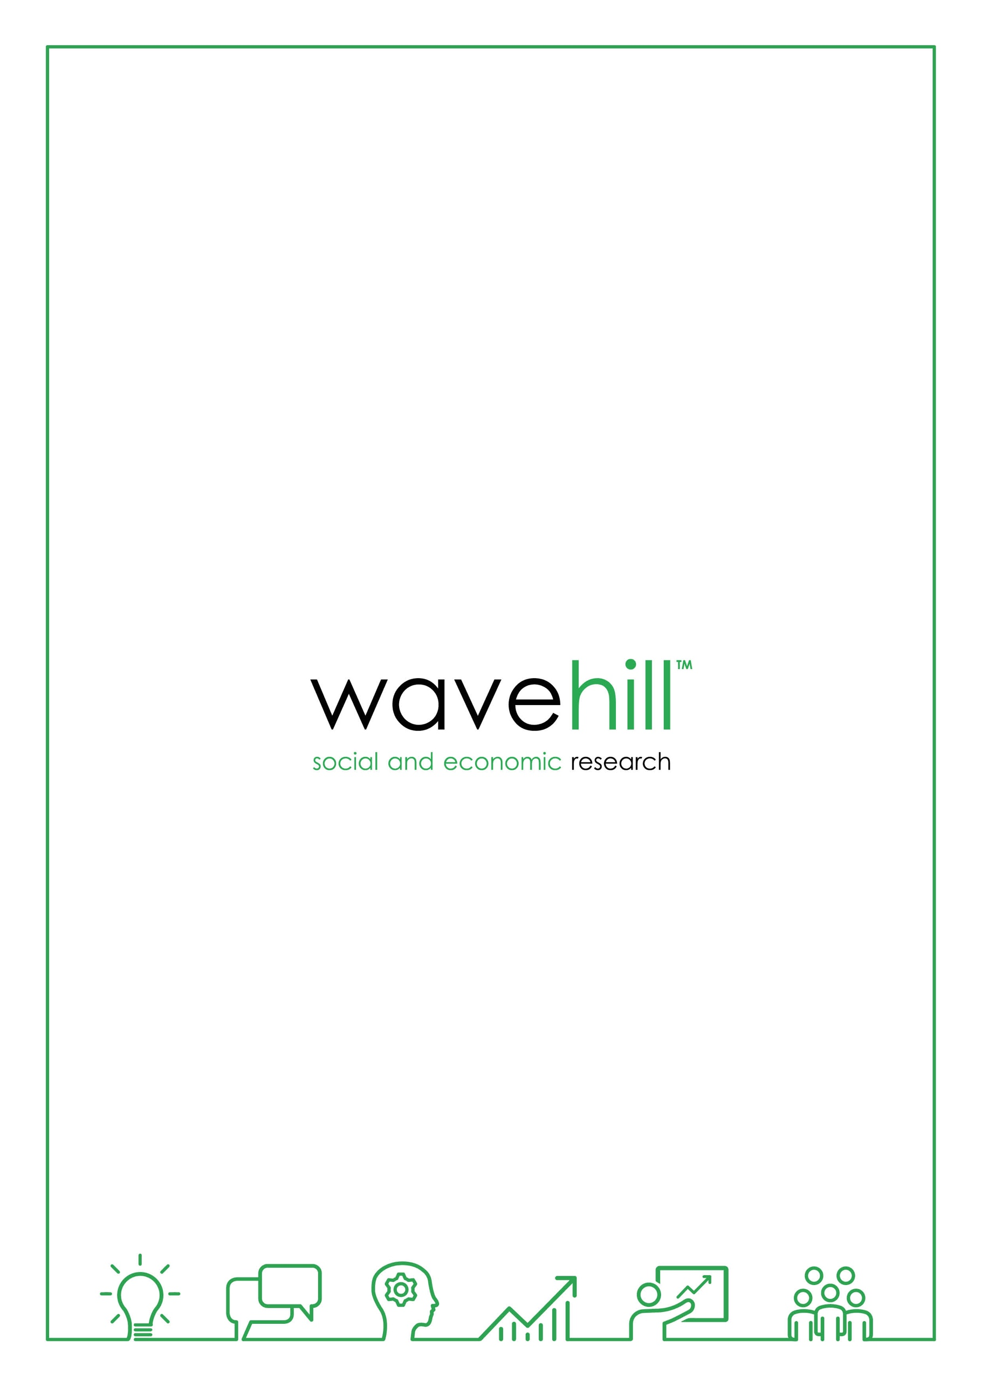
01545 571711
wavehill@wavehill.com
wavehill.com

A full list of all the localities can be found in Appendix 1 of this report.
You can watch a video on the Talk to Me principles by clicking on this link Explaining the Talk to Me Principles
See http://www.activityalliance.org.uk/how-we-help/research/1878-talk-to-me-october-2014
More detail on the methodology and the key data sources the evaluation is utilising can be found in Chapter 2 of the first annual report.
Definitions of each group are as follows: No activity – an average of 0 minutes a day; Very inactive – those doing more than none but less than 10 minutes a day; Inactive – those doing 11 to 20 minutes a day; Active – those doing 21 or more minutes of activity a day; Least active group is a combination of our inactive categories (very inactive + inactive).
Base = 344.
Gave a score of 7-10 when asked this question. 0 indicates a response of not at all, whilst 10 indicates a response of completely. The 7-10 scoring is used as the standard national measure for life satisfaction, that life is worthwhile, and happiness. The measure of anxiety focuses on a score of 0-3.
Base = 455, note these bases will increase as rolling data collection proceeds.
Base = 452
Base = 399
Base = 342
Base = 344
Base = 242
Base = 336
Formal volunteering roles are those where the role has a specific title for example Programme Assistant or Activity Leader. Informal roles tend to be more generic and focus on particular tasks including for example raising or handling money/taking part in sponsored events, visiting people, befriending or mentoring people, providing transport/driving, or baking the all-important cake. Informal volunteers are usually not registered with the programme.

