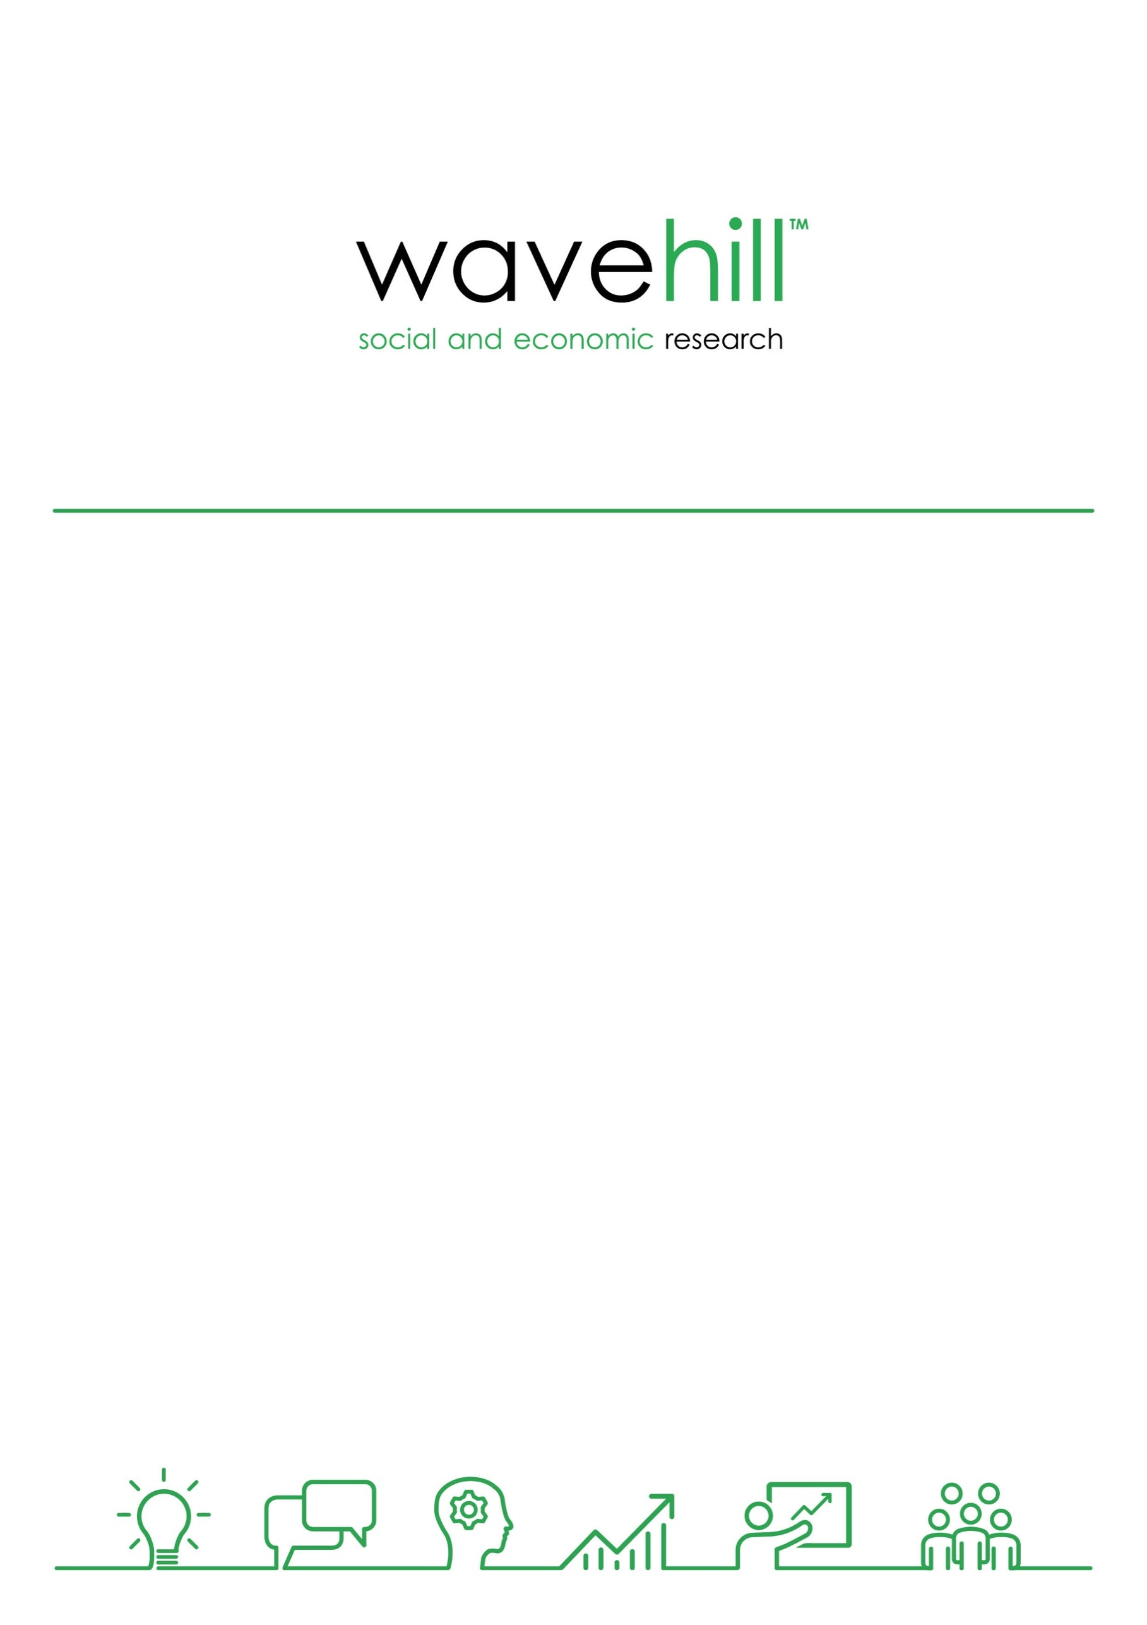

GOGA Evaluation

Final Summative Report

March 2020

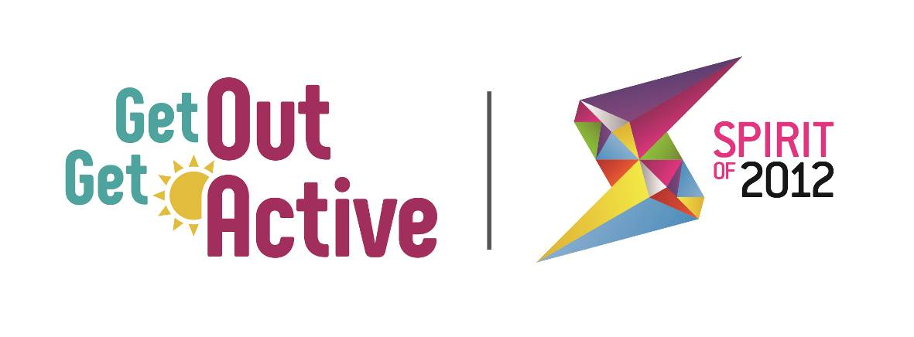

Wavehill: social and economic research

* Wales office: 21 Alban Square, Aberaeron, Ceredigion, SA46 0DB (registered office)
* West England office: 2-4 Park Street, Bristol, BS1 5HS
* North of England office: Milburn House, Dean Street, Newcastle, NE1 1LF
* London office: 52 Cecile Park, Crouch End, London, N8 9AS

Contact details:

Tel: 01545 571711

Email: [wavehill@wavehill.com](mailto:wavehill@wavehill.com)

Twitter: @wavehilltweets

More information:

[www.wavehill.com](http://www.wavehill.com)

<https://twitter.com/wavehilltweets>

© Wavehill: social and economic research.

This report is subject to copyright. The authors of the report (Wavehill: social and economic research) should be acknowledged in any reference that is made to its contents.

Report authors:

Eddie Knight, Paula Gallagher, and Simon Tanner

Any questions in relation to this report should be directed in the first instance to:

Simon Tanner ([simon.tanner@wavehill.com](mailto:simon.tanner@wavehill.com))

Date of document: 26th March 2020

Version: 2.1

Client contact:

Kat Southwell

Head of Programmes and GOGA Programme Manager

Activity Alliance

E: [kat@activityalliance.org.uk](mailto:kat@activityalliance.org.uk)

W: <http://www.getoutgetactive.co.uk/>

Acknowledgements

We would like to thank the many individuals who gave their time to assist in the evaluation, including National Partner leads, and locality leads and delivery staff in the 18 areas delivering GOGA.

Particular thanks are due to Helen Derby, Barry Horne, and Kat Southwell at the Activity Alliance, and Alex Johnston at Spirit of 2012 for their insight and valuable comments on all aspects of the evaluation work.

Most importantly, we acknowledge the participants, volunteers and peer mentors who have shared details of their experiences which have been particularly important in the writing of this report.

This evaluation would not have been possible without all these contributions.

List of abbreviations

|  |  |
| --- | --- |
| GOGA | Get Out Get Active |
| BAME | Black, Asian, and Minority Ethnic |
| DPULO | Disabled People's User Led Organisation |
| DR UK | Disability Rights UK |
| DSNI | Disability Sport Northern Ireland |
| DSW | Disability Sport Wales |
| MI | Management Information |
| SDS | Scottish Disability Sport0 |
| Spirit | Spirit of 2012 |

# Contents

Contents ii

Table of tables ii

Table of figures iii

1 Background 1

1.1 Introduction 1

2 Report Overview 3

2.1 Introduction 3

2.2 Data used to produce this report 3

3 GOGA Impact 4

3.1 Introduction 4

3.2 Specific Impacts of GOGA 4

3.3 Achieving GOGA aims 6

4 GOGA Approach 9

4.1 Introduction 9

4.2 Key components of the GOGA approach 9

5 The GOGA Sustainability Journey 23

5.1 Supporting participants to remain active post-intervention 23

5.2 Embedding new inclusive systems and practice 26

5.3 Supporting good quality transferable learning 28

6 Learning for Phase 2 Implementation 30

7 Conclusions 33

Appendix 1: Phase 1 GOGA localities 36

Appendix 2: Talk to Me Principles 37

## Table of tables

Table 3.1: GOGA performance against KPIs to Feb 2020 4

Table 4.1: Examples of delivery partner approaches (see **Figure 4.5**) 15

Table 5.1: Approaches to sustain active participation 24

Table 5.2: Methods to embed inclusive working 27

## Table of figures

Figure 4.1: Overview of the core delivery ingredients of the GOGA programme 9

Figure 4.2: How the cornerstones enable the ‘GOGA approach’ 11

Figure 4.3: Cornerstone 1 – Commissioner Support 12

Figure 4.4: Cornerstone 2 – Facilitation and development of partnership 13

Figure 4.5: Cornerstone 3 – Delivery partner approach 14

Figure 4.6: The participant ‘GOGA experience’ enabled by the GOGA approach 18

Figure 5.1: A participant journey to sustained activity 23

Figure 5.2: Overview of a changing approach to inclusive working (GOGA workforce and partners) 27

Figure 6.1: Key considerations for Phase 2 delivery partners – planning delivery 31

Figure 6.2: Key considerations for Phase 2 delivery partners – delivering the right participant experience 32

Figure 7.1: GOGA in One Page 34

# Background

## Introduction

In June 2016, Activity Alliance (formerly the English Federation of Disability Sport) commissioned Wavehill to evaluate Spirit of 2012’s Get Out Get Active (GOGA) initiative.

This report provides a summative assessment of the GOGA programme illustrating:

* its performance against key performance indicators
* key features of its delivery model that have underpinned success in achieving its outcomes, and
* its longer-term sustainability beyond the conclusion of the programme.

### The GOGA programme

A £4.5 million grant from Spirit of 2012 enabled the development and delivery of the GOGA programme.

The overall aim of GOGA delivery is:

“Supporting disabled and non-disabled people to be active together, GOGA aims to get some of the UK’s least active people moving more through fun and inclusive active recreation".

Programme delivery has taken place in 18 localities [1]across the UK. Activity Alliance led delivery, supported by the Home Nation Disability Sport Organisations (Disability Sport Northern Ireland (DSNI), Disability Sport Wales (DSW) and Scottish Disability Sport (SDS)).

Implementing key Spirit of 2012 principles[2], GOGA sought to enable people to participate in a wide range of activities and engage in their communities to:

* Improve their health and well-being, and as a result, improve communities and society.
* Improve their perceptions towards disability and impairment.
* Lead them to experience greater social cohesion and understanding.

GOGA delivery was guided at a local, national and programme level by the Talk to Me principles of Activity Alliance that seek to widen the delivery of inclusive practice, directly through the programme, AND influencing other organisations to incorporate such practice into their own delivery.

The ten Talk to Me principles[3] resulted from Activity Alliance research with disabled people, which explored what helps to make activities more appealing and accessible[4].

The GOGA approach tests whether the effective use of the principles will influence the extent to which people are supported to become more physically active, actively engaged, and sustain that engagement over the longer term.

A video explaining GOGA and its delivery approach can be found here:

[**What GOGA is all about**](https://youtu.be/3vKD_qQ8JXQ?t=8)

### GOGA Funders - Spirit of 2012

Spirit of 2012 (Spirit) are the London 2012 legacy charity set up by the National Lottery Community Fund. Spirit invests in happiness by funding projects that enable people to be active, creative and connected. Spirit funds arts and sports projects that foster greater community cohesion, empower those who are most under-served and challenge perceptions of disability.

Spirit have funded GOGA since 2016 with £4.5million being allocated for delivery over 4 years (to the end of March 2020). In September 2019, Spirit announced a further package of funding of £3million[5] for UK GOGA Phase 2, with an additional contribution of £1 million from Sport England to extend GOGA delivery in England.

In February 2020, the London Marathon Charitable Trust announced a further contribution to GOGA Phase 2 delivery of £1million to extend provision and impact across the UK. This brings the total funding for GOGA Phase 2 to £5million to support delivery across 21 localities across the UK[6] to 2023.

# Report Overview

## Introduction

This report provides:

* a **summative assessment** of the performance of the GOGA programme to February 2020
* **insight into the key process and practice** of a ‘GOGA approach’
* an **updated sustainability report** that highlights how GOGA has
  + facilitated and supported participants to improve their physical activity levels and embed opportunities for them to be active for life
  + enabled inclusive delivery to become a key part of local system delivery and practice
  + ensured the transfer of learning within, and beyond, GOGA programme delivery
* **key insight and learning from GOGA Phase 1** delivery to support the planning, development and delivery of GOGA Phase 2 as it prepares to commence in April 2020.

## Data used to produce this report

This report draws on a range of GOGA evidence collected by an independent programme evaluation that includes:

* Findings from 3 annual reports.
* Analysis of locality monitoring data showing activities delivered, and participant, volunteer and peer mentor numbers, characteristics, outcomes and impacts from programme start to February 2020.
* Quarterly monitoring reports provided by locality (18) and National Partners (to quarter 3 in 2019/20 delivery).
* Annual update telephone interviews with all locality leads, partners and national partners.
* Three baseline telephone surveys with GOGA participants, volunteers, and peer mentors conducted between May/June 2017 and July/August 2019.
* Three follow up telephone interviews with GOGA participants between 6-15 months after they completed a baseline interview to track impacts of participation conducted up until the end of December 2019.

# GOGA Impact

## Introduction

In this chapter, we summarise details of the impact of the GOGA programme updating figures from the 3rd Annual Report to provide a final position on performance against KPIs and GOGAs continuing progress against its key aims to:

* reach the least active and increase physical activity levels
* change perceptions of disability,
* impact positively on the wellbeing and social connectedness of participants.

The summary in this chapter is intended to illustrate where the programme has had particular success to provide context for our review (Chapters 4 and 5) of how this has been attained through the GOGA approach and focus on sustainability.

Further detail on how the progress against these measures has been achieved can be found in the 3rd Annual report and the very latest numbers can be found in a Power Point slide presentation that accompanies this report.

## Specific Impacts of GOGA

Table 3.1: GOGA performance against KPIs to Feb 2020

|  |  |  |  |
| --- | --- | --- | --- |
| **Key Performance Measure** | **Target** | **Achieved** | **% Achieved** |
| Individual Participants | 16,500 | 20,000 | 121 |
| GOGA Activities | 550 | 2,400 | 436 |
| GOGA Events Held | 100 | 227 | 227 |
| Attendance at GOGA events | 12,000 | 17,140 | 143 |
| Number of Volunteers | 2,300 | 2,799 | 121 |
| Number of People Trained | 4,500 | 2,000 | 44 |
| Number of Training Sessions | 500 | 196 | 39 |
| % participants sustaining activity 6 + months | 40% | 65% | + 25 percentage points |

Source: GOGA Monitoring Data to Q3 2019/2020 and Participant Tier 2b survey data.

**Table 3.1** illustrates that the GOGA programme has had notable successes in its delivery as measured by its KPIs.

Targets have been **exceeded** for:

* Number of individual participants
* Delivery of GOGA activities, and events and attendance at those events
* Proportion of participants who sustain activity after GOGA intervention, where almost two thirds are still involved with GOGA six to nine months after first engaging with the programme
* Number of volunteers recruited – localities have found difficulty in individuals wanting to fulfil formal volunteering roles preferring to undertake informal roles. Data from Volunteering Matters shows that accounting for these informal roles means that GOGA has in fact exceeded its Volunteer target reaching over 2,700 volunteers.

GOGA has fallen short of targets in relation to:

* Provision of training – original expectations had been that programme delivery would involve a greater volume of training. However, evidence collected from locality leads shows that training has been much more targeted on inclusive practice amongst delivery staff that will provide a stronger legacy from delivery.

The key learning from these figures around KPIs is that GOGA has been able to achieve most of its targets because it has been successful in attracting and retaining participants because their experience has been so positive. This has encouraged those participants to also help in programme recruitment because they have shared their positive experiences with others.

GOGA delivery is thus driven by delivery providing the ‘right’ experience for participants, as opposed to chasing participant numbers. This experiential focus has therefore been the key enabler of the numerical targets, as Table 3.1 above shows, being achieved.

It is therefore critical that planning for GOGA Phase 2 focusses explicitly on ensuring that the experience of all participants adheres to GOGA principles. An approach supported by targeted approaches to inclusive training provision, and volunteer recruitment, management and retention supporting the delivery of a positive participant experience.

We can highlight this because the aims of the programme have been achieved as a result of the approach to delivery that the programme has adopted. Process and practice that we identify as the ‘GOGA approach’ and will detail throughout the rest of this report.

## Achieving GOGA aims

Using this ‘GOGA approach’ the programme has been able to:

#### Reach the least active

* 65% of all GOGA participants come from the least active group[7] [8], with 42% admitting to no physical activity in the four weeks prior to them joining the programme[9]. These patterns are even more pronounced amongst disabled people with 71% coming from the least active group, and 46% saying they had not done any physical activity prior to joining the programme[10].

#### Increase the physical activity levels of all participants, including the least active

* 59% of GOGA participants at 6-9 months post GOGA start report doing 20 minutes or more on average per day of physical activity, this reaches 65% 15 months after GOGA participation.
* For the least active, 60% say they are doing more physical activity now than when they started GOGA, for 30% a lot more.[11]
* Disabled GOGA participants also show increased physical activity levels. Thus the proportion of disabled participants reporting no physical activity halved from when they joined the programme (50% said they were inactive) to 15 months after GOGA participation (15% were inactive).
* The survey also shows the extent of these increases the least active identify. These show they have increased their average daily amounts of physical activity by 18 minutes per day (very inactive) after 6 months, and by 24 minutes 15 months later. For inactive groups amounts of activity increase by 33 minutes per day 6 months after starting with GOGA, and by 12 minutes 15 months after starting GOGA. This compares with an increase 15 minutes after 6 months and an extra 16 minutes after 15 months respectively for all participants.
* The least active participants strongly associate their GOGA ‘experience’ with an increase in their physical activity levels. 69% say they have become more active, and that for this group, over nine out of ten (91%) attribute this to their GOGA experience. Furthermore, 43% of those in the least active group have moved into the active group (doing an average of 30 minutes or more per day) as a result of GOGA participation.

#### Change perceptions of disability

* 65% say they have a more positive view of disabled people with 58% of interviewees at 9 and 15 months after taking part in the GOGA programme say that their view of disabled people is more positive as a result of their programme participation.

#### Improve the wellbeing of participants

* Using the ONS[12] Wellbeing indicators positive trends in wellbeing measures are noted amongst all GOGA participants with statistically significant increases in those reporting improved life satisfaction and a sense of life being worthwhile. Thus
  + 74% of GOGA participants said they were very satisfied with their life , and this had risen to 83% 6-9 months after GOGA participation with a concurrent rise in the average score (when asked to rate how satisfied with life they were out of 10) from 7.50 to 7.88 6-9 months after GOGA participation.
  + Perceptions of how much participants feel that the things that they do in their lives are worthwhile rise from 83% to 86% scoring 7-10 for this measure (mean average score rising from 7.99 to 8.33 – a statistically significant change for these participants).
  + Feedback on participant Happiness shows minimal change with the average rating out of 10 rising from 7.91 to 8.06.
  + GOGA participants are reporting feeling less anxious, 59% of participants rated how anxious they felt yesterday as 0-3 out of 10 upon joining the programme which rose to 63% 6-9 months after participation. The average rating on anxiety fell from 3.30 at the start of engagement to 3.00 6-9 months later.
* Tracking respondents also shows that for the least active indicates that there are **statistically significant increases in the average rating of life satisfaction and whether participants believe their life to be worthwhile** following participation in the GOGA programme. Happiness has also risen following GOGA participation and the mean average of anxiety has fallen. Those with disabilities also demonstrate similar positive trends in their own sense of wellbeing. Thus for the least active:
  + For life satisfaction the average rating (out of 10) rose from 7.10 on joining GOGA to 7.50 6-9 months after joining.
  + Where participants rated things in their life as worthwhile the average rating rose from 7.85 to 8.03.
  + Those indicating their happiness showed a small rise in average rating from 7.81 to 7.91.
  + Anxiety levels showed falls, declining from 3.68 to 3.14 6-9 months after joining GOGA.

#### Increase the social connectedness of participants

* Following their engagement with GOGA, participants become more positive about taking part in activities in their local community. Prior to GOGA participation, 83% said they were positive about community engagement and 6-9 months after GOGA participation this had risen to 89%, and by 15 months from GOGA participation to 93%.
* Participants feel more engaged in their community after participating in GOGA. Prior to their participation, 83% said they felt engaged with their local community rising to 89% after participating in GOGA[13].
* 87% of all participants say that GOGA has had a positive impact on their engagement with their local community. 69% of participants six months after joining GOGA said they had made new friends in their local area as a result of their GOGA participation.

# GOGA Approach

## Introduction

In this chapter, we detail the key components (see **Figures 4.3 – 4.6**) for success that have helped the GOGA programme to achieve the outputs and outcomes identified in Chapter 3.

## Key components of the GOGA approach

Our summative assessment of evaluation and monitoring data identifies that the GOGA approach, as it can be termed, involves a key focus across programme delivery to enable it to deliver the core ingredients outlined in **Figure 4.1**.

Figure 4.1: Overview of the core delivery ingredients of the GOGA programme

Source: Analysis of evaluation data.

Delivery of these core ingredients has been possible because of GOGAs’ three cornerstones:

1. Commissioner support
2. Facilitation and development of partnership
3. Delivery partner approach.

The way these interact is illustrated overleaf, **Figure 4.2** illustrates how these three cornerstones (**Figures 4.3 – 4.5**) have combined through GOGA programme delivery to enable the delivery of the core ingredients shown in **Figure 4.1** and how this facilitates the provision of the right programme experience for participants (**Figure 4.6**).

Figure 4.2: How the cornerstones enable the ‘GOGA approach’

**Figure 4.3** illustrates the detail of the Commissioner support that has acted as the first cornerstone of the GOGA approach. In this case, for Phase 1 of GOGA delivery, this refers to Spirit.

Figure 4.3: Cornerstone 1 – Commissioner Support

Support from a commissioner that...

**Figure 4.4** illustrates the key elements of the facilitation of partnership development delivered through Activity Alliance, supported by the Home Nation Disability Sport Organisations, and national partners including Disability Rights UK, Volunteering Matters, Women in Sport and Sporting Equals.

Figure 4.4: Cornerstone 2 – Facilitation and development of partnership

A lead partner / programme consortium aiming to reach inactive participants that…

**Figure 4.5** shows the key components of how delivery partners have best facilitated the GOGA approach for participants and incorporated it into their own delivery, whilst **Table 4.1** provides some selected examples of how these components have been delivered.

Figure 4.5: Cornerstone 3 – Delivery partner approach

**Delivery partners that…**

Table 4.1: Examples of delivery partner approaches (see **Figure 4.5**)

|  |  |
| --- | --- |
| **Delivery partner approach components** | **Selected examples** |
| 1. Getting out and engaging | * Local community group encouraged to run disability friendly session in **Bradford** * Engagement with local high school to engage teenage girls leaving school in **Fife** * Specialist carer group engagement in **Rochdale**. |
| 1. Extending partnerships | * Accessing older people in day centres and sheltered housing in **Lincolnshire** and **Wandsworth**. * Work with the Royal British Legion in **Lincolnshire**. |
| 1. Actively consulting to understand barriers/hurdles | * Female fitness session altering start times in **Bradford**. * Couch to 5k sessions in alternative venues in **Nottingham**. * Advertising activities as volunteer led to make more informal and less scary in **Thanet**. |
| 1. Embedding ‘Active Together’ delivery | * Delivery moving away from disability only session in **Rochdale**. * Engagement of three family generations by activities in **Fife**. * Family orientated approach in family focussed events in **Forth Valley**, **Armagh, Bainbridge and Craigavon**, and **Derry and Strabane**. |
| 1. Actively encouraging and facilitating socialising | * Tea, Talk, Try sessions in **Derry and Strabane** and **Grampian**. * Emphasising social connection in **Thanet**, exercise is secondary. |

Table 4.1: Examples of delivery partner approaches cont. (see **Figure 4.5**)

|  |  |
| --- | --- |
| **Delivery partner approach components** | **Selected examples** |
| 1. Ensuring consistent friendly and welcoming delivery | * Cycling in **Pembrokeshire** built around building new friendship groups. * All ability boxing in **Bradford** encouraging social connection then physical activity. * Free introductory activity sessions in **Wigan**. |
| 1. Actively testing and piloting | * Testing of women’s golf in **Wrexham** where numbers were initially low but rose a word of mouth brought new members * Switch from Walking Football to multi-activity sessions in **Derry and Strabane**. |
| 1. Seeking help from specialist partners | * Support to identify need for engaging Women in **Thanet** and **Wrexham** from **Women in Sport**. * BAME and Faith Centre engagement support from **Sporting Equals** in **Bradford**. |
| 1. Structured approach to use of volunteers | * Complete revamp in use of volunteers supported by Volunteering Matters in **Fife**. * Online toolkit provided by **Volunteering Matters** drawn from examples across the GOGA programme. * Participants becoming volunteers in **Lambeth**, **Rochdale** and **Wrexham**. * Programme ambassadors in **RCT**. |
| 1. Workforce development focussed on inclusivity training | * Inclusivity training for new instructors and faith centres supported by Sporting Equals in **Bradford**. * Walk leader training in **Fife**. * Peer education work in **Wigan**. * All levels of staff in Leisure Centres provided with inclusivity training in **Thanet** and **Wrexham**. |
| 1. Focus on sustaining participation and progression | * Referral to leisure centre programmes and membership card options in **Wrexham**. * Prize giving and certificate issue in **Fife** and **Grampian**. * Loyalty and reward schemes in **Lincolnshire**, **Wigan** and **Wrexham**. |

As **Figure 4.2** shows these aspects combine to provide the framework for delivery of the GOGA approach that ensures a particular kind of experience for participants which they universally acknowledge as their main reason for initial engagement, continued participation, and enabling the outcomes they have achieved. The detail of this is illustrated in **Figure 4.6** overleaf. It also highlights how these ingredients provide examples of the Talk to Me principles in action – further detail on the Talk to Me principles can be found in **Appendix 2**.

Figure 4.6: The participant ‘GOGA experience’ enabled by the GOGA approach

A participant experience that has…

For participants, this framework illustrates how their ‘GOGA experience’ is clearly important to them and that these ingredients actively support their participation. In the examples below, we have sought to link them to specific boxes in **Figure 4.6** above:

“Being in a group situation has been really useful. The guys that have been around are all so encouraging and fab.”

**Sean, Wigan - see Figure 4.6 boxes a) and c).**

“She was very withdrawn and wouldn't look at people before and she's been going to the badminton for 2 years now and the difference in her is totally unreal, she's communicating more herself with people whereas before she would stand behind me and she has actually met up with one of the girls and they've gone for lunch, so it's given her a social life as well as bringing her out of herself and giving her a lot more confidence”

**Julie (Carer), Lambeth – see Figure 4.6 boxes a) and c)**

“The feeling of inclusion. Before I started going to GOGA activities I used to just go out for lunch every day and my home life was not half as active as it is now. I love the activities. I have made friends and experienced things I never thought I would. It has also improved my home life as now I am knackered and manage to sleep every night whereas before I was up every hour. Safe to say my mum loves me going to GOGA.”

**Marian, RCT – see Figure 4.6 boxes a) and f).**

“The other part of it which is just as important, if not more important is it's quite a social activity, it's very social compared to the typical gym and so therefore the connections I've made and the fact that I see the regular faces there is something that'll encourage me to carry on.”

**Naz, Bradford – see Figure 4.6 boxes a), c), f), g) and h).**

What it brings is very clear as summarised by these quotes overleaf drawn from case studies undertaken with participants. These provide insight into the critical features of the ‘GOGA experience’ that the GOGA approach through the trial and error and development approaches has been able to identify a ‘GOGA experience’ that brings these reactions for the previously least active:

“I loved it there, I loved every minute of it, I **loved the whole atmosphere** in the place as it was one of **lightheartedness, uplifting, bonding** with people you'd never met before and it was just like a big family although you didn't know people you got a great chance to exchange ideas and thoughts. I found it was a great forum for myself in that I became **much more aware of myself and what stage of my life I was at** and I learnt to look at things differently and learnt that there were **activities I could participate in even with my disability**.”

**Sharon, Derry and Strabane – see Figure 4.6 boxes a), c), d), e), and h).**

“Because initially it was **tailored to individual needs** very often especially the chair based exercises, everyone's got different requirements and the people involved there would tailor the exercises to suit you, if you couldn't do one exercise they'd give you something else if **they could make it harder** for you they would which is what they do with me as we go along…I've been doing more activities and I'm now **doing 9 different sessions a week**...”

**Howard, Nottingham – see Figure 4.6 boxes d), e), and h).**

“It gets us out of the house, it’s a way of meeting people and sitting down and talking to people while we're having a meal, it's **the community that you're mixing with** that keeps you going and it gets my wife going as she's taking part in **some form of exercise** which she wouldn't otherwise do.”

**Peter, Wigan – see Figure 4.6 boxes a), c), and f).**

“I think it was doing it with such a range of people so I didn't feel I was getting left behind with the things that I couldn't do, everybody had different abilities so **nobody was left out**, everything was tailor made to each person and their own ability which was absolutely fabulous, I loved the way they **adapted some of the exercise programmes** to suit everybody involved in the class.”

**Mo, Thanet -see Figure 4.6 boxes e) and h).**

These quotes also align with these summaries of case studies:

**Couch to 5K Nottingham- Helen – see Figure 4.6 boxes a), c), d), f), and h).**

Saw a Notts women runners group were doing a couch to 5k. Signed up and realised it was a GOGA Notts activity. GOGA had supported, by training the coaches and helping to run sessions in different areas around the city. She met many amazing women and got to learn their reasons for getting involved, this varied from wanting to become healthier, lose weight, make friends, be more social, boost mental health and wellbeing and of course fun!

**Dean- Fife Men’s health – see Figure 4.6 boxes a), c), g), and h).**

Signed up for a number of GOGA activities and is about to begin swimming competitively. Has competed in the Fife Track and Field Championships for the first time and was then selected for Team Fife for the Scottish Championships in Grangemouth Has enjoyed meeting new people and enjoys staying after the sessions to socialise with friends.

**Shirley Wrexham – see Figure 4.6 boxes a), b), c), d), f), and h).**

Wanted to get fit again after cancer and a mastectomy. Started couch to 5K. Now goes to swimming with GOGA ladies after. Has met new friends and has helped her believe in herself again raising her confidence.

Sections above have illustrated key components of the GOGA approach that have been identified through the successful delivery across GOGA Phase 1 delivery and how in the next chapter localities have also been through a journey around sustainability of the delivery to:

* Support Individuals to **remain active post intervention;**
* Influence organisations and partners to **embed new ways of inclusive working – systems and practice;**
* Provide **good quality transferable learning** on **how to reach the least active disabled and non-disabled** people and **support them to be active together.**

# The GOGA Sustainability Journey

This chapter provides a summary to illustrate how the GOGA programme delivery has enabled sustainability to be a key part of its delivery. It illustrates the journey that participants and partners (local and national) have taken through Phase 1 delivery that have laid foundations for the three sustainability aims of GOGA to be achieved.

These aims for sustainability for GOGA are to:

* Support Individuals to **remain active post intervention;**
* Provide **good quality transferable learning** on **how to reach the least active disabled and non-disabled** people and **support them to be active together.**
* Influence organisations and partners to **embed new ways of inclusive working;**

A key aspect of this has been about ensuring that the sustainability journey for delivery partners begins with a common understanding of these aims, and that sustaining the GOGA programme is about moving away from just continuing the provision of activity. Approaches that are first focussed on enabling participants to remain active in the longer term.

## Supporting participants to remain active post-intervention

**Figure 5.1** illustrates the journey that participants take as they ‘experience’ the GOGA approach as outlined in **Figure 4.6** above.

Figure 5.1: A participant journey to sustained activity

**Table 5.1** overleaf illustrates further detail on how this can be achieved.

Table 5.1: Approaches to sustain active participation

|  |
| --- |
| Key Approaches to Sustain Active Participation (1) |
| * There should be a focus on working with specialist support services (particularly those related to specific health concerns or the needs of specific community groups) to identify ways in which participation in active recreation could be added to individual or community support/engagement plans.   Examples include links to individual support plans in Rochdale; Targeting of local care homes and residents’ associations in Wandsworth; and work through health care professionals in Stoke.   * Progression and transition options for volunteers and mentors are as important as those for participants. These enable moves from informal to formal roles, or the shaping of new volunteer roles by the individuals themselves. Shaping these around the skills, interests, and lived experiences of the individual will be of particular benefit in such cases. Transition options should also include engagement such that the physical activity levels of volunteers and mentors can also be seen to increase.   Examples include use of volunteers as programme ambassadors in RCT; use of participants as volunteers in Lambeth, Rochdale and Wrexham.   * Establishing reward and recognition events for participants, volunteers, and mentors can reinforce the progress individuals have made and highlight how progression into further activity is a real possibility for them. Consideration should be given to establishing these as regular (Annual) events.   Examples include prize giving and certificate issue in Fife and Grampian; and loyalty and reward schemes in Lincolnshire, Wigan and Wrexham. |

Source: Evaluation analysis of partner and stakeholder interviews and participant survey responses.

|  |
| --- |
| Key Approaches to Sustain Active Participation (2) |
| * Helping participants build their own active support network through friends, families and peers should be actively encouraged. Wherever possible these individuals should be encouraged to take part in the activities put on, and volunteers and mentors encouraged to support the development of these networks. The social dimension of the activity is often as important, if not more important, than the physical activity for participants and encouragement to bring others can foster a stronger social or ‘community’ element of delivery.   Examples include free introductory sessions for family and friends in Bradford; family focussed events in Forth Valley, Armagh, Bainbridge and Craigavon, and Derry and Strabane; and buddy system in Lambeth, Manchester and Wigan.   * Partner interviews highlight that inclusive groups in GOGA delivery use ‘Tea, Talk, Try’ or ‘Meet and Greet Taster’ approaches to foster social interaction and as a key engagement approach. Partners identify that in GOGA delivery the least active may feel more comfortable in a ‘mixed’ ability group as they can perceive they will not be out of their depth in a group with people with disabilities.   Examples include beach cleaning in Pembrokeshire and Thanet, and work through the Royal British Legion in Lincolnshire.   * The ongoing recruitment and retention of ‘social focussed’ coaches skilled in appropriate scaling and empathising with those from least active groups should be a key focus for project development. Consequently, coaches or activity leads should be valued because of their social abilities, emotional intelligence, and friendly nature often above any expertise they might have in the activity involved, but they need to be skilled (or trained if skills gaps in this area exist) in managing inclusive groups to prevent groups segregating themselves on the basis of being disabled/non-disabled.   Examples include peer education approaches in Wigan; coach recruitment in Nottingham; and Ladies Night focus in Wrexham. |

Source: Evaluation analysis of partner and stakeholder interviews and participant survey responses.

## Embedding new inclusive systems and practice

Embedding of inclusive working has been one of the major features of success of the GOGA programme with significant change being seen across most partners (local and national).

Examples of these include:

* Constitutional change to the organisation – Fife
* Revised delivery focus with move towards active recreation – Fife and Grampians
* Increased use of inclusive practice – Rochdale and Wigan
* New local partners outside the sports sector – Lincolnshire and Wandsworth
* New relationships and delivery approaches delivered through local leisure trusts – Thanet and Wrexham
* Influencing other organisations and venues to deliver more inclusive opportunities – Nottingham and Wrexham
* Ensuring family activities are available at all venues – Bradford
* Tailoring of activities to localities and venues – Northern Ireland
* Communications approaches incorporate a greater focus on accessibility of messaging – Women in Sport
* Staff provided with Inclusive Champion role – Women in Sport
* Organisational focus shifted to include sport and physical activity fields – Volunteering Matters

**Figure 5.2** illustrates the journey taken by partners against this agenda.

Figure 5.2: Overview of a changing approach to inclusive working (GOGA workforce and partners)

Source: Thematic Analysis of Evaluation Interview Findings

**Table 5.2** shows how this journey has been supported by specific approaches embedding inclusive working.

Table 5.2: Methods to embed inclusive working

|  |
| --- |
| Key Approaches to Embed Inclusive Working |
| * Extending partnership working to engage a far wider range of community partners not necessarily already engaged in physical activity and sport. * Revisiting organisational aims and objectives to identify where scope might lie to embed inclusive delivery approaches as a cornerstone of future delivery. * Inclusive education and training should be provided to all staff working with targeted groups including front of house staff so all are able to engage groups effectively. * Spreading the word on learning from GOGA, and the value of adopting the ‘GOGA approach’ through local commissioning structures for health and social care services can help initiate new partnership arrangements. * Use the ‘Talk to Me’ principles or other local inclusivity approaches/principles to underpin any embedding work. |

## Supporting good quality transferable learning

Key examples of this transfer of learning includes:

* A range of toolkits produced and engaged with by localities to provide practical help and support, particularly around the recruitment, management, and retention of volunteers and peer mentors, engaging and retaining women, inclusive practice, and engagement with BAME groups – see examples from:
  + Women in Sport: <https://www.womeninsport.org/research-and-advice/our-publications/get-out-get-active/>
  + Volunteering matters: <https://toolkit.volunteeringmatters.org.uk/> .
* The monthly GOGA Hour has continued providing updated insight into practice around a range of topics including monitoring and evaluation, inclusive marketing and communications, and use of volunteers.
* Many national partners have made new partners through GOGA and signal that they want to keep working with these new partners within and beyond GOGA in the future including links between for example Women in Sport, Sporting Equals, and Volunteering Matters.
* Sharing of information across localities has been done well by Activity Alliance staff but also acknowledging that what works in one area will not necessarily work in another.
* A variety of new learning developed by National Partners which can be shared and disseminated across GOGA and beyond.
* Lots of learning that has informed wider working of organisations, for example Women in Sport have done deep dives with the learning and information producing an engaging women fact sheet.
* Evidence that involvement with GOGA has led to some national partners adapting and shaping their practice in order to apply the learning and support the very least active.

**Table 5.3** illustrates some of the key ways in which this has been achieved.

|  |
| --- |
| Key Approaches to Transfer GOGA Learning |
| * Partners (local and national) should continue to actively ‘spread the word’ on learning from GOGA and the ‘GOGA approach’ through local commissioning structures for health and social care services to help open up new future partnership arrangements. * Partners should actively seek out opportunities to engage with localities and other partners to share best practice and network. They should encourage local communities to utilise the range of online resources available through the project including the GOGA website and the Volunteering Matters Online Volunteering Toolkit. This is especially relevant as the development of GOGA Phase 2 delivery begins. * Stakeholders and partners should investigate the use of social media and other local communications networks to disseminate GOGA experiences and outcomes. They should actively seek help from the GOGA programme team and/or their national Disability Sport organisation to gain advice and support on the best ways to do this. * Stakeholders, partners and locality leads should ensure that they are providing detailed content on shared learning and practice through GOGA’s quarterly reporting mechanisms, and the GOGA monthly update. Contributions to the annual GOGA conference and other local conference or workforce development activities should be actively considered. * Stakeholders, partners and locality leads should transfer learning on the use and application of the ‘Talk to Me’ principles to partners outside of the GOGA network wherever possible. |

# Learning for Phase 2 Implementation

As GOGA Phase 1 delivery concludes and with planning already underway for GOGA Phase 2 (see Section 1.1.2) we are able to draw out some key learning from Phase 1 to support early delivery for the programme.

These insights are focussed on how localities might best begin to develop their delivery, and how they might ensure that delivery can provide the right experience for early participants. **Figure 6.1** overleaf highlights key delivery considerations for localities, whilst **Figure 6.2** highlights approaches that could be taken to lay the best foundations for the right participant experience.

Figure 6.1: Key considerations for Phase 2 delivery partners – planning delivery

Figure 6.2: Key considerations for Phase 2 delivery partners – delivering the right participant experience

# Conclusions

The main findings from this summative report demonstrate that GOGA Phase 1 delivery has exceeded many of its KPIs and embedded a ‘GOGA Approach’ of value to both participants and delivery organisations. This approach facilitates the least active to be enrolled, engaged by GOGA in the 18 localities across the UK and enables an increase levels of, physical activity for most participants.

The basis of this embedding has been achieved through the combination of components that has supported delivery of key ingredients of the GOGA approach namely (see **Figure 4.1** above):

Using active recreation to reach the least active disabled and non-disabled people

Proactively supporting disabled and non-disabled people to be ‘active together’

Using the Talk to Me Principles to engage participants and alter the practice of delivery staff

Focus on attaining a broad-based approach to sustainability (with details of how this has been achieved being shown in **Chapter 5**) ensuring:

Foundations are laid for participants to remain active for life

Inclusive delivery systems and practice are developed

Learning is transferred within and beyond the programme to support the further use of the GOGA approach, potentially in all forms of physical activity provision (with learning for GOGA Phase 2 delivery being highlighted in **Chapter 6**).

The components have come together (see **Figure 4.2**) through approaches across the programme delivery model that have included:

Commissioner support (**Figure 4.3**)

Facilitation and development of partnership (**Figure 4.4**)

Delivery partner approach (**Figure 4.5**)

These have acted as three cornerstones that have underpinned, facilitated, and supported the delivery of a participant experience (see **Figure 4.6**) that is the essence of the GOGA approach. An experience that ensures:

Fun, social connectedness as a prelude to physical activity

Delivery in ‘safe’ and ‘familiar’ settings

A consistent friendly and welcoming approach with active invitation to return

Delivery of activities that reassure through inclusive practice and scalability

Encouragement of disabled and non-disabled people to be ‘active together’

Participants can participate with their friends and family should they wish

Role models are available to support participants

Consultation with, and listening to, participants helps the development of a person-centred approach

An approach summarised in **Figure 7.1** overleaf:

Figure 7.1: GOGA in One Page

**How does a programme reach 20,764 through 2,400 activities and 409 events attended by 24,171, and ensure that 65% are in the least active group (42% not active at all) before taking part?**

**How does a programme:**

* Enable over half of its participants to do more physical activity, with over nine out of ten saying this is down to the programme itself?
* More than halve the proportion of disabled people who participate in it who were inactive at the start?
* Increase average amounts of physical activity by 15 minutes per day after 6 months, and by 16 minutes per day after 15 months?
* Give enough confidence to over half of its participants to take up additional sport and physical activity opportunities 9-12 months after taking part?

**It’s a programme that creates an infrastructure, a collaborative working approach, and ‘fear free’ attitude and philosophy of risk-taking and testing of new ideas, that allows participants an experience like this:**

* I can have fun and enjoy my activity every time I attend, and it all happens in settings where I feel ‘safe’ and that are familiar to me;
* In the sessions I can take part in welcoming and reassuring activities, some new to me, that I have had a role in deciding upon and a choice in participating in;
* I enjoy taking part in activities where disabled and non-disabled people are active together and can take part in activities with my friends/family members;
* I’m supported to attend by volunteers and/or have access to someone like me who understands me and can act as a role model for me;
* I’m actively encouraged to return and consider other forms of activity.

**A programme where partners:**

* Actively consult with the least active to understand the barriers/hurdles to participation and works with them to co-produce and co-create the activity offer;
* Embed an ‘Active Together’ approach to delivery that support the disabled and non-disabled to participate together;
* Ensure all delivery consistently offers a friendly, welcoming approach in locations/venues that participants feel are ‘safe’ and familiar to them supported by volunteers and peer mentors;
* Extend partnership building into communities and specialist community groups beyond traditional physical activity routes;
* Actively seek help from specialist partners to improve delivery;
* Underpin delivery through workforce development focussed upon providing inclusivity training for all levels of staff.

The summative reporting also highlights that the Talk to Me principles have played a key role with My channels and Me, not my impairment underpinning engagement of participants, whilst principles 2, 4, and 5 – 10 (see **Appendix 2** for details) have underpinned the activity provision the GOGA programme has been able to provide.

However, the evaluation has also highlighted the importance of considering a further, eleventh, principle – **Connect Me**. Social connectedness has been a powerful influencer in not only engaging participants in the GOGA programme, but also helping to sustain their participation.

This is because a focus on building a group dynamic between programme participants has enabled informal support networks to be built across groups and has provided new connectedness that has made individuals aware of others who have faced the same hurdles to participation as them. It has shown individuals that they are not alone in this and that through the group they can enjoy mutual support to help them overcome those barriers and sustain their activity in the longer term.

GOGA Phase 2 delivery could further test the detail of this new Talk to Me principle whilst also utilising the learning from Phase 1 delivery as highlighted in **Chapter 6** of this report.

# Appendix 1: Phase 1 GOGA localities

|  |
| --- |
|  |
| **England**   * Bradford Council |
| * Greater Manchester - Manchester City Council |
| * Greater Manchester – Rochdale Borough Council |
| * Greater Manchester – Wigan Council |
| * Kent/Thanet |
| * Lincolnshire |
| * London - Lambeth Council |
| * London - Wandsworth Council |
| * Nottingham City Council |
| * Stoke City Council |
| **Northern Ireland**   * Armagh City, Banbridge and Craigavon Council |
| * Derry City and Strabane Council |
| **Scotland**   * Fife Council |
| * Forth Valley: Stirling Council/Clackmannanshire Council/Falkirk Council |
| * Grampians: Aberdeenshire Council/Aberdeen City Council/Moray Council |
| **Wales**   * Pembrokeshire County Council |
| * Rhondda Cynon Taf County Borough Council |
| * Wrexham County Borough Council |

# Appendix 2: Talk to Me Principles

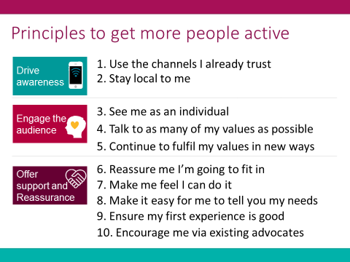

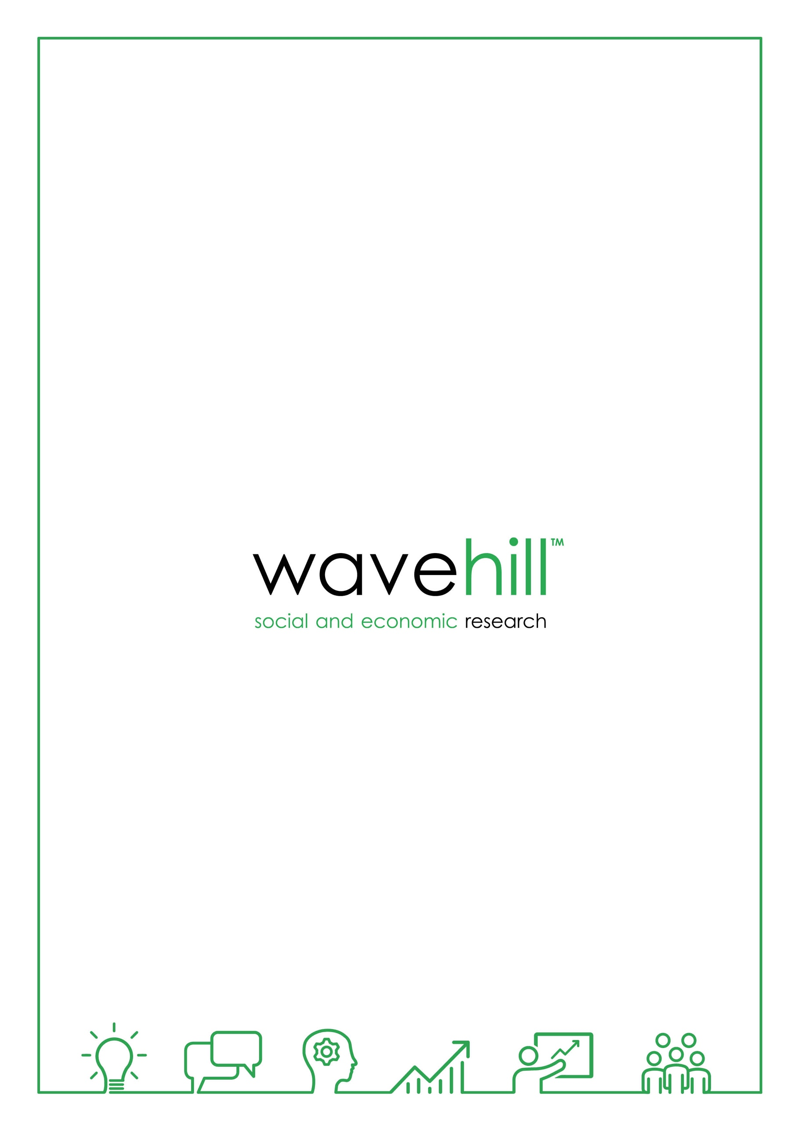

01545 571711

wavehill@wavehill.com   
wavehill.com

1. A full list of all the localities can be found in Appendix 1 of this report.
2. See <https://www.spiritof2012.org.uk/learning/understanding-our-impact> for more details and the Theory of Change that will lead to positive social change.
3. You can watch a video on the Talk to Me principles by clicking on this link [**Explaining the Talk to Me Principles**](https://www.youtube.com/watch?v=wp-CF8IhqUU)
4. See <http://www.activityalliance.org.uk/how-we-help/research/1878-talk-to-me-october-2014>
5. See <https://www.spiritof2012.org.uk/spirit-extends-its-funding-‘get-out-get-active’-programme-tackle-inactivity-across-uk> for more details
6. Details of the 21 localities in Phase 2 delivery can be found here: <http://www.activityalliance.org.uk/news/5593-more-uk-locations-to-benefit-from-get-out-get-active>
7. Analysis of these groups focuses upon: Very least active – no physical activity, or only up to 10 mins of physical activity (involving walking for at least 10 mins; gardening, cycling, sport, or dance) per day in the four weeks prior to GOGA participation; Least active – over 11 minutes and up to 20 mins per day on average; Active – 30 mins per day on average.
8. Sport England have a slightly different definition that capture the least active in an inactive group. In this the inactive group covers those doing 0 – 29 minutes of moderate intensity activity per week. Analysis of GOGA data shows that 40% of GOGA participants came from this group when joining the programme
9. Base = 658.
10. Base = 258.
11. Against Sport England activity level definitions GOGA data shows that 34% (114/249) moved from being inactive (less than 30 mins per week) to being fairly active (30minutes – 149 minutes per week) or active (150mins per week or more); 20% (68/249) moved from being inactive to active.
12. Office for National Statistics
13. Base = 336