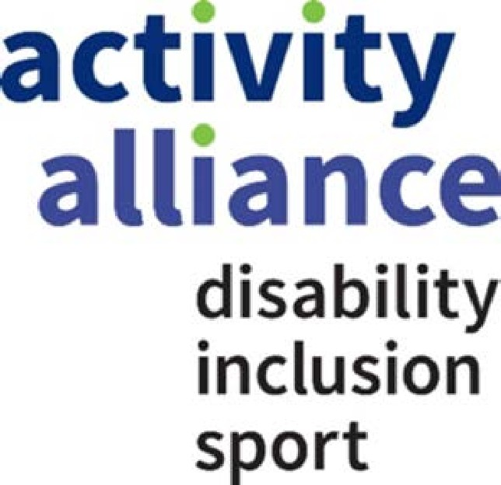

Privacy Notice

Privacy Notice
Who we are
We at Activity Alliance want to make sure all the personal details we hold about you are safe and secure, so we have put together this note to tell all anyone who is participating, peer mentoring or volunteering in one of our events or programmes how we make sure we just do that and what to do in case you have any questions for us or want to see what information we have.
We are, what is known as, a data controller. This means we have control over how your details are used and who we pass them to. This document explains when, why and how we collect personal information from you.
Where we have told you that we are acting as a ‘joint controller’ with a third party such as local partner for a particular event, any reference to ‘we’ in this notice will include a reference to them as a joint data controller, but Activity Alliance will remain the key contact.

Sometimes organisations need to appoint an individual called a Data Protection Officer to make sure that we are being very careful with your information.

Activity Alliance doesn’t need to have Data Protection Officer, but we have decided to put together a team of people instead to make sure your details are safe. They can be contacted at info@activityalliance.org.uk in case you have any questions.

What type of personal information do we collect from you?

- Your name
- Address
- Telephone numbers
- Email addresses
- Date of birth
- Your gender

- Information about who to contact in an emergency
- How you use our website and any passwords, usernames and other things that may identify you to us online
- Videos and photos of you
- Records that tell us when you were at our events
- Records of when you contacted us or we contacted you on the phone or by email or when you asked us something
Special information

We will also hold and use what is called “special information” about you, but we will only use it if we have a really good reason to do so such as where the law allows us to or you have told us you are happy for us to use it. This may include:

- Information about your race or ethnic background
- Information about ill-health or injury
- Information about a disability or long-term health condition
- Information about any time you have been in trouble that impacts on your relationship with us

When you volunteer at one of our events…..

…. Sometimes we may also collect the following:

- Your performance including any feedback provided to us by yourself, members of staff or other third parties
- A record of any jobs you have had or any work you have done as a volunteer, including details of the place you have worked or volunteered
- Copies of your identiﬁcation documents. Such as your passport or other ID cards

- All the information you gave us when you applied to be a volunteer, or work with us

- Details of the people we may ask to check that information you provided to us when you applied to volunteer with us

- The places where you have previously volunteered

When you take part in a sports event……

….. we may also collect:

- Copies of your identiﬁcation documents such as your passport other ID cards
- Your age, classification or sports grouping
- Records of whether you play at club, county or national level
- Records of your rankings and competition results, details of events you have attended and how well you are performing on any development programme you are on

How we collect personal information from you

We may collect personal information from you either directly or through one of our local partners when you apply to be a volunteer, peer mentor and/or take part in one of our programmes, events or charity campaigns.
We may also collect information when:

- You get in touch with us by phone, email, letter or social media.

- When you ask a question or make a complaint

- We may get information about you from other people or organisations that you volunteered with in the past or from any feedback provided to us about your performance as a volunteer/peer mentor.
- If you are providing us with details of referees, next of kin family members and emergency contacts they should also know what personal information we hold about them so please pass this privacy notice onto them too.
What do we do with your personal information?

There are many ways we will need to use your personal information. We will only use your personal information when the law allows us to and some of the main uses and reasons why we need to use it are set out below.
- To register you for an event and make sure the event you are taking part in or volunteering for runs smoothly
- We need to use your information to decide whether to appoint you as a volunteer and to manage the appointment process. It is in our interests ensure that our volunteers are suitable for the role.
- Where you are a volunteer, we may need to carry out some checks on you to make sure we can work together. This is in our interests, and in some cases we may be legally required to do so where you are working with children or vulnerable adults
- Where you are a volunteer and not yet 18 we may need to ask permission from your parent/carer to make sure you are allowed to participate.
- If you are a volunteer we will access your performance as it is in everyone’s interests to ensure your suitability for any future volunteering roles and to ensure that your volunteering experience with us is positive and worthwhile
- We may need to collect certain information about your physical or mental health (including any injuries) or disability status, to make sure we comply with health and safety laws so it is safe for you to attend our events and to provide appropriate adjustments to our facilities
- To help you if you have a question or you are not happy with something we have done. It is in our interests to make sure we deal with any issues you have quickly
- To help train our staff. This will be in our interests to make sure they deliver the high standards expected
- We may need to pay you for any out of pocket expenses if you are volunteering with us
- Where you have told us you are happy for us to do so, we may use images of you to promote our events and programmes and the work we do and to recognise the value created by our volunteers across the network
- We may need to collect some personal information for the purposes of equal opportunities monitoring. It is in our interests to make sure we provide you and others like you with the same opportunity to get into sport no matter who you are and where you come from
- To obtain any references from other organisations you have worked for or with. This will be in our interests to make you are suitable for the role and we may also be legally required to do this
- To conduct data analytics and analysis studies to review and better understand trends and to report to our external funders and evaluation experts. This will also be in our interests and we may also have a legal obligation to do this. We will anonymise and aggregate the personal information before sharing any reports
- To send you information we think you might find useful or which you have requested from us, including our monthly newsletter, event specific newsletter, our weekly media alerts for members, information about volunteering opportunities and other ways of supporting our organisation provided you have said you are happy for us to do so
- We will keep all of your details on our files. It is in our interests to hold your details on file so we can deal with any issues quickly and to make sure we do a good job in managing our relationship with you. Sometimes we may have to keep your details because the law tells us we have to.

Special information

Where we use any ‘Special Information’ about you for the above reasons, we will also make sure that we only use it if either:
- you have told us you are happy for us to use it;
- it is in the interests of the public and we have a lawful reason to use it;
- we need it to help us with a legal case we are involved in; or
- certain laws allow us to use it.

Who can see your personal information?
- We store your information securely to protect it against loss and misuse.
- We keep your personal information private and only share your personal information when we really need to.
- Your personal information is only shared with members of Activity Alliance staff that need it to see it.

We may pass your personal information on to:

•

- Anyone you have said you are happy for us to send your details to
- Service providers such as information technology service suppliers like Upshot or our marketing and research specialists who help us send out our newsletters to you
- Future organisations that you may wish to volunteer with

- Third parties that process personal information on our behalf such as organisations who help us to carry out data analysis of our events
- Funders of our programmes such as Sport England for reporting and evaluation purposes (but we will make sure you cannot be identified from this information before we disclose it)
- Sponsors of our events and programmes for promotional purposes (but only if you are happy for us to do this)
- Our legal and other professional advisers, including our auditors
- Governmental bodies, HMRC, regulators, police, law enforcement agencies, security services, courts/tribunals.
We will not share it with anyone else.

Will your data be transferred internationally?

Did you know that all ‘data controllers’ based in the European Union and the UK like us are subject to laws that make sure that your personal details are safe?
Sometimes the people who we share your personal information with may be located outside of the UK and European Union. Where this happens, we will do everything we can to make sure that your details are only used in the way we say they will be and are kept secure.
How long do we keep your personal information for?

We only hold information about you for as long as we need to. Unless the law requires us to, generally we won’t keep personal information about you for longer than 6 years after you were last in contact with us.

Your key rights

You have the right to:

- Be told about how your personal information is being used
- See the information we have about you

- Ask us to make any changes to the personal information we hold about you, if it is wrong

- Ask us to delete certain personal information unless we have a good reason to keep it

- In some cases, ask us to limit processing information about you

If you have told us we can use your information in a certain way and you would like us to stop, you can tell us to stop at any time and you can always tell us to stop sending you marketing messages.
More information about these rights can be found online here https://ico.org.uk/for-the-public/
Keeping your personal information up to date

We want to make sure your personal information is up to date. If any of your personal information has changed, please contact us and let us know as soon as possible. We do change and update our privacy policy, so please make sure you check our website for any changes or updates at www.activityalliance.org.uk/privacy

If you have any questions about these changes or updates or are not happy with the changes or updates, please contact us using the details below to let us know.

How can you get in touch?

If you have a question or a complaint, you can always get in touch with one of our team using the details below:

Email: info@activityalliance.org.uk
Telephone: 01509 227 750
Post: Activity Alliance, 3 Oakwood Drive Loughborough LE11 1PN

Charity number: 1075180

This privacy notice was updated on [12] November 2020

