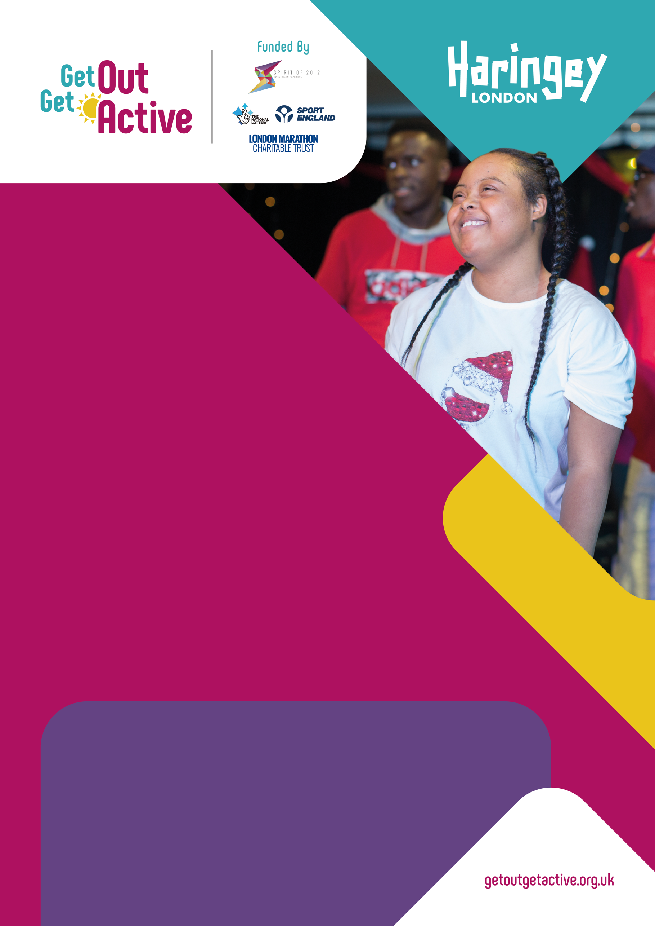

Developing
inclusive leaders
in Haringey
Research with activity deliverers
and participants: increasing
opportunities for disabled people
to be active and take on delivery roles.

Research report
February 2023
Research conducted by Activity Alliance
through their Get Out Get Active programme
in partnership with Haringey Council.

Contents
1. Introduction 3
2. The research 4
2.1 Research aims 4
2.2 Research methods 4
3. Research findings 5
3.1 Developing community leaders in Haringey 5
3.2 Key qualities and skills of community leaders in Haringey 7
3.3 Supporting deliverers to provide inclusive experiences for participants 11
3.4 Creating inclusive environments 15
3.5 Encouraging and supporting disabled people into the physical activity workforce 19
4. Recommendations for developing inclusive leaders 24
4.1 Recommendations for the Council 24
4.2 Creating an inclusive workforce 25
5. Further reading and resources 26
6. Thank you 26

Introduction

Background
We know that both disabled and non-disabled people prefer being active together. But disabled people often have lower participation and enjoyment of physical activity. Disabled people are underrepresented among the people working in the sport and activity sector: only 22% said they see ‘people like me’ working in sports and physical activity roles. However, there is strong interest from many disabled people in taking on paid and voluntary roles. In Haringey, there are many successful initiatives and individuals who have led the way in improving representation, engaging disabled people, and helping everyone can be active together.

This research report explores the development of leaders in inclusive activities, and how more disabled people can be encouraged into the workforce. We produced other resources from this research and will continue to build on the insight to support other organisations.

Get Out Get Active (GOGA) is a UK wide programme that supports disabled people and non-disabled people to enjoy being active together. It was launched in 2016 and funded by Spirit of 2012 with further investment from Sport England and London Marathon Charitable Trust. For more information visit getoutgetactive.co.uk.

Guided by Activity Alliance, GOGA was initially delivered in 18 localities and now works with partners in 21 localities across the UK. Activity Alliance's Ten Principles underpin GOGA projects to make activity more appealing and accessible.

GOGA Haringey, led by Haringey Council, work with local delivery providers to engage young people in the most deprived parts of the Borough. This research was funded by GOGA and Haringey Council. It was conducted by Activity Alliance in partnership with Haringey Council, from August to November 2022.

Definition and language notes:
- In this report, the term ‘inclusive activity’ means disabled and non-disabled people taking part in physical activity together.
- By ‘disabled people’, we mean anyone who has an impairment or long-term health condition that affects their ability to do normal daily activities.
- By ‘deliverers’, this means people who deliver sport and activity on the ground, from coaches, instructors, and teachers to volunteers.
- By ‘leaders’, we mean they were not directly delivering activity, but were leaders in the community or stakeholders to GOGA or the Council.

The research

2.1 Research aims
The research explored how future opportunities to be active in Haringey continue to provide quality experiences for disabled people.
- Understand the qualities, behaviours, and attitudes of key deliverers and community leaders in Haringey.
- Explore how these, and other factors, can create an inclusive environment for disabled participants and deliverers.
- Determine how Haringey Council can encourage the development of inclusive environments, and identify, promote, and support future inclusive leaders.

2.2 Research methods

Desk research review:
- Existing resources and evidence were reviewed to inform the design of the research materials. This included Activity Alliance research, GOGA and Inclusive Activity Programme learning, and resources on employment for disabled people.

Qualitative interviews:
- Qualitative interviews were undertaken online with 10 activity deliverers and stakeholders in Haringey. The interviewees were recruited through Haringey Council’s networks. Two interviewees defined themselves as a disabled person.
- The interviews were used to explore the research aims and inform the development of the surveys.

Surveys:
- Activity deliverer survey - 13 respondents took part in the survey. Two respondents were disabled, and half were involved in the GOGA programme.
- Activity participant survey - 111 respondents, 19 were disabled people.
- Similar questions were asked to both deliverers and participants to enable comparison and combining of data. In addition, there were specific questions to each group of research respondents.
- The survey respondents were recruited through Haringey Council’s networks and promoted on social media.

Site visits:
- Activity Alliance attended two activity sessions, identified as leaders in inclusive delivery in Haringey, to observe sessions in action and to have informal conversations with organisers, coaches, volunteers, and participants.

Co-production workshops:
- Two online co-production workshops were conducted with activity deliverers, community leaders and disabled people.
- The workshops shared and discussed research findings, recommendations and ideas for resources or tools. This enabled research participants to direct the recommendations and resources from the research.

The small sample size is a limiting factor in this research. Despite this, importantly the data and evidence are mainly consistent across research methods. The qualitative data was thematically reviewed, with supporting data from the surveys where relevant.

3. Research findings

3.1 Developing community leaders in Haringey
There are various factors and key events that influence and impact a community leader’s development into their role in inclusive activity.

The most common ways that deliverers and leaders first became aware of inclusive activity were:
- Experience from previous work or volunteering.
- Experience from local communities.
- School, college, or university education.
- Lived experience.

Less frequently, deliverers became aware of inclusive activity through seeing or taking part in inclusive sessions themselves, childhood experiences or the internet or social media.

Experience from previous work or volunteering
Experience from previous work was the most common factor, which includes working or volunteering in sport or the local community. Leaders had backgrounds in different sport and physical activity sectors, as well as non-sport backgrounds such as education, local councils, or marketing. During their careers, many had achieved formal qualifications in sports such as gymnastics, basketball, or tennis. For some, this included playing sport professionally. Participation in activities, whether playing professionally or as a coach, led to a desire to share their experience, knowledge, and skills.

“I played for the England team when I was 21. It was new, it was fresh - I wanted to impart the knowledge I had as a youngster, so I started coaching very early.” (Deliverer, interview).

Previous work and volunteering roles helped deliverers and leaders to seek advice, learn and develop their understanding of inclusivity and adapting activity:

“When I was working with my colleagues in that setting, the advice they gave me was ‘It is like no other session’. All you need to do is to adapt the session sometimes just to ensure that everyone gets the same opportunity.” (Leader, interview).

Working with and learning from others is one of the most important ways deliverers become inclusive leaders. Previous experience working with disabled people, in the community, health-based work and in education was also common. This work instils organisational values of inclusivity, accessibility, and equality into individuals.

Career backgrounds provided interviewees with knowledge, understanding and networks to assist in developing their organisations and projects. Some interviewees spoke of working extensively in a voluntary capacity when setting up their organisations or projects, before obtaining funding.

Strong community connections and relationships
Community connections are an important factor in deliverers’ and leaders’ development. This includes growing up, living, and working in the community, using local facilities and centres, as well as being from a shared cultural and heritage background, such as African Caribbean culture. This creates shared understandings, connections, and relatability.

“We can relate because from ancestral lineage. That is what Haringey represents - it's different people with so many cultures.” (Deliverer, interview).

Several interviewees had positive relationships and strong connections with Haringey Council. In particular, the Active Communities team. This was perceived as important to their own development in becoming leaders in inclusive activity.

School, college, or university education
Positive experiences of sport and physical activity through supportive and inclusive education was important, especially for disabled deliverers. Another example is the influence on non-disabled deliverers who attended school or college with disabled people.

“In the college, we always had a special needs unit. And I found sports with something that cut across some of that.” (Deliverer, interview).

Experience of education alongside and inclusive of disabled children helped to build awareness of different abilities and an understanding of adapting approaches, communication needs, and inclusive principles. This contributed to a positive image and understanding of disability, and inclusivity.

Lived experience of disability
Lived experience was very influential and important for deliverers in the qualitative interviews. This includes being disabled themselves, having family who are disabled or having a family member working with disabled people. This personal connection and/or childhood experience of disability instils awareness and positively impacts a deliverer and leader’s development from an early stage.

3.2 Key qualities and skills of community leaders in Haringey
The attitudes, behaviours, and skills of inclusive activity deliverers were explored with interviewees and in the desk review, which provided lists for the surveys.

From the interviews, site visits and co-production workshops, it is evident there are different types of successful inclusive deliverers and leaders, not one profile. Not all leaders will have strengths in all areas.

“You can’t expect deliverers to do everything, to be good at everything – so they can focus on what they are great at, coaching, delivering, people skills, not the managing or networking.” (Leader, site visit).

Combining data from both the deliverer and participant surveys (Figure 1), indicates the most important qualities are:
- Trustworthy
- Patience
- Enthusiasm and passion
- Open-minded
- Empowering and motivating
- Empathy

Figure 1: Proportion of deliverers and participants selecting each quality as ‘very important’ for leaders in inclusive delivery
Question: How important do you think each of these qualities are for leaders in delivering inclusive activity? Base: 10 deliverers and 104 participants (114)

Previous GOGA learning largely supports this list, with alignment on top values like being enthusiastic, empowering, and encouraging.
- ‘Being bold and creative’ was seen as less important in this research than in previous GOGA learning.
- Being ‘open-minded’ provides a similar value, as interviewees discussed using new approaches and new ways of thinking.
- ‘Patient and trustworthy’ was viewed as more important in this research, highlighting the importance of these values in Haringey.
- Connections and understanding of the community were less often chosen as important.

As shown in Figure 2, the skills that were most often chosen as important by deliverers and participants in the surveys were:
- Communication
- Able to adapt to different needs and abilities
- Coaching skills
- Safeguarding
- Disability awareness
- Preparation and planning

Figure 2: Proportion of deliverers and participants selecting each skill as ‘very important’ for leaders in inclusive delivery

Question: How important do you think each of these skills are for leaders in delivering inclusive activity? Base: 10 deliverers and 104 participants (114)

Adaptability, patience, planning, and disability awareness
The ability to adapt activities effectively to suit different situations and individual needs was emphasised as the most important quality, behaviour and skill for inclusive activity deliverers and leaders.

“When we teach, our format is flexible. It will develop depending on who is in front of us.” (Leader, interview).

The deliverers and leaders we spoke to have a strong understanding of how to adapt physical activity and embraced inclusive approaches. This was demonstrated by being positive, celebrating differences, open to changes, as well as being realistic about individual needs and experiences of the session.

“I prefer mixing [disabled people and non-disabled people]. I am always saying to myself: I am [interviewee name] – I am adapting to a mainstream society.” (Deliverer, interview).

Deliverers linked their ability to adapt activities to other qualities, like patience – and skills in disability awareness and preparation and planning.

Disability awareness included being aware of types of impairments, the barriers disabled people face in life and in physical activity, such as venue or facility access, transport and logistics and accessibility issues.

“People working in these activities should inform themselves about a variety of disabilities, shadow someone for half a day. Do not ask intrusive questions unless you have a relationship – “what happened to you?” Is not a good question “how can I best support you?” is better before you make assumptions. Look at your spaces and the routes to them and between them – can I get to the toilet? How are things online? Tell me as much as possible, show me pictures.” (Disabled person, survey).

Preparation and planning, includes planning appropriate ways to adapt certain sports or types of activities, and planning support such as sign language interpretation.

“You have got to see what is working well. Or if it is not working well, being willing to change. So, it is being able to think and adapt quickly. And anticipating what barriers might be and building that into your plan.” (Leader, interview).

Communication and understanding
Effective communication, listening and observation skills are vital skills and behaviours is vital, this includes using and understanding different types of communication and learning styles.

“It’s that understanding – it helps you to deliver the format or learning that is right for the person in front of you.” (Leader, interview).

Understanding and communicating are important skills that benefit everyone attending a session. Examples given in the interviews and co-production workshops were:
- Knowledge of different communication needs or preferences, such as speed of speech and sign language.
- Proactively asking for support or access needs.
- Positive communication to encourage participation.
- Understanding communication needs of people with profound or complex impairments.
- Communication with people whose first language is not English.

Communication skills enabled deliverers to be empathic, more open-minded, and willing to learn, with less concerns about delivering to disabled people.

Passion and enthusiasm
Passion and enthusiasm in involving and coaching disabled people and empowering them to develop and achieve are important qualities. This includes being passionate about sharing their knowledge, building support for inclusive activities, and having enthusiasm and focus to include participants and enable them to succeed.

“I love seeing them pick up their medals. I love seeing them achieve and I love seeing them build confidence.” (Stakeholder and leader, interview).

“It is a special needs school with children with visual impairments and wheelchair users. That is my main passion - to go to those kids because they are lovely, and they just love sport. I love going there to deliver sports and to see the joy on their faces.” (Stakeholder and deliverer, interview).

Empowering and motivating
Effective deliverers understood their role in empowering and motivating participants. This could be through encouraging personal development, life skills, sport skills, or achievements in competitions or events. Deliverers aimed to instil confidence and self-belief. For community leaders, they used their own background, leadership skills and professional experiences to provide a positive role model to young people in their sessions. Some deliverers proactively provided opportunities for development, like mentoring or pathways to coaching roles to empower participants.

“Once you make them feel confident that they are able to take part - the only way you can do that is by going into the schools, putting the same coaching regularly, coaching the youngsters giving them self-belief.” (Leader, interview).

Deliverers also valued collective approaches to leading and delivering sessions, where deliverers encourage sharing of responsibilities and involve participants within delivery.

Community connection
Community connection and responsiveness to the needs of the community was frequently identified as a key quality in the interviews (though was less prominent in the survey). This includes:
- Designing projects, sessions, and support on the needs of the local audience or target group.
- Continually using co-production approaches or acting on feedback to deliver most needed activities.
- Building connections and familiarity over time with local people, services, and groups to build trust, engagement, and relationships. This improves community cohesion and means deliverers can use their local knowledge when planning activities.
- Signposting and connecting people to other relevant and trusted local sports or community organisations.
- Professional connections and involvement in relevant committees and groups.

Encouraging future deliverers and leaders
Understanding and promoting these qualities and skills will help develop future leaders in inclusive activity. These can be used to identify potential candidates for delivery roles and for leaders to use when supporting volunteers or people new to their roles.

Interviewees emphasised that people need time, opportunities, and support to develop these qualities and skills. This was often related to organisational capacity, and a need for more funding and resources. Leaders said they knew many potential candidates for great future deliverers of inclusive activities in Haringey, including disabled people, but it is difficult to sustain their involvement without more defined roles or rewards.

“It is easy to find good people who have skills to coach - it is harder to sustain them. We lost a lot during the pandemic. It is the low wages, even if you have lots of skills, or years of experience. We need to have higher wages and a clear progression path.” (Leader, site visit).

3.3 Supporting deliverers to provide inclusive experiences for participants
Experience of support and training, and future preferences were explored with interviewees and in the survey.

Experiences of support and training
Most interviewees had not received formal training or support, on their inclusive activity journey. Instead, they focused on the value of informal training, and learning ‘on the job’. This included:
- Observing others
- Volunteering
- Learning from colleagues
- Working with disabled people or having disabled friends or family
- Doing their own research.

For those who had accessed formal training, this was most commonly from an educational course or professional body.

Preferences for future support
The most preferred forms support people delivering inclusive activity require are:
- Support with funding and resources
- Connections with other sports and activity organisations
- Examples of good practice.

Other types of support mentioned included peer support networks, mental health or wellbeing support, career development and progression, and mentoring / advice.

Funding and resources
For types of support, all deliverers and leaders spoke about funding from different sources, including:
- Sustainable and longer-term funding.
- More funding for smaller / grassroot organisations.
- Comprehensive and flexible funding.
- Reward successful and quality provision.
- Help others to replicate or scale-up quality delivery.

“Grassroots organisations need funding to grow and develop, to get the support that they need and help them understand how you do things, and then they can support you.” (Leader, interview).

“I am very critical of some governing bodies because they get funding… and by the time it reaches grassroots organisations, not a lot is left.” (Leader, interview).

Organisations need to be able to obtain funding that covers different aspects of a project, not just activity delivery. This includes funding for preparation, engagement and promotion, resources, sessions, venues, post-session activities, and staff and support staff wages. Many interviewees voiced that shorter-term sport projects have less impact. The needs of participants can vary and may change beyond the initial funding requirements.

“You are being driven by the funding, not driven by participants.” (Leader, interview).

“The one thing I hate, is you give the youngsters a taste of something, then there’s no follow up.” (Leader, interview).

For small organisations, they can be restricted in what they can apply for, despite a need for their work. The policies, processes, requirements, and time constraints of funding applications were perceived to hinder inclusive activities. Newer organisations may particularly benefit from support with writing funding bids and awareness of available funding.

“Small amounts of funding are available which means you can’t reach the number you want to reach. The quality of what is being delivered is important. Funding should reflect the quality of what’s being delivered.” (Leader, workshop).

Some deliverers highlighted the positive work being done, and felt frustrated this could be limited by funding, particularly when inclusive activities required more money than mainstream activities.

"We are lucky to have facilities, skilled and knowledgeable people, therapists on hand who are great. We took on provision workers who got experience through volunteering, they were young and did a fantastic support job. The community were blown away by how they worked. Haringey is a strong community. I agree that quality is key, but this comes with need for funding. Sometimes staff are costly because they are so good. If you want to expand, it gets stopped by money." (Leader, workshop).

“It is important to recognise that inclusive work does not just happen. It comes at a cost, and it is more expensive to do inclusive work.” (Stakeholder and deliverer, interview).

"As a young person doing a lot for the community, I found it frustrating being in Haringey because it was always about lack of funding. We see other boroughs doing lots of training or workshops and getting paid for it, why can’t we do this?" (Disabled person, workshop).

Working with and connections with others
Deliverers requested support in making connections and learning from others:
- This will enable sharing information, experiences, skills, and knowledge.
- It utilises local and wider community connections, such as sport and physical activity organisations, disability organisations, education, health providers, local authorities, transport, private business, parks and green spaces and leisure providers.
- Learning from participants and disabled people’s lived experiences.
- It can provide mutual support, helping deliverers discuss issues and problems.
- A support network for inclusive deliverers was indicated as potentially useful. For disabled deliverers, a specific support network could help to share experiences and connections.
- Many interviewees spoke of positive relationships with the Active Communities team at Haringey Council, being approached directly by the Council to deliver work, such as GOGA, and receiving funding for specific projects.

Deliverers gave examples of ways that this support could be provided: a method of sharing successful projects, a database of organisations providing inclusive activities, examples of good practice, stories, case studies, a forum for informal discussions, as well as formal networking and partnership working.

Preferences for future training
Interviewees preferred informal training to develop knowledge and skills, though formal training was still valued and provided credentials and professional development. Some recognised that training delivered by disabled people themselves would have more impact, as well as training that showed clearly how to implement learning in their sessions.

The most useful training topics were:
- Adapting sports and activities for different impairments.
- Promoting to and engaging with disabled people.
- Disability awareness.
- Getting funding or resources.
- Accessible communication and formats.
- Co-production.

Less often chosen training topics were engaging with carers or families, building rapport or connections, changing attitudes about disability, and leadership.

When asked what formats for training or tools would be useful, deliverers choose:
- Principles to develop an inclusive workforce.
- In-person training.
- Personal stories.
- Step-by-step guides.
- Job description or profiles.

Less often chosen formats were online training, webinars, and videos.

Adapting activities and disability awareness
The most useful topic to support the development of future inclusive leaders was training on adapting activities for different impairments and ability levels, and inclusive principles. Leaders discussed the importance of making sure more deliverers had the right skills and experiences to provide quality inclusive experiences.

“Unless clubs actually try to develop coaches – so supporting to go to special needs schools or had children with special needs come to their sessions, you'll never going to break the mould.” (Stakeholder, leader, interview).

There is also a need for more specific adaptability training that covers communication and language needs. For example, learning about language, non-verbal communication, British Sign Language, and Makaton. Increasing disability awareness, including knowledge on the social model of disability and accessibility audits, was also identified as important for future deliverers.

“People delivering should learn about the social model of disability and micro-aggressions.” (Disabled person).

3.4 Creating inclusive environments
‘Inclusive environments’ refers both to physical aspects and human aspects of a place or space. This environment helps more disabled people to be active and could help more disabled people feel comfortable taking on responsibilities and roles. In the surveys, we asked participants and deliverers to use three words to describe a place where they feel welcome and included (Figure 4).

The most often used words are shown below in descending order.
- Friendly
- Inclusive
- Safe
- Fun
- Welcoming
- Open
- Free
- Clean
- Accessible.

Figure 4: Words used to describe an inclusive environment
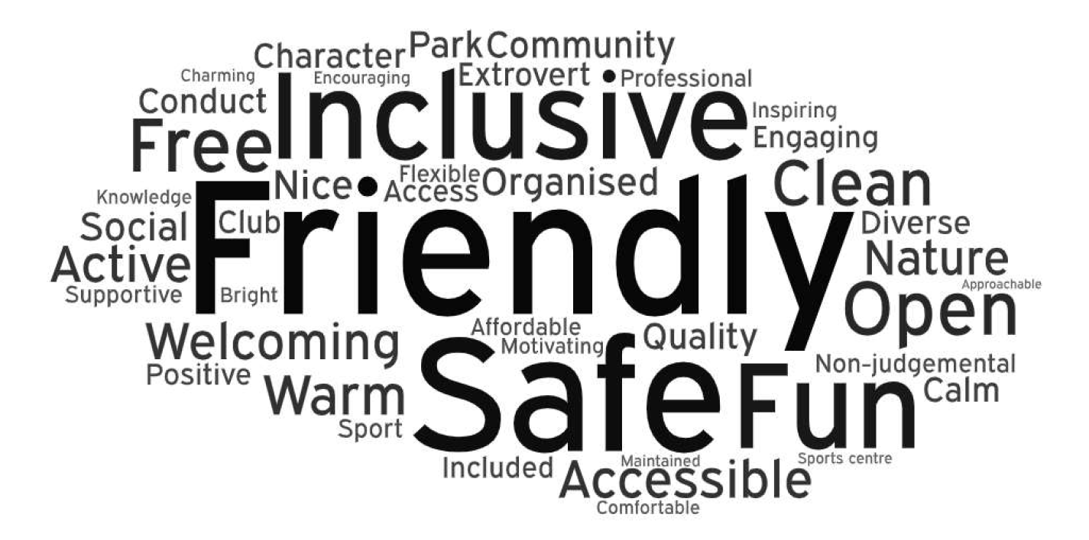
Question: What three words would you use to describe a place to be active where you feel included and welcome? Words shown had 2 or more mentions. Size is relative to the number of mentions. Base: 102 participants and 8 deliverers (110)

Barriers to providing inclusive activities
Inclusive activities, where disabled and non-disabled people take part together, are preferred by most people, regardless of whether the person is disabled or not. The organisations and people involved in this research demonstrated many examples of positive practice and have benefitted many people across the borough.

This research investigated how other organisations, or deliverers, may be prevented from delivering more inclusive activity opportunities (Figure 5). The most commonly chosen barriers were perceived to be:
- Lack of knowledge about physical activity.
- Lack of access to facilities.
- Lack of funding.
- Lack of confidence about adapting physical activity.
- Lack of training for deliverers or coaches.

Figure 5: Barriers for organisations offering inclusive activities

Question: What do you think stops other people or organisations from offering activities where disabled and non-disabled people take part together? Base: 88 participants and 9 deliverers.

Good practice in delivering inclusive activities
The interviews explored what has made the inclusive activities in Haringey so successful. There were three main factors:
- Accessibility, communication, and engagement
- Integration and inclusion
- Support and involvement.

Accessibility and engagement
Understanding and meeting needs appropriately was key to success. Deliverers used their skills, values, and knowledge of disability and inclusion, to design activities that meet the needs of the least active in the Borough. Each project considered the venue and facility’s accessibility from a physical access point of view, as well as needs such as travel or cost. Some interviewees thought Haringey could benefit from more secure venues with longer-term access.

“People have got to have a real passion about something to attend it. Especially now post-COVID, it is even harder to get people truly engaged. More background effort must be put into projects before they are set up and delivered.” (Stakeholder, interview).

Engaging effectively with participants has been recognised as a key factor in the success of activities. Deliverers were able to connect and communicate with local communities and partners and utilise effective marketing to inform and attract target audiences.

“The key first of all, is for people to be aware of what they can access and how to access it.” (Stakeholder, interview).

Integration and inclusion
The people running the sessions involved in the project understood the importance (and the value) of proactively bringing together disabled and non-disabled young people together. Deliverers spoke of how they adapted environments or delivered sessions to provide positive experiences for all.

“People with disabilities and those without can actually work together and quite easily, and that can be facilitated. It takes a bit of thought and a bit of awareness, but it can happen and successfully as well.” (Stakeholder, interview).

“We just work with a big group of people where everybody’s different and everybody’s difference is there and is unique. And then we allow those people to shine.” (Stakeholder, interview).

Some leaders highlighted the importance of giving opportunities to participants to take more ownership and responsibility. Either during sessions or through volunteering or work to encourage them to grow as individuals.

“I have some kids who work here…he comes in and helps restock shelves and things. Hopefully we will get him maybe doing some serving on the counter. (I think people straight away recognised he is slightly different) but he's here and he's working and he's getting involved.” (Stakeholder, interview).
“I'm not saying everyone likes sports, but there are common themes of leadership, communication, motivation, and teamwork. We bring these to the young people through the projects that we run without them actually realising. Those are the fundamental key learnings that we're teaching them. So, when they start to communicate, their tone of communication starts to change.” (Stakeholder, interview).

Support and involvement
Another factor for success was enabling people to be involved in the activity in their own way and providing appropriate support. This is achieved by knowing the importance of providing support, and understanding the experience and barriers faced by disabled people when being active.

“Knowing how to support and knowing when to support and knowing when to be supported within this game. It lends itself to everybody being able to be involved without having to fear ‘Oh, I can't play as well as somebody else’.” (Leader, interview).

“I would say to people: ‘look, by the time that person has got to you, do you realise how much stuff they've had to overcome from finding out about you, getting through the door, then getting into the classroom?’. It is huge. People go, ‘Oh, yeah I never thought about it’.” (Leader and stakeholder, interview).

Capacity is needed to provide that support proactively. This can be support from assistant coaches, support workers, volunteers, parents, or other participants.

“If they come with support or they don't come with support and they're able to sort of, even if it might take hard work from some of the assistant coaches – but you get them active.” (Deliverer, interview).

"It’s our job to open kids up to activities and show parents that it’s ok. Parents are often very worried and do not know what can/can’t be done. We always have enough staff on if something does not work out. Our role is to challenge the parents as much as anything in terms of attitudes." (Deliverer, workshop).

Deliverers and leaders understood that sport and physical activity supports people’s physical and mental health and has social and community benefits. They used sport and physical activity as a learning tool, for example - imparting motivation, leadership, communication, and teamwork skills.

The Council’s role in creating inclusive environments
When deliverers and participants were asked in the surveys what the Council and other organisations should focus on (Figure 6), the most chosen responses were:
- Accessible facilities and equipment.
- Changing attitudes about disabled people.
- More capacity and resources.
- Sustainable funding.

Figure 6: Areas the Council should focus on to create inclusive environments
Question: What do you think the Council or other organisations could do to create environments where disabled and non-disabled people can be active together? Base: 87 participants and 8 deliverers (95)

3.5 Encouraging and supporting disabled people into the physical activity workforce
This research examined the barriers that prevent disabled people taking on roles in the sport and physical activity delivery workforce, and what support is needed to enable them to become part of the workforce. This section emphasises the voices of disabled people, but also includes the views of non-disabled delivers and leaders who are experienced in working with and supporting disabled people, so can contribute understandings and insight towards disabled people’s valued experiences.

There was strong support for a more diverse workforce, and for encouraging more disabled people to take on leadership roles. There are some similarities with barriers and support between disabled people in the delivery workforce and participation within activities.

Barriers for disabled people working or volunteering in sport and physical activity
There are many barriers that can prevent disabled people from having equal access to become part of the activity delivery workforce. Combining the data from the deliverer and participant surveys (Figure 3), the most commonly chosen barriers are:
- Physical access barriers
- Inaccessible venues and facilities
- Transport and travel
- Lack of support workers, personal assistants.

This chart shows data from non-disabled and disabled people, with a higher proportion being non-disabled people.

Figure 3: Proportion choosing each barrier to disabled people working or volunteering in sports and physical activity

Question: What do you think are the main things that stop disabled people from working or volunteering in sports and physical activity? Base: 8 deliverers and 85 participants (93)

When compared to all responses, as shown in the above figure, disabled people were more likely to say a lack of support workers or personal assistances (63%), finances / lack of money (63%) and communication barriers (56%) prevent them from taking on roles in sport and physical activity. Disabled respondents who were interested in becoming part of the workforce gave additional reasons why they had not explored opportunities; a lack of time to take on new roles or volunteering, inadequate pay and not knowing about training or support.

“I would need professional training and adequate pay delivering this role. Many people have a full time or part time job and are not able to comply with extracurricular activities due to their financial commitments.” (Disabled person, survey).

Physical access barriers
Physical access was viewed as a common barrier for disabled people taking on roles delivering activity. This includes physical access to facilities, venues and clubs and access to buildings, doors, lifts, specialist equipment and storage for equipment.

Negative perceptions
Negative perceptions about disability prevented many disabled people from accessing roles. Respondents spoke of worries about having to experience, address or manage other people’s attitudes, concerns, and expectations (both colleagues and participants).

“It’s ignorant people working in these spaces [stops disabled people from taking on roles].” (Disabled person, survey respondent).

“Negative connotations around disabled people being incompetent at a task or skill.” (Disabled person, survey respondent).

“It is getting over that initial barrier. Whether they are confident enough that if somebody does say something that is unkind, that they can cope with that. So, giving them the tools to be able to be strong enough to cope with those situations.” (Leader, interview).

Attitudinal barriers, of experiencing and dealing with other people’s expectations and belief can be a barrier for disabled people’s participation in the workforce.

Lack of confidence
Not having confidence or self-belief can derive from lack of support, encouragement, and opportunities that disabled people can experience throughout their life. This can be from family and friends as well as colleagues, support workers, teachers, or deliverers. More positive support and role models provide inspiration, motivation, and encouragement for disabled people, which builds confidence.

"Lack of confidence is a big thing - people delegate to someone else. Depends on your past experiences, someone telling you that you can’t do something. This could be motivation, but for others, it impacts negatively on their life. We need an opportunity to show people that we can do this." (Disabled person, workshop).

"A lot of disabled people don't get involved because the effects of their disability prevent them from doing so many things. They don’t feel as though they can contribute 100%, so feel like they might let people down. To help this – we need support from the organisation, this would be individual for the person." (Disabled person, workshop).

Communication
Communication and language barriers are also prevalent. Disabled people can experience difficulties accessing communication, understanding, and learning during activity sessions, and also when they go on to being part of the delivery. Communication barriers can prevent disabled people from accessing activity delivery training and then from delivering actual sessions.

Transport and support workers
Difficulties accessing public transport and support for travel can affect some disabled people, as well as availability and costs for support workers or personal assistance. This can prevent more disabled people working or volunteering. There may be additional concerns about transporting equipment for physical activities.

“That person has to hire a carer or has transport issues - they should be paid for their time like anybody else.” (Stakeholder, interview).

"Transport and travel are a huge barrier - it has to be part of the preparation and planning of any activity." (Deliverer, workshop).

Supporting disabled people into delivery roles
This research identified ways to address these barriers, to support and encourage disabled people into the activity delivery workforce. This includes how disabled people become aware of these roles and how they access them:
- Providing and promoting opportunities.
- Role models, peer connections and representation.
- Practical and logistical support to attend training and development opportunities and also deliver sessions.
- Building confidence and responsibility.
- Person-centred learning styles to suit individuals.
- Pathways for delivery or leadership opportunities.

Many interviewees spoke of providing access to work experience, volunteering, and training opportunities, with appropriate support. According to data from disabled survey respondents 47% of disabled participants have been offered the opportunity to become involved with volunteering or delivering activities in Haringey. A higher proportion of disabled respondents, compared to all respondents, are interested in becoming an inclusive activity deliverer, as 53% are definitely interested and 20% are interested but would like to know more.

Disabled respondents indicated that other types of support would help them take on roles:
- Access to professional training, education, and qualifications.
- Access to more experiences to develop confidence and skills.
- Support with adequate funding and paid roles.
- Support with communications and advertising.

Providing and promoting opportunities
Encouraging ongoing involvement in physical activity settings is vital to demonstrating the opportunities available, and for establishing interest in delivery roles.

“Once you've introduced the activity to them, then make them part of that activity and like in sport, turn them into coaches, turn them into leaders. Because then they are starting to feel part of the program.” (Stakeholder and leader, interview).

Giving incremental opportunities for taking on responsibilities during sessions, builds confidence, and teamwork and leadership qualities. This is particularly influential for young disabled people. Opportunities can include demonstrating for other participants, helping adapt for other participants, attending or helping with events or competitions, shadowing volunteers or deliverers, leading to qualifications, courses, voluntary or advocacy work, or work experience or paid roles.

“People start with us from school age. When they are 11-12, they run for me, they compete for us, and then when they're 14, if they are interested, we offer them work experience or, most importantly, is leadership courses in a variety of sports. That way it's bringing up them up in our ethos, in our methods, in our way, in our beliefs. That is important in our belief and our desire and it's just the whole aspect of the trust.” (Leader, interview).

"Since I was a child, I have been curious about the world and taking opportunities. But what do you do with the opportunity? An activity deliverer told me I could be an advocate for others and said I could have some training - it gave me confidence because he was given an opportunity to be a leader as a black and disabled person. It motivated and inspired me to take on bigger roles." (Disabled person, workshop).

Presenting these opportunities, along with time, encouragement, feedback, and support, helps individuals, and the organisations providing the activities, to develop.

“It’s getting someone that believes in them - that brings out the best in them and giving them the confidence within.” (Deliverer, interview).

Role models and representation
Role models, peer connections and representation help encourage and empower disabled people to take on new opportunities and delivery roles. Role models and peer connections enable positivity, sharing of lived experiences and can facilitate encouragement, inspiration and instil self-belief and confidence.

“I think it's just getting someone that believes in them and with that brings out the best in them and giving them the confidence within.” (Disabled deliverer, interview).

"It's inspiring to see disabled people in the workforce, it’s really reassuring to see this as a disabled person myself. Disabled people are very much in their own spaces, and we need to get disabled people out of the house. Zoom in lockdown is great and accessible but it did keep people in their homes and are now not as confident at coming out." (Disabled person, workshop).

Practical support and access
Practical support, including access to formal support, access to facilities, travel and finances was important for some. Each person will have their own preferences and needs for support.

To be more accessible for disabled people’s participation in the delivery workforce, organisations could:
- Understand mechanisms for providing support workers.
- Understand accessibility of facilities and buildings, and transport, involved in the role.
“Funding and grants to create safe places and environments where the community feel safe to travel – so we can be the change you want to see in your community.” (Disabled person, survey).
- Reassure on accessible formats, reasonable adjustments, role adaptations, ongoing support, and give a commitment to supporting disabled people in the organisation.
- Be adaptable, understanding, and flexible with working policies.
“Organisations can be more adaptable - so you can plan to make sure the person doesn’t need to get the busiest bus in the morning. Be flexible in terms of start/finish time to accommodate transport. Bear in mind that the day might not run the same as it would for someone else… the person might be tired or have an appointment. It is important to be as flexible as possible.” (Deliverer, workshop).
- Access to different types of support, such as managing administration or making connections with others.
- Allow time to learn and develop.

4. Recommendations for developing inclusive leaders
These research findings were explored with disabled people and deliverers in the co-production workshops, which built on suggestions and ideas from the interviews and surveys. We then applied knowledge from the Active Communities Team, Activity Alliance, and GOGA colleagues to produce recommendations to secure the future of inclusive delivery in Haringey.

4.1 Recommendations for the Council

Strategic
- Use resources and funding to expand or replicate existing successful inclusive projects. Also, include capacity for current leaders to identify and develop participants into confident and experienced deliverers. Organisations working on inclusive activities will also benefit from improved facilities and accessibility of venues.
- An award system or system for recognition, which can help to sustain involvement, motivation, and good practice.
- When strategy planning, speak with a range of deliverers and disabled people to ensure that their voices are heard and considered.
- Develop a ‘standard’ or ‘mark’ for organisations or sessions that meet criteria for an inclusive organisation delivering inclusive activities. Support organisations to meet these criteria.

Promotion and marketing
- Produce and promote a step-by-step pathway, showing opportunities and benefits of being a physical activity professional, including promoting available qualifications and courses in sports and inclusion.
- Campaign or support, collaboratively with providers, for more availability of paid roles for young deliverers and for higher wages that progress with experience.
- Plan public campaigns to change attitudes about disabled people, to increase positivity and awareness for disabled and non-disabled people participating in activities together. Use ambassadors and celebrities, to motivate young people. Support community / fun events, to enhance togetherness and increase awareness of opportunities.

Support and connectivity
- Create and/or promote central hubs for learning and sharing information and knowledge. These can be local and national formalised sharing of knowledge and good practice. See GOGA locality Nottingham Deliverer’s Network as an example.
- Increase awareness of mailing lists and other forms of communications about inclusive delivery and opportunities. Consider capacity for an administrative role that can keep information online updated. Administrative support, particularly for smaller groups, would be valued as well as support on bridging connectivity between different types of organisations in Haringey.

“Pay disabled people and provide opportunities for disabled people to be in positions of leadership within the council.” (Disabled person).

“Encourage current providers to take part in training their people and evaluating their premises. Introduce an award system.” (Disabled person).

4.2 Creating an inclusive workforce
Recommendations for increasing and encouraging disabled people’s participation in the delivery workforce, for Haringey Council and other organisations:

Provide and promote opportunities
- Increase opportunities for supported volunteering, work experience and paid roles, within sport and physical activity delivery. The GOGA Volunteer Management Toolkit will help build an inclusive volunteer workforce.
- Create and communicate clear pathways for disabled people to develop from activity participant to activity deliverer, with access to opportunities and support – include unpaid roles, apprenticeships, and leadership opportunities.
- Promote opportunities through local networks, and disability employment platforms, and disability websites. Have a strong statement on your organisational commitment, and be clear on what support is available, and the environment and accessibility.

More accessible job roles and inclusive teams
- Make job roles more accessible through flexible working patterns, reasonable adjustments, general workplace practices for inclusive meetings or job reviews, and adapting instructor roles – Aspire’s guide for employers contains detailed guidance, and employers can gain accreditation through the Government’s Disability Confident scheme.
- Make environments more inclusive by promoting accessible training tools, to venues and people involved in your organisation, both in and out of delivery roles – e.g.
  - Disability Matters awareness training
  - Activity Alliance customer service training
  - Activity Alliance Inclusive Communications Guide and Ten Principles
  - Scope guide to conversations about disability at work and Aspire guide for employers.
  - PurpleSpace - professional development hub for disability network leaders.
  - Ensure the culture of your organisation is inclusive through Activity Alliance’s Lead - improvement, development, and leadership toolkit.
- Support the development of accessible facilities, venues, and equipment, and improving public transport and travel support in your area – Aspire’s guide contains a checklist for creating a physically accessible workplace.

Development and support
- Identify potential future leaders of inclusion (using job profile, interview questions tool) to develop - using informal ‘on the job’ training, and easy-to-access courses such as Inclusive Activity Programme.
- Increase disabled people’s confidence, through providing opportunities, support, responsibility, role models and connections with others, as well as getting feedback on areas for improvement.
- Working more with specialist organisations and people with specialist knowledge, such as special educational needs schools or impairment-specific organisations.

Further reading and resources

GOGA resources:
- Creating a workforce that gets me resource
- GOGA Volunteer Management Toolkit
- Top tips to setting up a deliverer's network resource
- Driving organisation and system change resource

Activity Alliance resources:
- The workforce perception gap research report
- Inclusive Communications Guide
- Ten Principles resource

UK Coaching resources:
- What is great coaching? resource

Training
- Activity Alliance Inclusive Activity Programme
- Activity Alliance, Lead - improvement, development, and leadership toolkit
- Activity Alliance – Delivering an excellent service for disabled customers training
- Activity Alliance and Quest - Engaging with disabled people and people with long-term health conditions
- Disability Matters website
- Aspire EmployAbility Leisure Guides
- Department for Work and Pensions Disability Confident scheme

6. Thank you
With thanks to the following contributors to the research:
- Haringey Sport Development Trust
- 2TR Football
- Disability Action Haringey
- Thru Life
- Haringey Shed
- Sanjuro Martial Arts
- Haringey Basketball Association
- Pavilion Sports

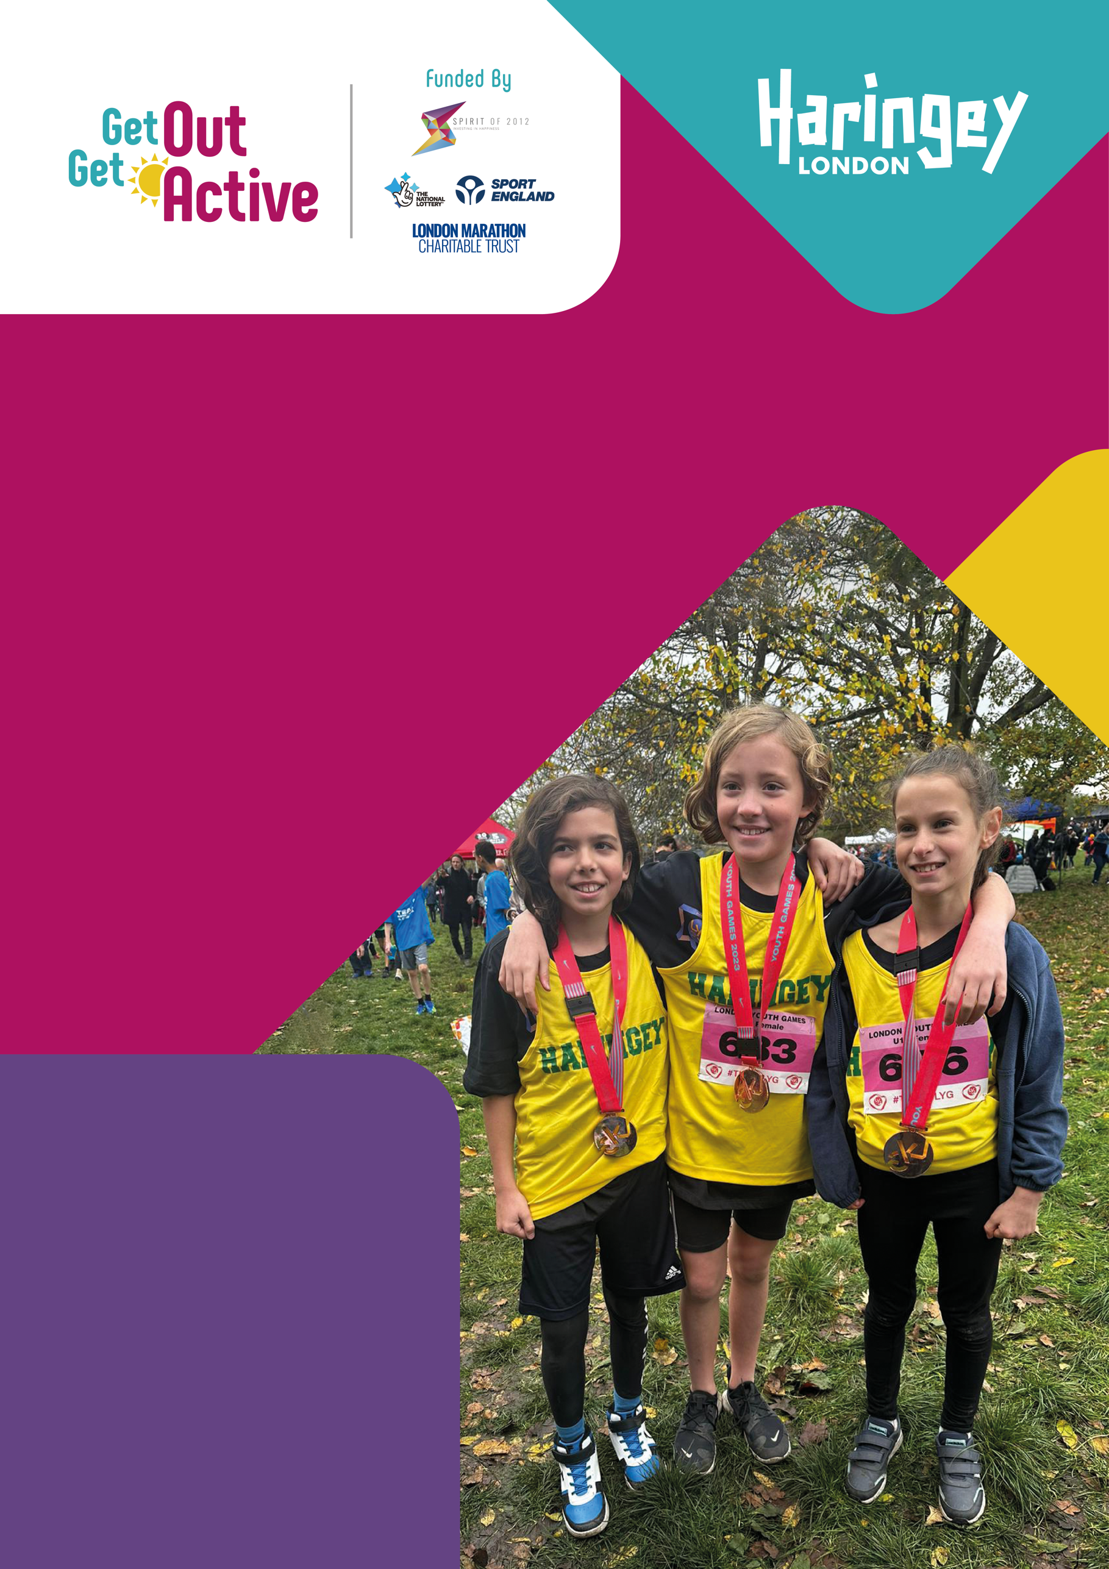

Get in touch to find
out more about GOGA:
01509 227750
goga@activityalliance.org.uk
www.getoutgetactive.co.uk
@GetActiveGOGA

This document is also
available in accessible Word
format. Please contact us
if you need more support.

Report published
in February 2023.
Photo credits: Haringey Shed
Inclusive Theatre (1), Haringey
Sport Development Trust (28).

Activity Alliance, Annual Disability and Activity Survey 2022-23 (to be published in 2023)

